**NCYC 2019**

**in Indianapolis**

**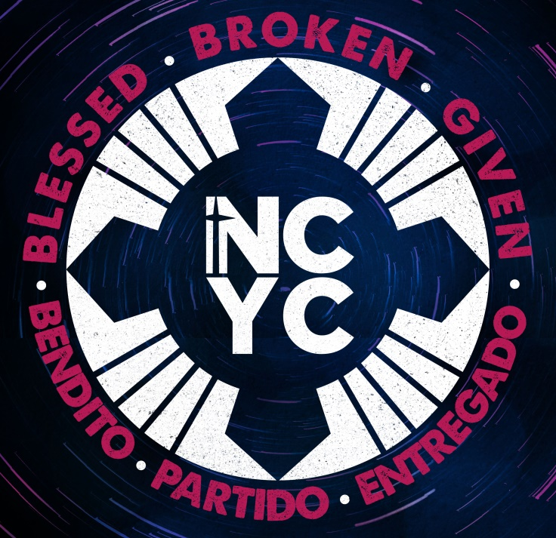**

**Catholic Diocese of Youngstown**

**Group Leader Manual**

**The National Catholic Youth Conference**

**(NCYC) Pilgrimage**

**November 21 – 24, 2019**

**A Guide to organize a group of high school teens and adult chaperones from your parish, cluster or school for the NCYC**

DIOCESE OF YOUNGSTOWN

NCYC PILGRIMAGE GROUP LEADER MANUAL

**Manual at a glance: Page:**

What is NCYC 2

Youngstown pilgrimage package 3 – 4

Buses and Hotel 3

Diocesan Preparation Gatherings 4

Finances 5 - 6

Adults/Chaperones 7

Registration Form Information 8 - 9

Communications 9

Deadlines 10

NCYC Schedule – local events and Indy pilgrimage 11 – 12

Forms, part one (More forms will be posted this summer) Appendix

## Some Helpful Abbreviations:

**ADA**—Americans with Disabilities Act **DOY**—Diocese of Youngstown

**CC**—Convention Center **FCFS** – First Come- First Served

**FAQ** -– Frequently Asked Question **LOS**—Lucas Oil Stadium

**NCYC**—National Catholic Youth Conference **OY&YAM**—Office of Youth and Young Adult Ministry

**NFCYM**—National Federation for Catholic Youth Ministry

**INTERESTED? Here is a brief summary of what a Group Leader would need to do:**

Step 1 – **PREPARE**: Read this manual carefully – underline, highlight, note questions…

and watch the videos posted at: <http://www.ncyc.info/>

as well <https://youngstownoyyam.weebly.com/2019-ncyc-pilgrimage.html>

Step 2 – **PLAN**: Based on the diocesan deadlines and prices, set your parish/cluster prices and

deadlines (I recommend at least two weeks prior to give yourself time to process).

Step 3 – **PROMOTE:** Begin publicizing in your parish/school—personally invite potential chaperones

and key youth you think would benefit from this opportunity. Share web links. Invite past participants to

share their stories from NCYC and the benefits they experienced. Plan fundraisers as needed.

Step 4 – **PAPERWORK and administration**: Attend a couple of meetings, share information, and

collect, collate, check, check-again, copy and submit all the necessary paperwork and payments!

Step 5 – **PRAY:** For those you invited to respond and for them to be open to the experiences of the NCYC

pilgrimage so that we will return to the diocese, our parishes/schools and our homes more faith-filled

disciples of Jesus!

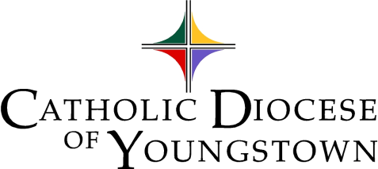Diocesan Delegation Leader**: Cindee Case**

**Office of Youth and Young Adult Ministry (OY&YAM)**

144 W. Wood St., Youngstown, OH 44503

Phone: 330-744-8451 ext. 280/ Fax: 330-744-5899

[ccase@youngstowndiocese.org](mailto:ccase@youngstowndiocese.org)

1

# NCYC_2015_colorLogo**NCYC - What is it?**

The **National Catholic Youth Conference** (NCYC) is an exciting, biennial three-day (plus one travel day) experience of prayer, community and empowerment for Catholic teenagers and their adult chaperones. The schedule includes general sessions and workshops addressing a wide variety of topics as well as opportunities for reconciliation, daily liturgy and special activities such as concerts, a dance and a comedy club. The “thematic village” is a unique venue incorporating traditional exhibits with interactive educational and recreational activities as well as vendors. More than 20,000 attendees are expected to participate.

**What Makes This Conference So Unique?**

In a distinctly Catholic setting, the National Catholic Youth Conference invites participants

to **encounter** Christ, **experience** church, and be **empowered** for discipleship.

**This is a pilgrimage of faith** – parishes/clusters/schools are asked to prepare their young people to attend this event by gathering the youth together on a regular basis and leading them in prayer, reflection, service and community-building experiences in addition to any fundraising events the group undertakes.

**At NCYC youth and adults**…

* Gather as a church on a national level
* Learn more about themselves and their relationship to the Catholic Church
* Celebrate their Catholic Christian faith
* Meet thousands of other Catholic youth
* Share beliefs and experiences

Many young pilgrims return home full of enthusiasm, renewed faith, “borrowed” ideas and willingness to share their experiences with others. These can be positive benefits to your parish/school ministry as well as to the pilgrims who attend as you allow them to help energize your local efforts with youth!

**PILGRIMAGE VERSUS TOUR**

A pilgrimage differs from a tour in several important ways - first of which is being open to God’s grace along the journey. No matter how well the programs are planned, unexpected things will happen. This requires patience from the pilgrim, and an openness to seek God’s presence in that moment.

*A successful pilgrimage involves a commitment to leave behind one's problems and to focus instead on seeking to learn more about our heavenly Father, making one's heart full of desire for special graces, praises, petitions and thanksgiving, returning home transformed, renewed and restored by the abundant blessings received.*(from <http://www.medjugorje.org/whatisapilgrimage.htm>)

So, be patient and open to some amazing grace!

Main Stage Speakers/Performers:

**Emcees**: Katie Prejean McGrady, Fr. Agustino Torres, CFR

**Keynotes**: Immaculee Ilibagiza, Sr. Bethany Madonna SV, and Mark Hart

WHO CAN GO?

**Youth** must be in ***9th-12thgrade during the 2019-20*** school year to attend as a youth participant.

**Chaperones** must be 21 years or older and be found in full compliance with the Diocese of Youngstown Child Protection Policy. (See page 7 for further details.)

**Young Adult Non-Chaperones** are a limited number of post high school youth (ages 18 – 20) who cannot serve as chaperones but may assist adults in enforcing the Code of Conduct, leading discussions, and accompanying the teens. (Yes, this is new and up to local Group Leaders to allow or not. Remember, this conference is offered for high school students. However, if you have young adult assistants who want to come as an adult participant, you can allow it!) 2

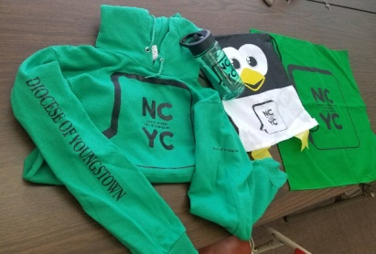**The Diocese of Youngstown Package includes**:

* NCYC conference fees
* hotel lodging for 3 nights
* diocesan trading items
* diocesan shirt
* 3 hot breakfast buffets
* a Saturday late-night pizza party
* taxes and tips for hotel and bus *2017 hoodie, water bottle, string bag and bandana*
* motor coach transportation(to and from Indianapolis, as well as daily service to and from the convention venue).

**HOW WILL WE GET THERE?**

The Youngstown Diocese will be traveling by **motor coach bus**.

We will travel during the morning/afternoon of Thursday, November 21 and return on Sunday, November 24 in the afternoon/early evening. This is approximately a 6-8 hour bus ride. These coaches will provide daily transportation between the hotel and convention venue.

Groups will provide their own transportation to the motor coach pick-up/drop-off sites within the diocese; these pick-up/drop-off sites will be determined based on participating group sizes and locations. Each bus will have a “Bus Captain” that will check with group leaders to ensure all riders are accounted for, coordinate onboard activities, and be available in case of an emergency. All pilgrims are asked to follow the direction of the Bus Captains.

FAQ: Our parish has a van – can we use that for travel and save on buses?

No. The NCYC pilgrimage is a diocesan event and safety is our first concern. We have contracted with an insured bus company. Additionally, the planning team has prayer and discussions planned for the bus rides as part of the pilgrimage. For you and your teens to be part of it, we need you to ride with us.

**WHERE WILL WE STAY?**

### The Diocese of Youngstown is assigned lodging at Springhill Suites Indianapolis/Fishers. *Please DO NOT contact the hotel prior to our trip. Direct questions or concerns to Cindee in the OY&YAM.*

**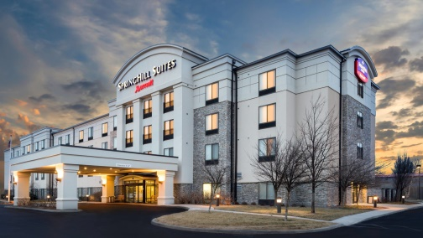Youth** will be staying in “quints” – that is 5 persons to a room. That means — 5 persons in a room with 2 beds - sharing a bed - plus one getting a sleeper sofa. Youth who do not wish to share a bed may want to bring a sleeping bag and sleep on the floor (with no reduction in cost). If your numbers are such that you prefer 6 per room, with two sharing the sleeper sofa, let me know. We do NOT have enough rooms available at this hotel for quads, so be sure to discuss with your teens ideas on scheduling shower time with a shared bathroom among 5 people.

**Adults** can stay 2- 5 persons per room, as you wish to fill them. (On Form D, you will notice that Adult room boxes have two spaces, and three “as needed” (a/n) for those who wish to have 3 or 5 per room.). A *very* limited number of single-person rooms are available at actual cost.

FAQ: I have family in Indy – can I stay with them and save my hotel costs?

No. The NCYC pilgrimage is a unique opportunity to be part of the diocesan Church.

Plus, safety concerns make it impractical - and downright dangerous - for us to allow special accommodations. But, definitely ask your family to pray for you. If your relatives will be attending NCYC, plan beforehand to meet up with them at the thematic village or a workshop!

### 

### Notes about Springhill Suites:

### Each room will have a small refrigerator and microwave

### We will have a hot breakfast buffet each morning

### There is a ‘sundry shop’ for any on-the-spot individual purchases

### 3

### j0310740PILGRIMS WITH DISABILITIES OR SPECIAL NEEDS

Please notify the OY&YAM as soon as possible so arrangements can be made with NFCYM for any participants requiring ADA accommodations, or to make arrangements with the hotel for handicapped accessible rooms, refrigerators for medication, etc. Sign interpreters will be available at NCYC sessions.

**DIOCESAN GATHERINGS**

The OY&YAM will sponsor gatherings for the entire delegation to get to know each other prior to our pilgrimage including a “Send-Off” to pray, distribute DOY shirts, share last-minute information and celebrate our upcoming journey. Please share these dates with your delegation as they are confirmed:

**Pilgrim Preparation: Sunday, September 29, 2 – 5 p.m.@ St. Joseph Parish, Canton**

This is an important gathering to help prepare pilgrims for the NCYC experience.

**Send Off: Sunday, November 3, 1:30 – 5:30 p.m. @ St. Columba Cathedral**

We will gather in the Parish Hall at 1:30 p.m. for prayer and meeting,

then join the Cathedral parish at the 4 p.m. Mass with Bishop George Murry,

and finish with a group picture before you head home. Families are welcome to join us at Mass.

**Reunion: Tentatively: Saturday, December 7, TBD**

An opportunity to pray together and share stories from the NCYC experience.

**Scholarships Collection at Mass**

Thousands of dollars are collected each year for scholarships for teens to participate in the next NCYC and grant-funded projects throughout the country. The Diocese of Youngstown has often benefited from these scholarships. During the Closing Mass on Saturday night, a collection will be taken. Each participant is asked to “Set aside $10” or more for this collection. This is in addition to your NCYC fees. Please plan accordingly.

## TRADING ITEMS

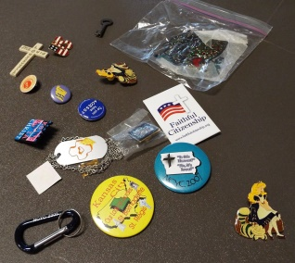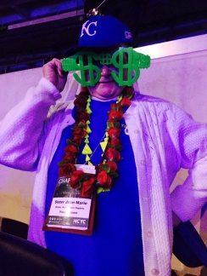Youth from all over the country bring prayer cards, hats, t-shirts and small trinkets featuring their town, diocese, state or local landmark to trade at NCYC as a fun way to break the ice and meet new people. The OY&YAM includes a few trading items for each pilgrim. Feel free to create and bring trading items from your parish/school as well. (However, do not put personal names, phone numbers or addresses on items, just the parish/school.)

*(Sr. Jean Marie shows off some of her trading “gets” – hat, glasses, necklaces, pins, etc.; and a look at some smaller traders, some of which are hand-made)*

**THE THEMATIC VILLAGE:**

A key component of the NCYC is the thematic village, an interactive venue featuring the College Corner, a technology lounge, the Market Place, vocation areas, interactive games, service project areas, and various entertainment stages.

The thematic park is NOT to be missed! However, it may be tempting to spend all one’s time there, so *encourage* teens to plan time for the park but to also attend the workshops and prayer services!

**Other Helpful bits of information:**

* **COMFORTABLE SHOES:** These are a necessity. Even with our bus dropping us close to the hotel and Lucas Oil Stadium, keep in mind this is an NFL Stadium, then we walk to a very large convention center and food venues will be blocks away. Make sure your group is prepared!
* **SLEEP**: While excitement of meeting new people may bring insomnia, encourage sleep!
* **HYDRATION:** Keep refilling your water bottle to keep up one’s energy!
* **SOUND:** As the target audience is teens, expect LOUD music, speakers and activities. Bring ear protection if you are sensitive!

4

**What Will This Cost?**

*The Diocesan Pilgrimage Package is priced according to the number of persons per hotel room*:

|  |  |  |  |  |  |
| --- | --- | --- | --- | --- | --- |
| # Persons per room | **5 PERSONS** | 4 PERSONS | 3 PERSONs | **2 PERSONS** | 1 PERSON |
| bs01887_# Beds/room | 2 beds plus 1 sleeper sofa | 2 beds plus sleeper sofa\* | 1 bed plus sleeper sofa\* | 1 bed/1 sleeper sofa\* | 1 bed |
| **Diocesan Package**  **Price** | **$570 pp** | $590 pp | $625 pp | **$700 pp** | $930 pp |
| **Notes:** | **All youth,**  **adults upon request**  *(Call if you want to fill a quint with 6 teens)* | **Adults only**  *(Call if a special request needed)* | **Adults only** | **Adults only – most popular option** | **Adults only, limited space** |

\*Subject to change to a two bed room depending on availability, but one cannot count on that option.

When setting your parish/group rates, consider any additional costs you may have with a group shirt, trading items, activities and preparation sessions you may offer. For these, you may need to ADD TO the posted fees.

Group Leaders may also wish to discount participant costs by providing parish/school scholarship funds or applying income from fundraisers. Different leaders apply different rules, such as each person pays $400 and the rest is to be fundraised….or each participant in a fundraising activity earns towards his/her fees.

When setting your parish/school group price, keep in mind the overall costs for the teens and adults. It is typical for a group to help fundraise for/with the adults.

*Group example: St. Marie’s will have 5 teen girls, 5 teen boys (10 x $570 quints= $5,700)*

*And 2 adult women and 1 adult man sharing a room with another (3 x $700 doubles = $2,100)*

*For a total of $7,800 due to the diocese. Factors to $600 per person.*

*They will also get a group shirt and trading items at $18, and the group leaders will get drinks and snacks to take on the bus for $3 per person. For a total of $621 per person…..*

*Then you can give credit income from fundraisers from there should you fundraise together!*

*(To charge only $400 pp, you need to fundraise about $2,873 total.)*

# **WHEN WILL MONEY BE DUE?**

|  |  |  |
| --- | --- | --- |
| **DATE** | **AMOUNT DUE** | **j0238701PAYMENT** |
| April 19, 2019/FCFS | $100 per person | Non-refundable Deposit |
| June 19, 2019 | $250 per person | 2nd Payment |
| August 19, 2019 | Remaining balance | Final Payment |

**All checks** should be made payable to the **Diocese of Youngstown**; please write “**NCYC**” on the memo line. A payment form (FORM B) must accompany all payments so they may be properly credited your group.

NOTE: To eliminate confusion, all payments must be collected and submitted by the group leader. All charges for a group will be listed under a parish/school name (not the individual participant’s name). It is also the responsibility of the group leader to track individual payments for your group. The diocese only tracks the group as a whole.

Prior to August 19, the OY&YAM will email the Group Leader an Invoice with the balance due.

5

**CHANGES IN YOUR GROUP SIZE AFTER THE APRIL 19 DEPOSIT:**

* **Decreasing Your Group Size:**

If you paid for more deposits than you need, you are not entitled to a refund. However, those deposits can POSSIBLY be “sold” to another parish that is hoping to increase their group size. If you would like to try to “sell” some of your deposits, please contact the office. The OY&YAM will work to connect you with a “buyer” and help you with the transactions that are required. If we find a “buyer”, your group will be credited for any payments you have made on the spots you sold on your next invoice.

* **Forfeiting Spots:**

If you or the OY&YAM cannot find a parish that is willing to purchase your spots from you, we do give you an opportunity to forfeit those spots prior to the next payment. By forfeiting those spots, you surrender the non-refundable portion of any previous payments, but you no longer make payments for spots you are not able to fill.

* **Increasing Your Group Size:**

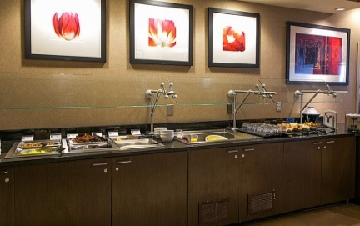If you did not make enough deposits, it is still POSSIBLE to have a larger group. There are two ways that your group size can grow. First, if you want to increase your group size, let us know. We’ll try to match you up with a parish that has spots for sale. Second, if no parish is trying to sell spots, you will be put on a waiting list. Once the waiting list reaches over 20 spots, we will work to increase our hotel block to make room for all the spots on the waiting list. At that point, I will increase your group size and bill you for any missed payments on your additional spots during the next billing cycle. Please note that NFCYM adds fees for Additions made after June ($50), after August ($60) and late registration ($70), so those fees are passed along to you.

### MEALS:

A hot breakfast buffet will be provided at our hotel on Friday, Saturday and Sunday mornings that will include scrambled eggs, assorted pastries, fruit, cereal, yogurt, and coffee.

There will be a pizza party at the hotel on Saturday evening.

Participants are on their own for all lunches, dinners and snacks. Approximately $100 per person is suggested. There are many restaurant options available within walking distance of the convention center as well as vendors inside that will be selling food. No youth should leave the conference sites unattended; chaperones must accompany the minors. There is no hotel room service available.

Snacks that can be carried by individuals in their purses/backpacks are encouraged.

\*\*\* No catered meals from outside the convention center or stadium will be allowed. \*\*\*

## SPENDING MONEY

In addition to meal-money, please know that there will be various vendors in the thematic village of the NCYC with books, music, clothing and souvenirs. You may wish to bring along cash or authorized credit cards for purchases. Also, do not forget the “Set $10 Aside” collection at Mass.

SCHOLARSHIPS

A limited number of scholarships will be available through the NFCYM.

Applications (Form 15) will hopefully be posted by the NFCYM soon. Stay tuned!

## FUND RAISING

Fundraising may be economically necessary, but it is also useful for building community as part of the pilgrimage preparations. You may visit the virtual OY&YAM for additional ideas:

<http://youngstownoyyam.weebly.com/fundraising.html>

**TRAVEL INSURANCE:**

Travel Insurance is available for purchase from Allianz (formerly Access America) at: [www.allianztravelinsurance.com](http://www.allianztravelinsurance.com) or 800-284-8300. Prices varied from $26 - $51 for a 16 year old (varies by age and level of coverage) when checked in March 2019.

6

**SELECT OPPORTUNITIES FOR TEENS:** (Subject to change by the NFCYM)

**+ YOUTH ANIMATORS:** This program is currently being restructured. As information is made available, the OY&YAM will share it in a Group Leader Update. However, this is typically a chance for teens to assist with workshops sessions by serving as greeters, prayer leaders, speaker introductions, distributing handouts, etc.

## CHAPERONES/ADULT PARTICIPANTS:

#### \*\*\* VERY IMPORTANT! \*\*\*

#### Diocese of Youngstown CHILD PROTECTION

All chaperones must be in full-compliance with the Diocese of Youngstown Child Protection Policy. Those who were in full compliance by September 27, 2016 and have continually serviced in ministry in our diocese are still listed as compliant until April 1, 2020. For newer adult volunteers and employees, this process can take 4 to 6 weeks. **Start this process no later than July 1, 2019** (earlier is recommended).

To be in compliance, new Chaperones must:

* **Receive and read the DOY Child Protection policy booklet**
* **Complete and sign the background questionnaire**
* **Participate in a VIRTUS in-service training** (See link on www.doy.org for dates/times)
* **Complete a Webcheck (fingerprinting) and have the Webcheck report sent to their parish**

**or school Child Protection Compliance Officer**

**Parish or school Safe Environment Compliance Officer then submits records to diocesan administrator Msgr. John Zuraw**, utilizing the Child Protection Policy Compliance Checklist—including dates—for information to be recorded in the diocesan database. **Send this form no later than August 19**. If the above steps have not been **completed chaperones will not be permitted to attend NCYC. This may exclude your youth from attending as well if it impacts your ratio.**

***Chaperone to youth ratio is 1:6.*** *Every group must have a minimum of 2 chaperones.*

PLEASE NOTE: Consider the gender breakdown of your group when selecting chaperones so that both sexes are appropriately supervised. You must have female chaperones for girls and male chaperones for boys. **Parishes may combine their groups in order to meet the chaperone ratio requirements.** For example, St. Brigid parish may have two male chaperones and St. Kevin has three female chaperones; these two parishes may cluster together to supervise up to 30 teens as a group. *Make sure these teens and adults meet each other prior to the NCYC!*

*Chaperones should be aware of the physical nature of the conference with potential for a lot of walking (easily 3 – 5 miles per day), standing in long lines, limited sleep, navigating in a crowd of 20,000+ people, and safety issues of being in a large city. Also, while chaperones tend to have a fun and inspiring time at NCYC, the priority is for a safe and potentially transformative time for the teens in our care.*

NFCYM YOUTH PROTECTION

In addition to our diocesan policy, two important documents regarding safety, *Safeguarding God’s Children*, and the *NFCYM Emergency and Crisis Manual,* should be available at the following web address, <http://www.nfcym.org/youthprotection/>.Please review these documents with your chaperones before they complete their Registration Forms. If you are unable to download the documents, contact Cindee for a copy.

## MANDATORY CHAPERONE MEETING

**All chaperones will be required to attend an evening chaperone meeting prior to NCYC.**

Each adult must select one of the meetings: **Thursday, August 22 or Tuesday, August 27.** Locations TBA.

WORKSHOPS FOR PARENTS at NCYC

Parents serving as chaperones may be happy to see workshop sessions geared to their important role in family/faith development (perhaps a few parents will volunteer to serve as chaperones to attend).

7

MEDICAL PROFESSIONAL

j0279548The OY&YAM would like to have one designated medical professional — doctor, nurse or EMT — for the diocesan group. This person will receive all the medical forms for review, be asked carry copies during the conference and to attend to any medical emergencies of our group members. If needed, on site medics will be available in Convention Center and stadium.

This person will be determined on a first-come first-served basis, must have valid medical certification and meet all chaperone requirements. This person will receive a modest stipend for this service.\*\* Contact Cindee by June 19 if you have an adult attending that may qualify and be willing to serve in this capacity.\*\*

**REGISTRATION FORMS**

As soon as possible, beginning in April, submit Form A and Form B with a $100 per person non-refundable deposit to the OY&YAM. *Any deposits received AFTER the April 19 deadline will be placed on a Waiting List.*

Keep track of payments using the Payment Form (Form B). Submit Form B with each payment to OY&YAM. See the chart on page 10 for payment deadlines.

Groups may reserve spaces without providing names until August 19.

Space is limited to 165 and will be filled on a first-come, first-served basis. Once we reach our limit of 165 pilgrims, additional names will be placed on a waiting list. Group leaders will be notified when registration openings occur. HOWEVER, the diocese will make every effort to accommodate ALL who submit deposits by April 19 (even if this number exceeds 165). If we have less than 165 registrations by June 19, the extra hotel rooms will be released. Therefore, registrations received after June 19 are not guaranteed space (even if the total count for the diocese is less than 165).

\*\*This summer, group leaders will receive the individual registration forms (typically four-pages per person) and an Excel spreadsheet to submit to the OY&YAM no later than September 1st.

**Group Leaders must MAKE AND KEEP COPIES of all forms submitted to the OY&YAM, including waivers and medical forms.** The group leader must CARRY a copy of all forms for group participants during the conference.

**NOTARIZATION**

DOY Individual Registration/Medical Permission Form (FORMS E & F) must be **NOTARIZED**. Most banks and city/township offices have a notary. ***The OY&YAM suggests each group offer a “Notarizing Night” where a volunteer certified notary is available for families to complete, notarize and submit forms.*** Note: the Notary must witness the official signatures, so be sure to let parents know that they can complete all the medical and general information, but leave a signature line open to sign in front of that Notary!

TRIPLE CHECK THE FORMS

Prior to submitting forms to the OY&YAM, PLEASE be sure to check and recheck that ALL the appropriate sections have been completed and signed or initialed by each teen and guardian (and the chaperones) on all four (4) pages of registration forms.

**If there are any changes in medical information (insurance, illnesses, etc.) between time of submission and the pilgrimage, please be sure to notify the OY&YAM.**

**All forms must be submitted to Cindee in the OY&YAM, except where noted.**

**Reminder: Group Leaders must MAKE AND KEEP COPIES**

**of all forms submitted to the OY&YAM,**

**including all waivers and medical forms.**

8

WHAT IF SOMEONE CANCELS?

**Cancellation/Substitution Policy**

**Cancellation**: All cancellations must be submitted on **FORM C** to the OY&YAM. Those received on or before Friday, September 1st will be refunded as possible, minus **$100** non-refundable deposit and any other payments that have been made by that time. Refunds may not be issued until after the NCYC.

**Substitution**: All substitutions must be submitted on **FORM C** to the OY&YAM. There is a NFCYM fee for all substitutions received after June 19 ($50), after August 19 ($60) and after September 1 ($70). To the extent that appropriate age and gender hotel rooms are still available, substitutions will be accepted through October 2. From October 3 - November 16, substitutions must be of the same gender and age group (youth or chaperone). Please keep in mind that chaperone substitutions must still adhere to DCPP policies.

**FORM DISTRIBUTION**

With so many pieces of paper, it can be confusing on who should get what, so here is a quick

“Who Gets What” list:

**j0299547**

**Youth**

1. NCYC Brochure

2. NCYC Youth Code of Conduct

3. Form E (Diocese of Youngstown Individual Registration and Liability Form)

4. Form 13 (NFCYM Individual Registration Form) – coming this summer

Optional:*Youth Animator Application (possibly available online this summer?)*

**Adults**

1. NCYCBrochure

2. NCYC Adult Code of Conduct

3. NCYC Youth Code of Conduct

4. Form F (Diocese of Youngstown Individual Registration and Liability Form)

5. Form 14 (NFCYM Individual Registration Form) – coming this summer

6. Link to NFCYM Youth Protection Documents (should be found at:

<http://www.nfcym.org/youthprotection/> ) or copies you provide for them.

Optional: Diocese of Youngstown Child Protection Policy, if not already in compliance.

j0303509

## COMMUNICATIONS: GROUP LEADER UPDATES

Group leaders will receive updates by email prior to the NCYC.

Please pass along information to your group in whatever method works best for your participants.

While in Indianapolis, at least one adult chaperone per group will need to have a cell phone

with texting for any immediate information updates.

For **GROUP LEADERS**, be sure to visit and bookmark the pilgrimage Leaders website:

<https://youngstownoyyam.weebly.com/ncyc-group-leaders.html>

For idea sharing, use the Facebook Group Page for Group Leaders:

<https://www.facebook.com/groups/235746699787715/>

There is also a general webpage for our delegation at:

<https://youngstownoyyam.weebly.com/2019-ncyc-pilgrimage.html>

For your **TEENS, their parents and CHAPERONES** on Facebook,

there is a diocesan group page, which will be a good place to get updates as they become available regarding schedule changes and announcements from the NFCYM. This will also be where I will be looking for decisions on things like shirt design, color, style, etc. So, please “join” and/or share this information with your delegation:

Group Name: **Youngstown NCYC**

Direct link: <https://www.facebook.com/groups/126698777411259/>

9

DEADLINES

|  |  |  |  |
| --- | --- | --- | --- |
| **DUE DATES** | **Form** | **What it is** | **Descriptions & Instructions** |
| **Friday,**  **April 19\***  **(Earlier OK)**  **First Come- First Served** | Form A  Form B  and $100.00 per person | Initial Deposit/Group Registration Due | Complete Form A and B and send to the OY&YAM (with $100 per person to save your place).  *\*This is the only “flexible deadline” as others will be accepted as space allows.* |
| **Possibly Wednesday**  **May 1\*** | Form 15, once it is posted | Scholarship Application Deadline | A limited amount of scholarship money is available through the NFCYM. Please complete and return the application to **Cindee** in the OY&YAM. |
| **Wednesday,**  **June 19** | Form B (again) and  $250.00 per person | 2nd Payment due | Complete Form B and send to the OY&YAM (with $250 per person). |
| **Monday,**  **July 1\*** | LAST DAY TO BEGIN Child Protection Process, if necessary | Child Protection Compliance Process | LAST DAY TO BEGIN this process for an adult to attend the NCYC. |
| **Monday, August 19** | Form B (again) with  Remaining Balance per person  If needed, Child Protection Policy Compliance Checklist—**Send to diocesan** **administrator** | Final Payment Due  Report for diocesan database | Complete Form B and send to the OY&YAM (with balance due per person).  Child Protection Policy Compliance Checklist—Send **to Msgr. Zuraw** to update information in the diocesan database. |
| **Friday, August 30**  **(Mail by Wednesday, August 28)** | INDIVIDUAL REGISTRATION FORMS  Form E and 13 (youth)  Form F and 14 (chaperones  and YAMC)  Group Spreadsheet  Form D | DOY and NFCYM Individual Registration/ Medical Permission Forms  Spreadsheet  **Rooming List Due** | Separate forms for YOUTH & ADULTS **(Notarization required on E & F)**  (NFCYM form available in Spanish)  *YES, we need both the diocesan and the NFCYM forms for EACH person*  Please complete and return all of these to the OY&YAM. |
|  |  |  |  |
| **September 1 to October 2\*** | Form C  and substitution fees | Substitutions with fee ($70) | Additions, cancellations, substitutions or information updates. See page 9 for Cancellation/Substitution Policy. |
| **October 3 to Conference \*** | Form C  and substitution fees | Restricted Substitutions with fee | Additions, cancellations, substitutions or information updates. See page 9 for Cancellation/Substitution Policy. |
| **Thursday, November 21** | (Take copies of your groups forms with you on the bus!) | NCYC-bound! | Make sure your group members all check in on the bus, then check in at the hotel. Enjoy the NCYC! |

\* Optional

10

## Diocesan NCYC Event Schedule

|  |  |  |
| --- | --- | --- |
| **DATE (S)** | **WHAT** | **NOTES** |
|  |  |  |
| **Thursday, March 28 at 11 a.m.**  **OR**  **Monday, April 1, 6 p.m.** | Virtual Group Leader Meeting, | Pick one of the two options for quick 30 overview of the DOY Pilgrimage and time for  Q & A |
| **Tuesday, June 11, 5:30 p.m.** | Group Leader Meeting prior to the Youth Ministers Gathering | @ Lil Paws Winery  17574 Mahoning Ave., Lake Milton OH 44429 |
|  |  |  |
| **Thursday, August 22**  **at 6:30 – 8:30 p.m.**  **OR** | Mandatory Chaperone Meeting  (Eastside of diocese) | Every adult attending NCYC must select one:  *@ TBA depending on where registered groups are located* |
| **Tuesday, August 27**  **at 6:30 – 8:30 p.m.** | Mandatory Chaperone Meeting  (Westside of diocese) | *See above*  *(Let Cindee know if you wish to host!)* |
|  |  |  |
| **Sunday, September 29**  **at 2:00 p.m. – 5:00 p.m.** | Participant Gathering #1  (Preparing the Way) | All teens and adults gather for prayer and preparation  @ St. Joseph, Canton |
|  |  |  |
| **Sunday, November 3**  **at 1:30 p.m. – 5:30 p.m.** | Participant Gathering #2  (Send Off) | All teens and adults gather for prayer and preparation  @ the Cathedral and St. Columba Hall, Youngstown |
|  |  |  |
| **Thursday to Sunday, November 21 – 24** | NCYC in Indy | Bus pick up locations TBD |
| **Saturday, December 7**  **TBD** | Participant Reunion/Advent Prayer | Location and time TBA |

**NCYC 2019 Tentative Event Schedule**

**Thursday, November 21, 2019 (Subject to change as the NCYC nears)**

**START EVENT LOCATION**

TBA am Load up the buses from various parish sites in the diocese TBD

Freshen up/drop off luggage at hotel, if time permits Springhill Suites Hotel

4:00 p.m. Region 6 Mass Convention Center TBD

6:30 pm Stadium Doors Open Lucas Oil Stadium

8:00 pm Opening Session Lucas Oil Stadium

10:15 pm Load onto buses, return to Springhill Suites

10:45 pm Chaperones/Group Leaders Meeting Springhill Suites

Midnight Lights out/quiet time/sleep

**Friday, November 22, 2019**

**START EVENT LOCATION**

6:30 am Breakfast Springhill Suites

7:15 am Buses depart for downtown

7:30 am Gathering and Entertainment Lucas Oil Stadium

9:30 am Prayer and General Session Lucas Oil Stadium

11:30 am Chapel Open Convention Center—Ballroom

11:45 am Workshops Round A Convention Center

11:30 am Thematic Village Open Convention Center—Halls A-E

12:00 noon Sacrament of Reconciliation Available Convention Center—Reception Rm

1:45 pm Workshops Round B Convention Center

Lunch break – arrange with your parish/school group TBD 11

3:45 pm Workshops Round C Convention Center

Dinner break – arrange with your parish/school group TBD

5:30 pm Daily Liturgy Convention Center—Hall H

6:30 pm Stadium Doors Open Lucas Oil Stadium

6:30 pm Gathering and Entertainment Lucas Oil Stadium

8:00 pm Prayer and General Session Lucas Oil Stadium

10:15 pm Load onto buses to return to the Springhill Suites

10:45 pm Chaperones/Group Leaders Meeting Springhill Suites

11:15 pm Report to rooms Springhill Suites

Midnight Lights out/quiet time/sleep

**Saturday, November 23, 2019**

**START EVENT LOCATION**

6:30 am Breakfast Springhill Suites

7:15 am Buses depart for downtown

7:30 am Gathering and Entertainment Lucas Oil Stadium

9:30 am Prayer and General Session Lucas Oil Stadium

11:00 am Chapel Open Convention Center—500 Ballroom

11:45 am Workshops Round A Convention Center

11:30 am Thematic Park Open Convention Center—Halls A-E

12:00 noon Sacrament of Reconciliation Available Convention Center—Reception Rm

Lunch break – arrange with your parish/school group TBD

1:30 -3:00 pm Discernment Sessions Convention Center

3:30 -5:00 pm Comedy Club Convention Center—Hall H

3:30 -5:00 pm NCYC’s Got Talent Finale Convention Center—Hall J

3:30 -5:00 pm Dance Convention Center—Halls A-B

Dinner break – arrange with your parish/school group TBD

6:30 pm Stadium Doors Open Lucas Oil Stadium

6:30 pm Gathering and Preparation for Liturgy Lucas Oil Stadium

8:00 pm Closing Liturgy Lucas Oil Stadium

10:30 pm Load onto buses to return to the Springhill Suites

11:00 pm Pizza Party Springhill Suites

Midnight Lights out/quiet time/sleep

**Sunday, November 24, 2019**

**START EVENT LOCATION**

TBD Load on buses for return to Ohio Your bus!

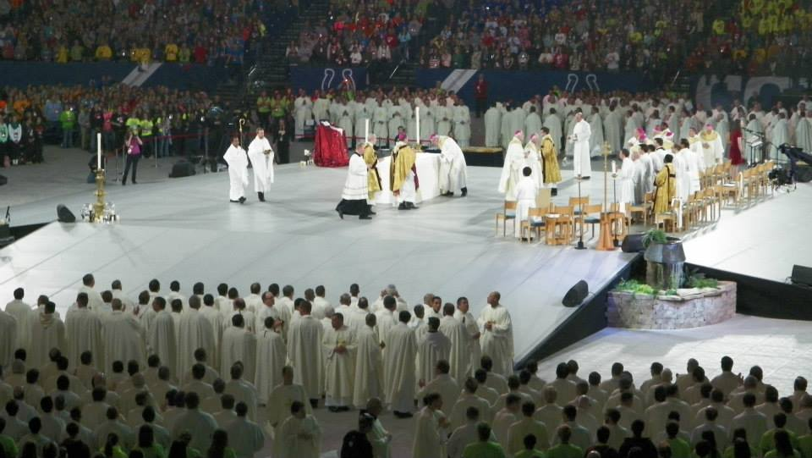TBD Return to Parish Drop-Off Point

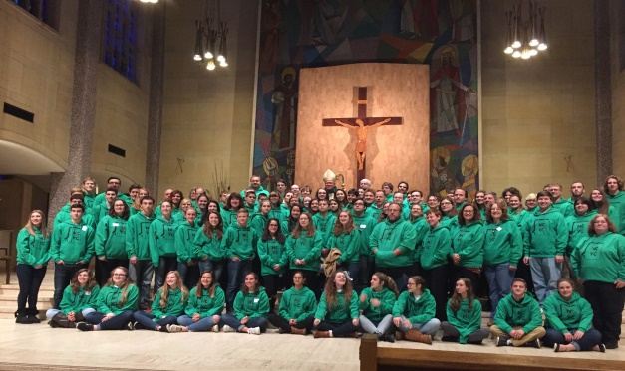

(Priests and Bishops at NCYC 2015 Closing Mass) (2017 DOY Group Picture in St. Columba Cathedral) 12