For more information, and to register, contact:

_____________________________________

Deadline: ____________________________

Requests for financial assistance through the diocese are due September 23rd .

What teens from past DYCs said about the event:
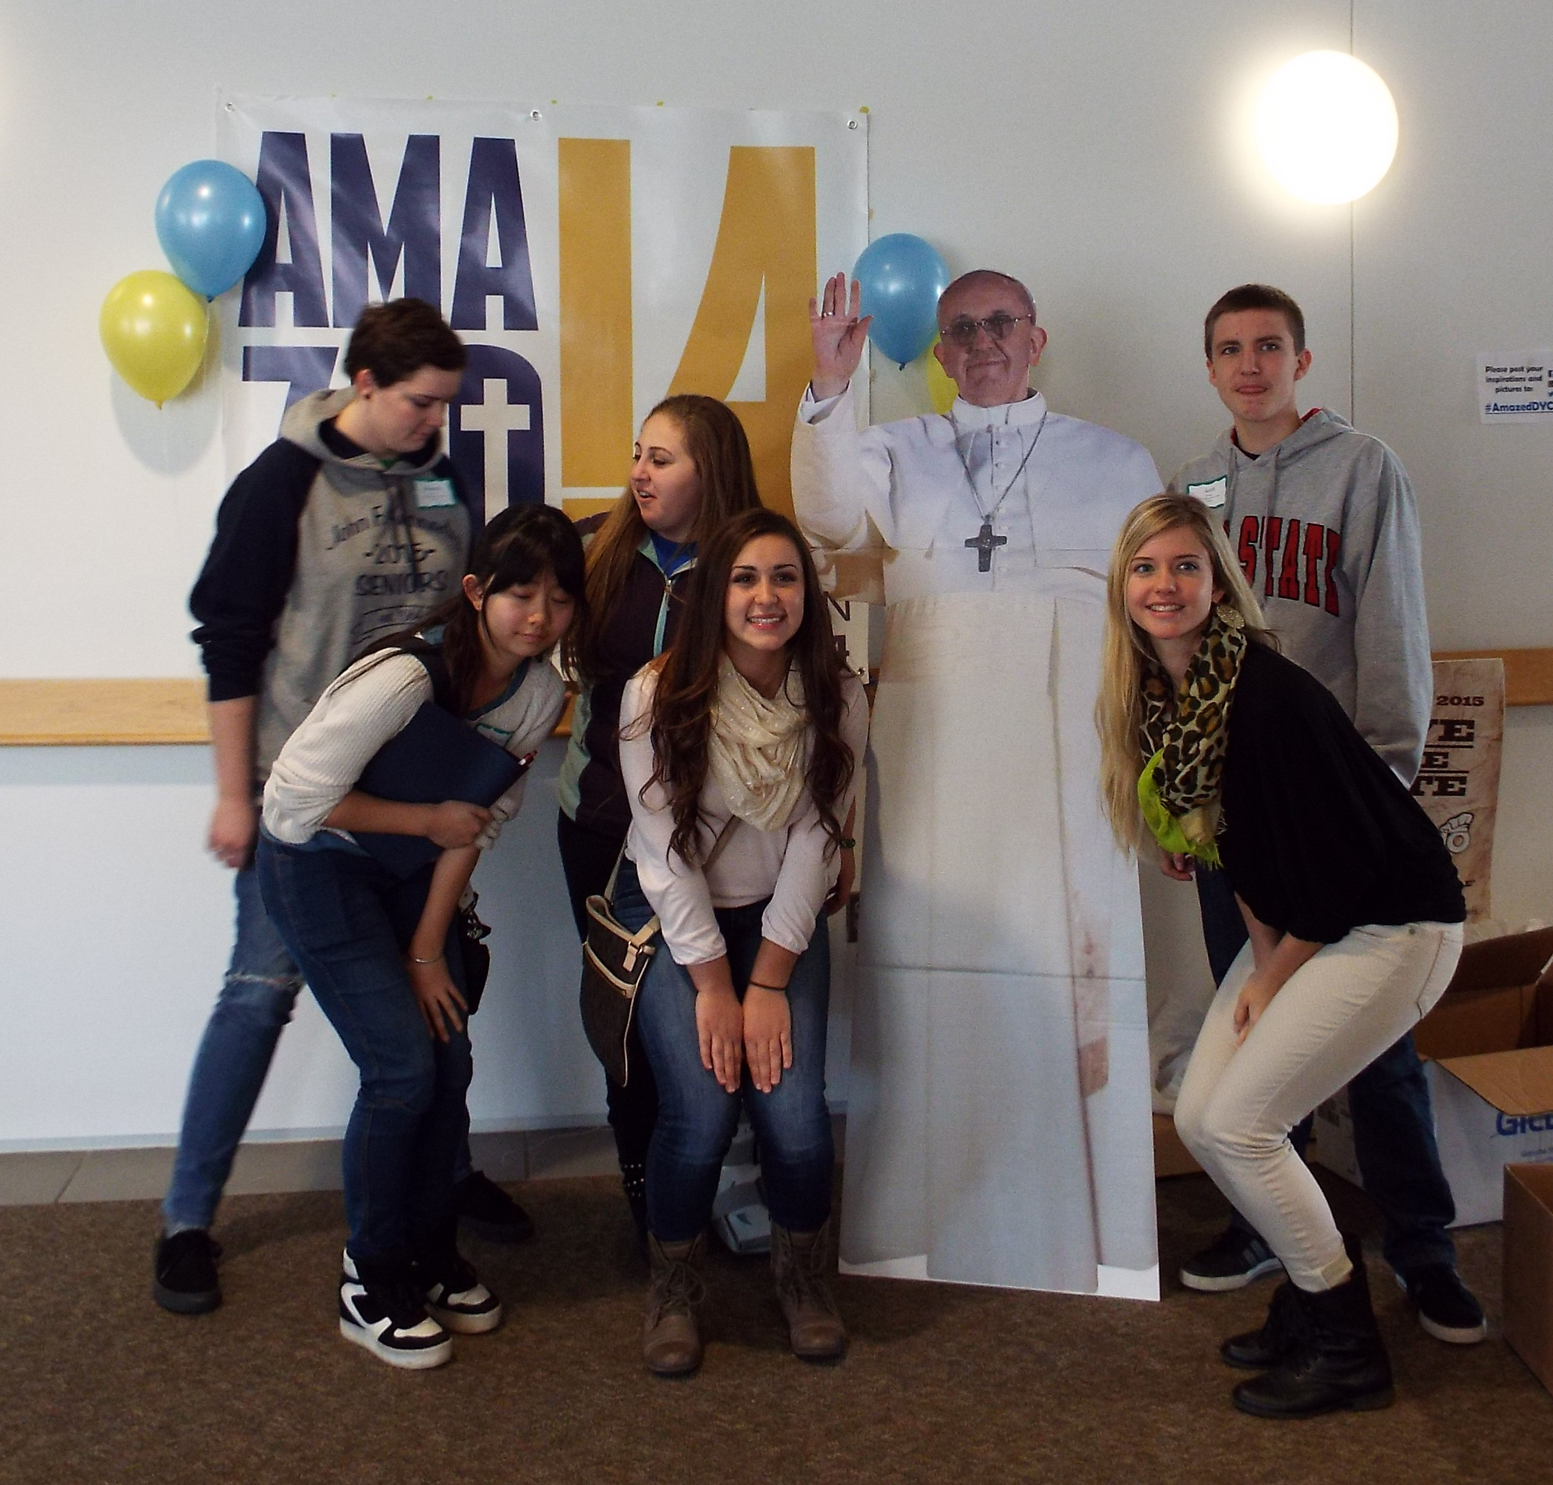
What I liked best was…

….meeting new/friendly people
… being with other Catholics
… the Workshop classes
… the Interactive area
… Mass was powerful
… the openness I could have with people

- What I will tell others about the DYC is…

… How much I learned and how much fun I had
… How I would do it all over again
… It was amazing! I am filled with happiness
… Even though we are only teenagers we can still make a
difference
… You really do feel Christ’s presence at this convention; I
couldn’t imagine anything better

Sponsored by:
Diocese of Youngstown
Office of Youth and Young Adult Ministry
144 West Wood Street, Youngstown, OH 44503
(330) 744-8451

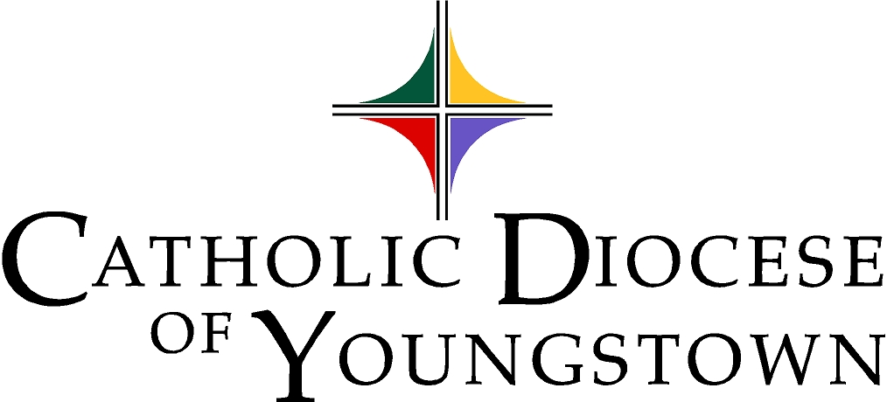
Funded in part by:

The Annual Bishop’s Appeal

St. Michael Parish, Canton,

And our generous donors
(to be listed in the event program book)

Catholic Diocese of Youngstown Office of Youth & Young Adult Ministry Presents:

2016 Diocesan Youth Convention
For High School Teens
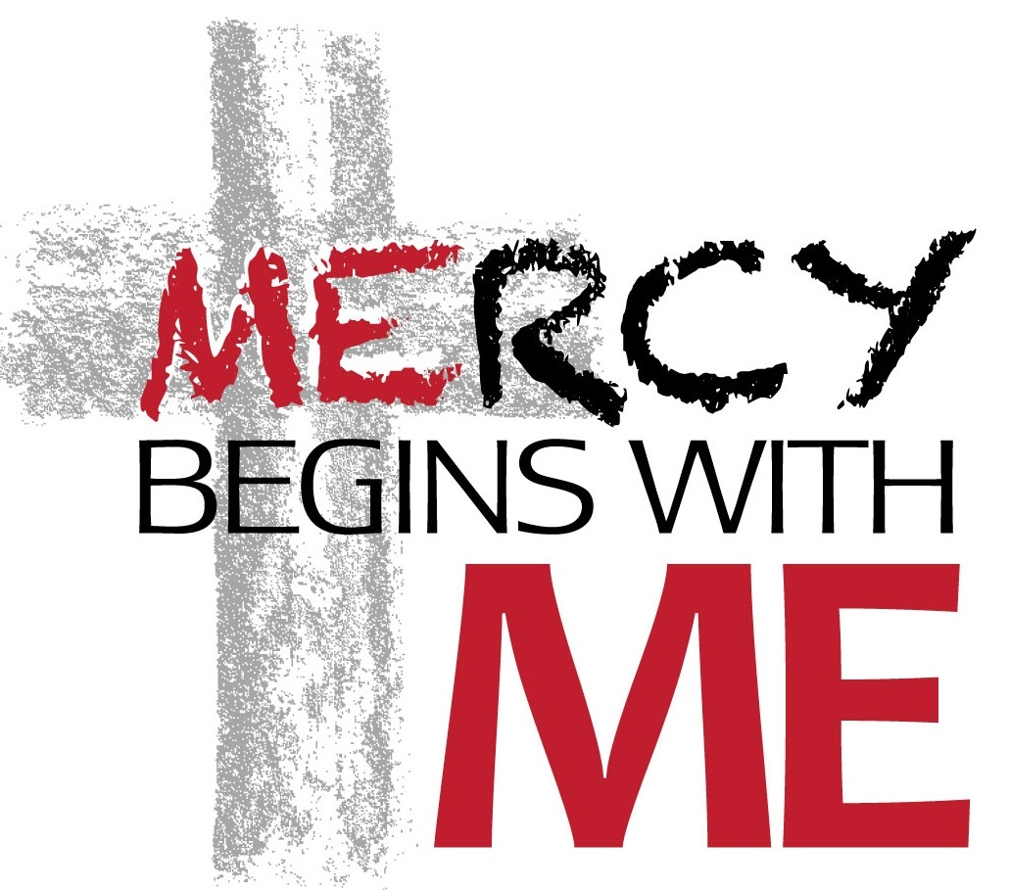

Sunday, November 6, 2016
@ St. Michael Parish, Canton, OH

Cost $

Diocese of Youngstown
2016 Diocesan Youth Convention


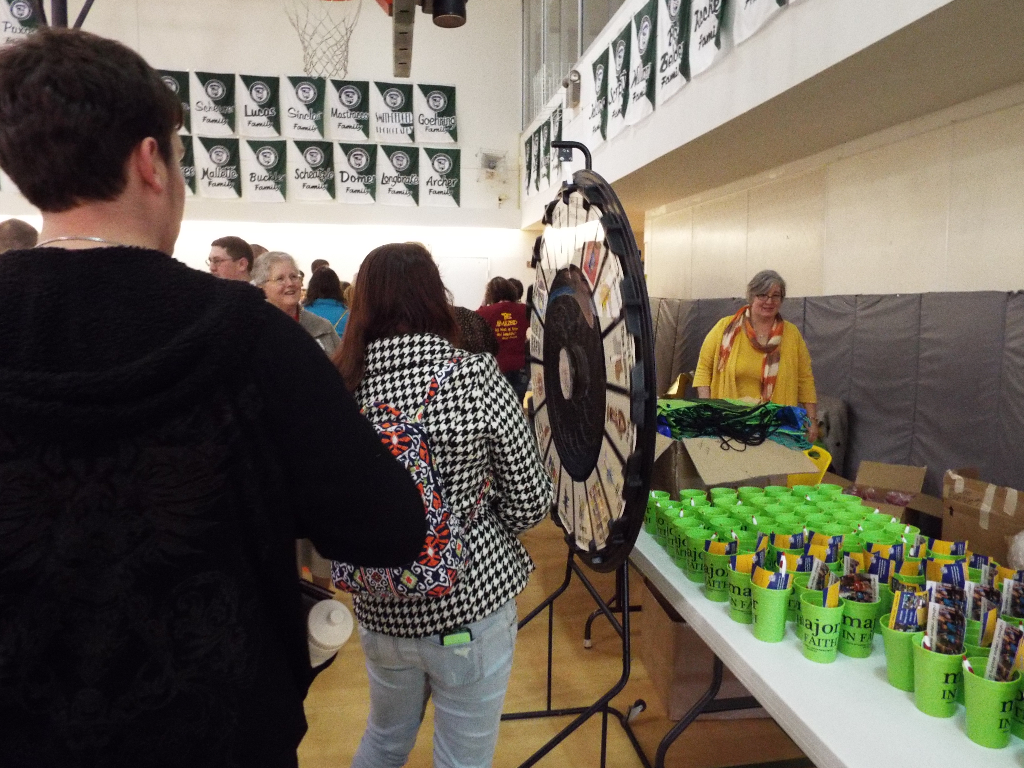
Come join Bishop George V. Murry, S.J., Mr. Ben Walther, great workshop presenters and hundreds of teens to learn, pray, play and celebrate. Together, we will explore ways that “Mercy Begins With Me” and how to be agents of Mercy as Pope Francis challenges us to do.

Activities

Pray
Sacrament of Reconciliation
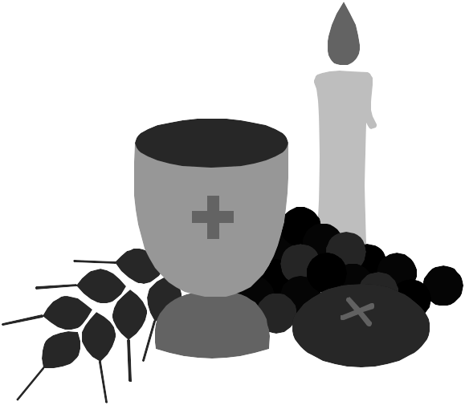
Petition writing
Music
Sunday Mass

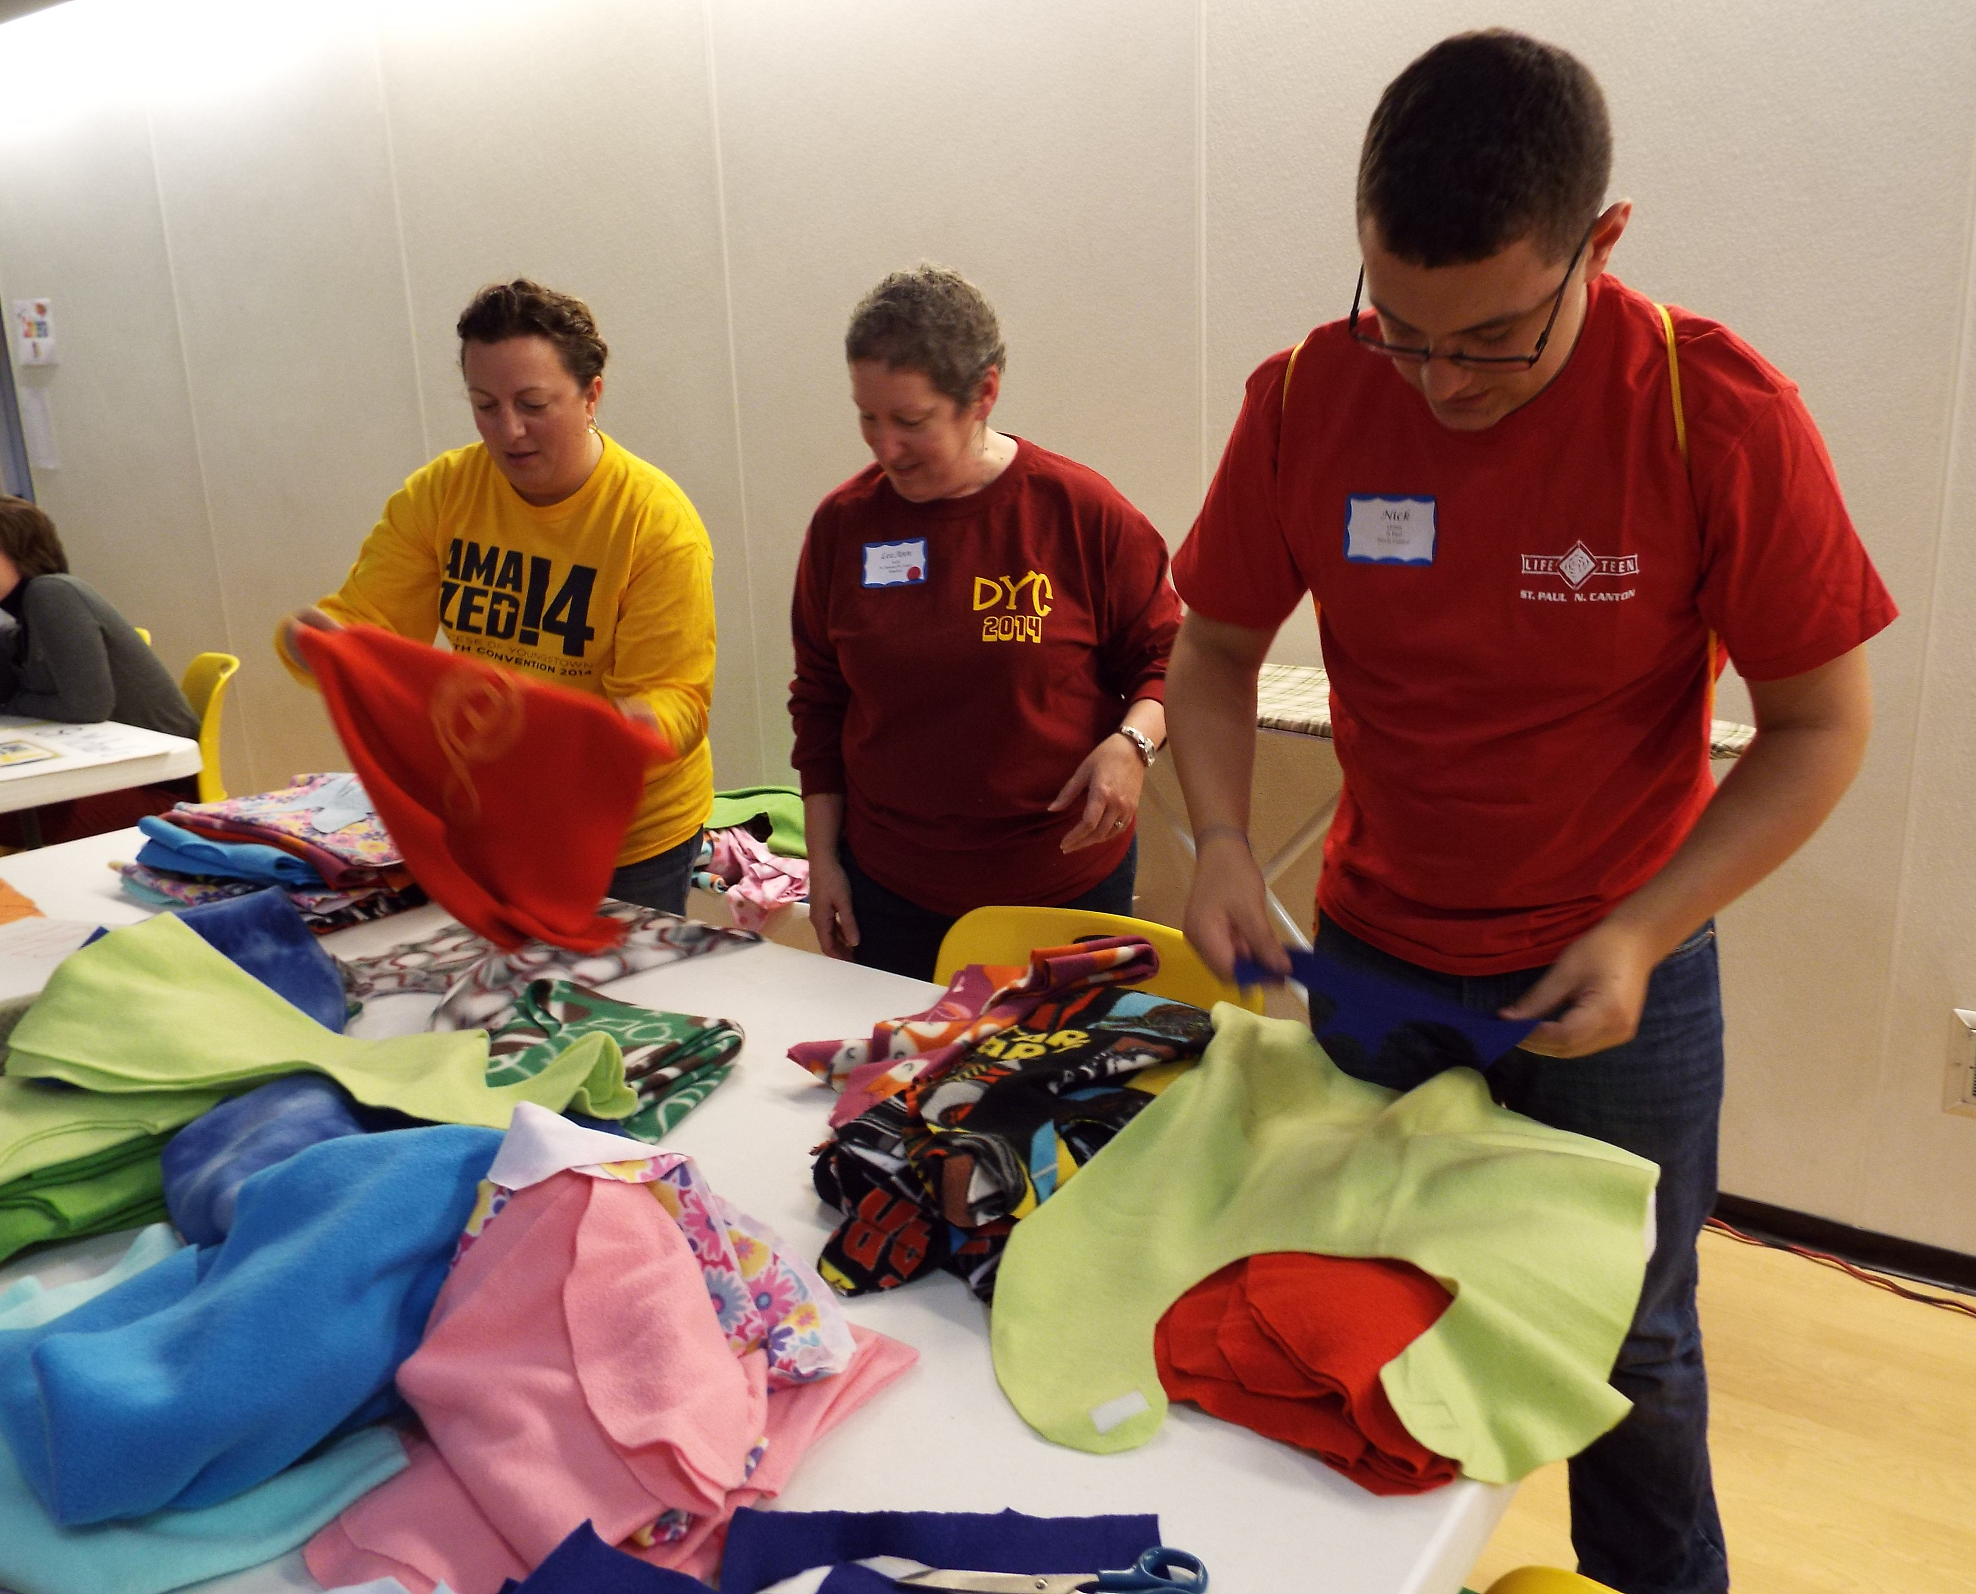
Serve
A number of service organizations will be on-hand to introduce you to their ministries as you contribute to their work. You can record a message for our Catholic Media, write a card to someone in a nursing home who needs some cheer, and much more.

Learn
Chose two workshops from a list of options to learn more about your faith during the Workshop break-outs!
Please, bring one (or more)
of the following items to donate to our
Catholic Charities around the Diocese:

Hand Soap, Shampoo, Conditioner
Bath Soap Toothbrushes Tooth paste
Personal Hygiene items Deodorant Dental Floss
Q-Tips Lotion Razors

Our Keynote Presenter:
Mr. Ben Walther

Ben is a songwriter, worship leader and speaker with OCP (Oregon Catholic Press) Spirit and Song. He has spoken at the National Catholic Youth Conference, Los Angeles Religious Education Congress and the National Catholic Singles Conference. Originally from Texas, he and his wife and 6 children live in North Canton and participate at St. Paul Parish.

Sunday Mass will be celebrated with the
Most Reverend George V. Murry, S.J.
Bishop of Youngstown
Following A Conversation with The Bishop

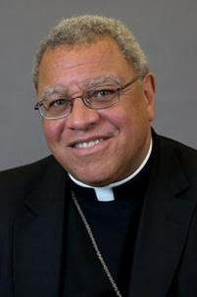
Bishop Murry was born in Camden, New Jersey in 1948. He was ordained in the Society of Jesus (the Jesuits) on June 9, 1979. He earned a Masters of Divinity, and a doctorate in American Cultural History. He served as Auxiliary Bishop of Chicago and Bishop of St. Thomas in the Virgin Islands. He was installed as the fifth Bishop of Youngstown on March 28, 2007.

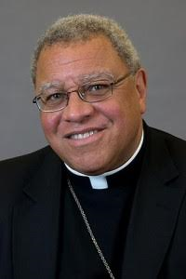
His favorite foods include dry roasted peanuts, popcorn, blueberries, iced tea, meatloaf, and Italian food. His hobbies are cycling, tennis, going to the symphony, and visiting the Butler and other art museums.

