NCYC
National Catholic
Youth Conference

2019 Diocese of Youngstown Pilgrimage
NOW is the time to Register!

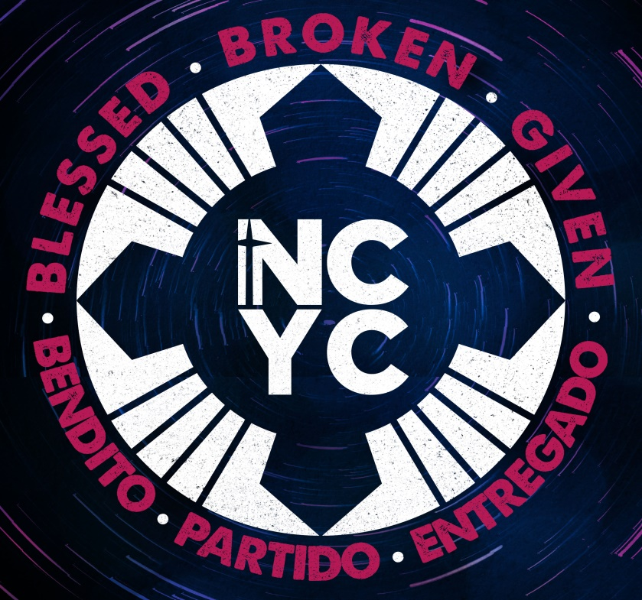
What is NCYC?
In a distinctly Catholic setting the National Catholic Youth Conference invites participants to:
- Encounter Christ.
- Experience church.
- Be empowered for discipleship.

Who attends NCYC?
High school teens in grades 9 – 12 for the 2019-2020 school year be it at public, Catholic, private, online or homeschool settings, as well as Diocese of Youngstown Child Protection Compliant adult chaperones over the age of 21, including interested parents, clergy and religious. (New this year, Young Adult Non-Chaperones can attend but must follow all the “adult” rules while not counted as chaperones. Consider them as volunteer assistants with leading small group discussions, counting for check-ins, etc.)

When is the NCYC 2019?
We will travel by coach buses from designated locations around the diocese on the morning of Thursday, November 21 and return to those locations on Sunday afternoon, November 24, 2019.
In addition, there will be a Diocesan Preparation Session held on the afternoon of Sunday, September 29 and the Send-Off Gathering (including Mass with Bishop Murry) on Sunday, November 3.

How can I find more information?
For general information, you can visit: http://www.ncyc.info/
and https://youngstownoyyam.weebly.com/2019-ncyc-pilgrimage.html
Contact your parish Coordinator for Youth Ministry or Catholic School Campus Minister to inquire about pricing, payment schedule, etc.
(Insert your contact info here,
And delete yellow above if you are not taking YANC)

