2015 National Catholic Youth Conference (NCYC)

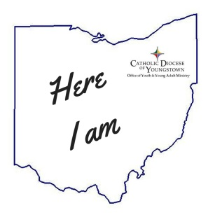
THANK YOU for choosing to be part of the
2015 NCYC experience with
the Diocese of Youngstown Delegation!
We realize you will be making some sacrifices to part of this (money, time off school or work, etc.), but I pray that the benefits will FAR outweigh these as I have witnessed the impact this opportunity has provided to others over the years. Our pilgrimage begins before we board the busses November 19th, so be sure to have the following dates marked on your calendar and do your best to be part of these:

Delegation Gathering #1: Preparing the Way
For all teens and adults and interested parents
Sunday, October 4th
2:00 – 5:00 p.m.
@ St. Charles Borromeo Parish
7345 Westview Dr., Boardman, 44512 (faces Route 224 near Route 7/Market Street)

We will officially kick off our Pilgrimage as a Diocesan group with prayer, reflection, snacks, and information sharing. We will begin in the main Church. Please wear comfortable shoes as we will be on the move to a variety of activities to help us prepare for our NCYC experience. Snack will include hot dogs, chips and fruit (you are most welcome to bring you own if these will not work for you.)
RSVP to your Group Leader by September 27.

Delegation Gathering #2: Send Off
For all teens and adults and interested parents*
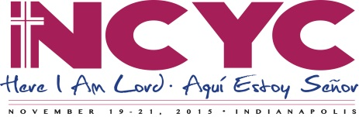
Sunday, November 8th
2:00 – 6:00 p.m.
@Cathedral of St. Columba
154 W. Wood. St., Youngstown 44503

Includes 4:00 p.m. Mass with Bishop George V. Murry and the Cathedral Parish.
We will begin in the Parish Hall by meeting to review necessary trip information (bus pick up assignments, parking suggestions, etc.) and end with a quick dinner. *Due to the limited space in the hall, we may ask parents to go tour or pray in the Cathedral during the meeting.
RSVP to your Group Leader by November 2..

Keep up to date with information by visiting our diocesan site: http://youngstownoyyam.weebly.com/2015-ncyc-pilgrimage.html and Facebook group: https://www.facebook.com/groups/126698777411259/

