Where will we stay in Indianapolis?

Springhill Suites
Indianapolis/Fishers Hotel

Teens will say 5 per room (2 beds plus a sleeper sofa).
Please DO NOT contact the hotel prior to our trip. Direct any questions or concerns to Cindee at: 330-744-8451, X 280 or ccase@youngstowndiocese.org.

What is NFCYM?

Located in Washington, D.C., and staffed by a team of energetic and creative individuals, the National Federation for Catholic Youth Ministry (NFCYM) is a membership organization working on behalf of youth and diocesan youth ministry leadership across the country and on U.S. military bases. Members include ninety-six percent of all U.S. Catholic dioceses (including Youngstown), the National Catholic Committee on Girl Scouts and Camp Fire and more than seventy youth-serving organizations.

Catholic Diocese of Youngstown
Office of Youth and Young Adult Ministry Presents:

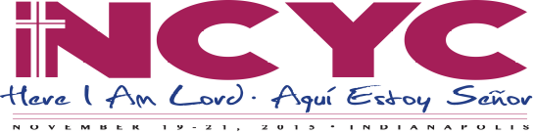
NATIONAL CATHOLIC YOUTH CONFERENCE 2019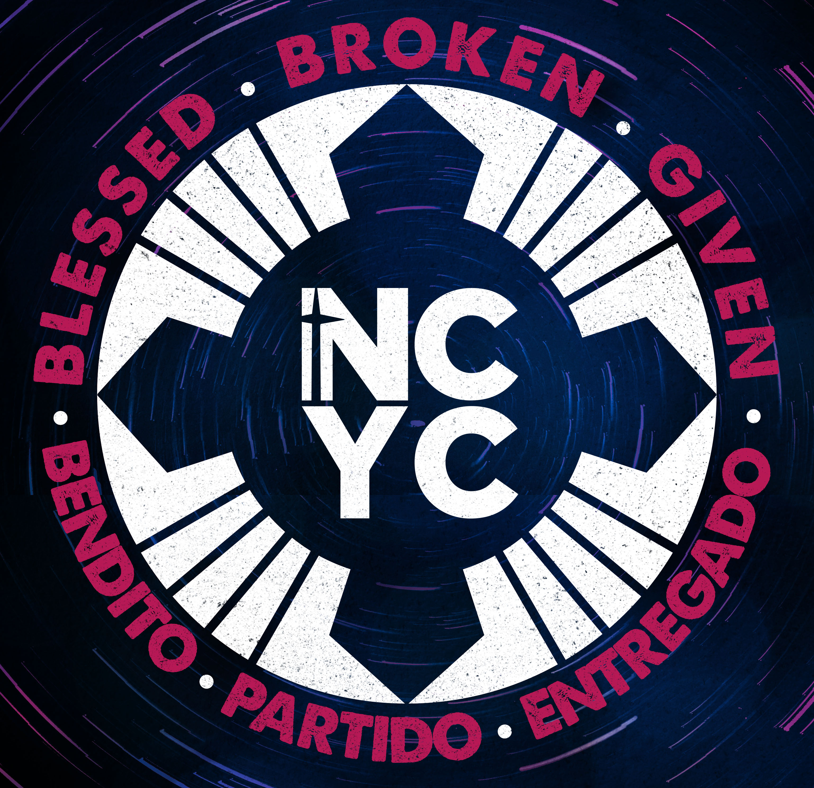
How much does
NCYC cost?

DOY Package Costs include: NCYC Conference Fees, lodging, hot buffet breakfast, a pizza party, taxes, tips, diocesan trading items, diocesan shirt and motor coach transportation.

$ per teen
$ per chaperone

PLEASE NOTE: Most meals (lunch and supper) are NOT included. (Breakfast on Friday, Saturday and Sunday, plus one pizza party are the meals covered.)

Meal Costs: A rough estimate of how much money will be needed for meals is $100 per person.

Other Costs: You may wish to bring spending money for NCYC souvenirs and other merchandise available from vendors at the conference, and for Closing Mass offering “Set aside $10.”

For what other dates should I plan?

Pilgrim Preparation: Sunday, September 29
2 – 5 p.m. @ St. Joseph Parish, Canton

Send Off: Sunday, November 3
1:30 – 5 p.m. @ St. Columba Cathedral
Gather in the Parish Hall at 1;30 p.m. for prayer and meeting, then join the Cathedral parish at the 4 p.m. Mass with Bishop Murry

Reunion: Sunday, December 3 Location and time TBD
A time for sharing our experiences and continuing the journey back in our diocese.

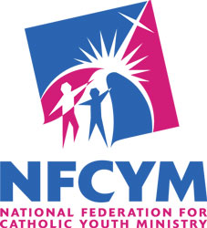
415 Michigan Avenue, NE, Suite
Washington DC 20017
Tel: 202-636-3825
www.nfcym.org

Parish/school
Group name

Sponsored by the
National Federation for Catholic
Youth Ministry, Inc.

Hosted by the Archdiocese of Indianapolis

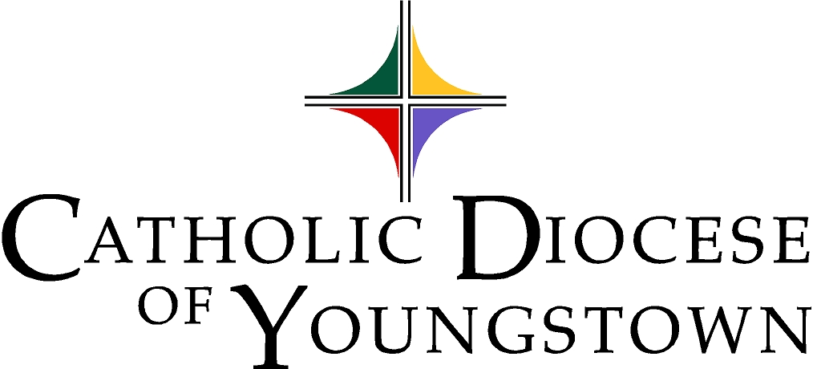
Office of Youth and Young Adult Ministry

Cindee Case, Director
144 W. Wood Street
Youngstown, OH 44503
330-744-8451
ccase@youngstowndiocese.org

Helping Serve the Young Church in northeast Ohio

Who attends NCYC?

High school age Catholic teens (grades 9-12) in public, Catholic, private or home-school and their diocesan Child Protection Compliant adult chaperones (over age 21) from all over the United States attend NCYC.

Why attend NCYC?

Youth and adult participants attend the NCYC because they want to:
- Gather as Church on a national level
- Learn more about themselves and their relationship to the Catholic Church
- Celebrate their Catholic Christian faith
- Meet thousands of other Catholic youth
- Share beliefs and experiences
- Recognize their role in the larger Catholic Church
- Hear/meet some of the best Catholic speakers, singers and performers!

How can I register

To register for the 2019 NCYC,
contact your parish youth minister, parish director of religious education or Catholic high school campus minister:

NAME

PHONE

EMAIL _____________________________

All individuals register with a parish/school group. Those groups then must register through the Office of Youth and Young Adult Ministry. For more information, contact Cindee Case at 330-744-8451 X 280 or ccase@youngstowndiocese.org.

Visit our pilgrimage webpage at: https://youngstownoyyam.weebly.com/2019-ncyc-pilgrimage.html
to view the NCYC promotional video, hear a sample of the theme song, and get more information as it is available.

Schedule of Events
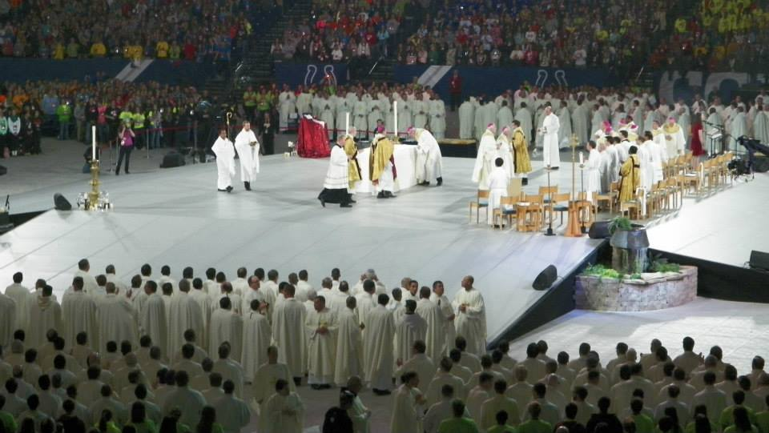
(Subject to Change)
Thursday, November 21, 2019
Approx. 7:30 A.M. Board bus at designated site
3:00 P.M. Arrive at hotel, drop off luggage
4:00 p.m. Region 6 Gathering and Mass
7:00 P.M.–8:00 P.M. Gathering & Entertainment
8:00 P.M.–10:00 P.M. Opening Session
10:30 P.M. Return to hotel
11:00 P.M. Chaperone Meeting
Midnight Lights out!
Friday, November 22, 2019
7:00 A.M. Breakfast (included)
7:30 A.M.–9:00 A.M. Gathering & Entertainment
9:00 A.M.–11:00 A.M. Prayer & General Session
11:15 A.M.–12:30 P.M. Concurrent Sessions &
Workshops Round 1
11:30 A.M.–7:00 P.M. Thematic Park Open
12:30 P.M.–2:30 P.M. Lunch Break (on own)
12:30 P.M.–6:00 P.M. Sacrament of Reconciliation
12:30 P.M.–6:00 P.M. Prayer Chapel Open
1:45 P.M.–3:00 P.M. Concurrent Sessions &
Workshops Round 2
3:45 P.M.–5:00 P.M. Concurrent Sessions &
Workshops Round 3
5:30 P.M.–6:15 P.M. Daily Liturgy
5:00 P.M.–7:00 P.M. Dinner Break (on own)
6:30 P.M.–8:00 P.M. Gathering & Entertainment
8:00 P.M.–10:00 P.M. Prayer & General Session
10:30 P.M. Return to hotel
11:00 P.M.–11:30 P.M. DOY Chaperone Meeting
Saturday, November 23, 2019
7:00 A.M. Breakfast (included)
8:00 A.M.–9:00 A.M. Gathering & Entertainment
9:00 A.M.–10:30 A.M. Prayer & General Session
11:15 A.M.–12:30 P.M. Concurrent Sessions &
Workshops Round 4
11:30 A.M.–7:00 P.M. Thematic Park Open
11:30 A.M.–6:00 P.M. Adoration Chapel Open
11:30 A.M.–6:00 P.M. Prayer Chapel Open
11:30 A.M.–6:00 P.M. Sacrament of Reconciliation
12:30 P.M.–2:00 P.M. Lunch Break (on own)
1:30 P.M.–3:00 P.M. Discernment Time
3:30 P.M.–5:00 P.M. Comedy Club
3:30 P.M.–5:00 P.M. Concert
3:30 P.M.–5:00 P.M. Dance
5:00 P.M.–7:00 P.M. Dinner Break (on own)
7:00 P.M.–8:30 P.M. Gathering & Entertainment
8:30 P.M.–10:30 P.M. Closing Liturgy
10:30 P.M. – 11:30 P.M. DOY Pizza Party

Sunday, November 24, 2019
7:30 A.M. Breakfast (included)
8:00 A.M.—3:00 P.M. (TBD) Travel home

What is NCYC?

The National Catholic Youth Conference (NCYC) is an exciting, biennial three-day experience of prayer, community and empowerment for Catholic teenagers and their adult chaperones (plus a travel day).

The schedule includes general sessions and workshops addressing a wide variety of topics including Catholic spirituality and prayer, social justice issues, relationships and leadership.

There are also opportunities for daily liturgy, reconciliation, and special activities such as a dance, comedy club and concerts.

The thematic park (exhibit hall) is a unique venue incorporating traditional exhibits with interactive educational and recreational activities, service and vendors.



