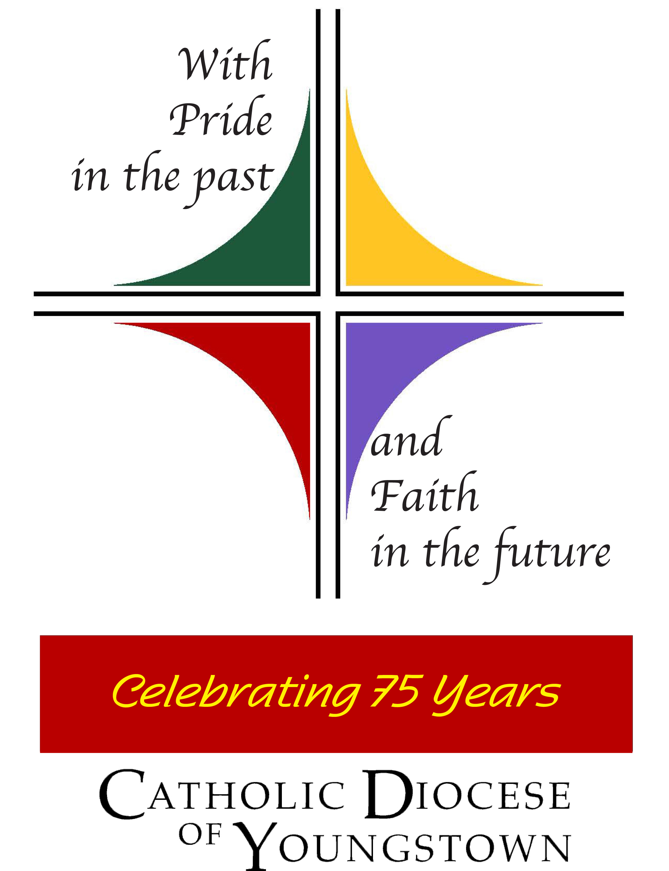
2018 Diocesan Youth Convention

Parish/School Group Leader
Planning Manual

Planning Manual Contents:
General Information pages 2-3
Tentative Event Schedule page 3
Group Leader Tasks page 4
Chaperones page 5
Registration Process pages 5-6
Costs and Deadlines page 6
Publicity page 6
Ads page 7
Paperwork Checklists page 7
Forms follow
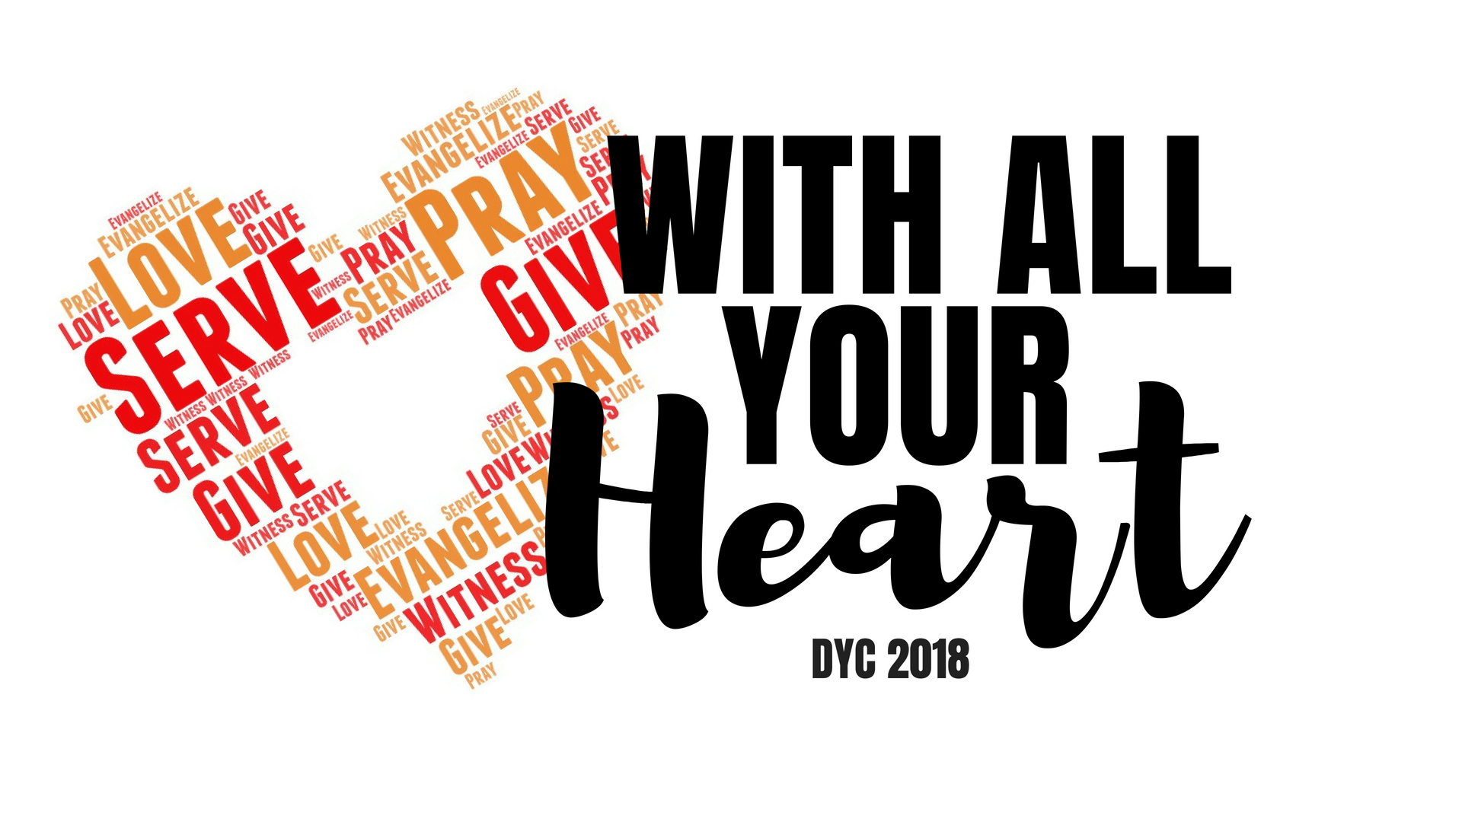
THANK YOU, Adult Group Leader, for taking the time to review this information so that teens from your parish or school might be involved in the biennial Diocesan Youth Convention! In the past, this event has been helpful to local youth and campus ministries by giving the teens an experience of the larger Church while providing prayer, education, service projects, and fun to supplement your ongoing efforts. We anticipate the same outcomes for 2018!

When and Where: Sunday, November 4, 2018

12:30 PM – 7:00 PM

Optional Concert till 8:30 p.m*.

St. Michael Parish, Canton, OH
3430 St. Michael Blvd. NW, 44718 (near corner of Whipple and Fulton)

BASIC DRIVING DIRECTIONS: Exit I-77 at Fulton Road. Go west onto Fulton Rd., State Route 687,
veer right. Church campus will be on the right. (If you reach the light at Whipple, you just missed it.)

*It is up to each group leader to decide, perhaps with your group/parents of the teens, if staying for the concert can work for your group with the added travel time you have. We will have reserved seating for the concert for those that can stay.

If your parish is close enough to St. Michael’s that parishioners may want to come for the concert, please do help us advertise! There will be a free will offering collected for those able to give to off-set the costs of out DYC. Plus, it might be nice to parents to experience with their teens.

THEME: “With All Your Heart”
Taken from the Gospel of the day, Mark 12: 28b – 34, as Jesus responds to the scribes with the Greatest Commandment: "The first is this: Hear, O Israel! The Lord our God is Lord alone! You shall love the Lord your God with all your heart, with all your soul, with all your mind, and with all your strength. The second is this: You shall love your neighbor as yourself. There is no other commandment greater than these."
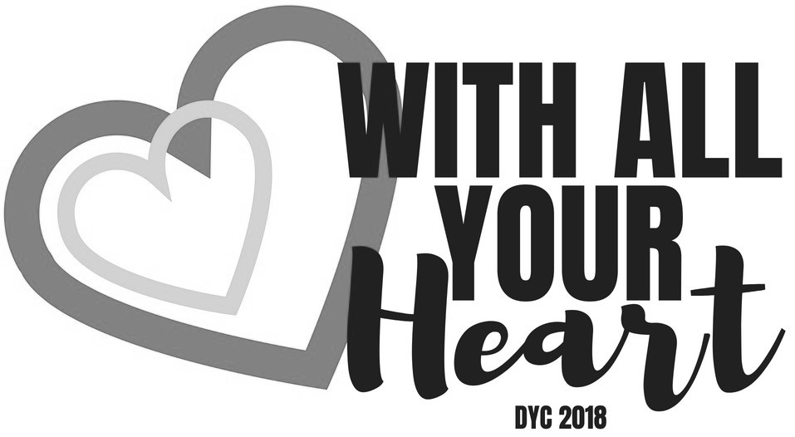
We have asked keynote presenter Jesse Manibusan to address how we, as humans, are to follow these Commandments, and that our love, service and prayer must engage our whole heart, just as God loves us with all God’s heart!

Keynote speaker: Mr. Jesse Manibusan
Jesse Manibusan is a composer, singer/songwriter, storyteller, humorist, catechist, evangelizer and encourager. Working with any and every age group, Jesse has that knack to build instant rapport, connect to his audience, and create life-giving memories that help deepen faith and cultivate the joy that inspires service, sacrifice and the celebration of life.

Jesse earned an MA in Multicultural Ministries from the Franciscan School of Theology, Berkeley, CA, and gives concerts, workshops, parish missions, and retreats. Jesse’s music is published by Oregon Catholic Press and Spirit & Song (a division of OCP). In 2014, Jesse received the National Catholic Youth Award, for Presenter/Artist Category by the National Federation for Catholic Youth Ministries, Inc.

A few of the songs used in Liturgies around the diocese include: Open My Ears Lord, Come and Fish with Me, Bread of Heaven, Malo, Malo, Thanks be to God, Gracious God and Gloria. You can listen to a few of these at: https://jessemanibusan.com/music

General Information:
- Remember to turn your clocks back—Daylight Savings Time ends November 4 at 2 a.m.
- The Diocesan Youth Convention is designed and intended for high school age youth only (grades 9-12).
- Handicapped access is limited. However, we welcome youth of all abilities, and thus request that the Group Leader please contact the OY&YAM if special arrangements need to be made for participants with mobility or other concerns. You will need to provide an aide for any participant who may need one.
- All registration check-ins will take place in the main church gathering space.
- Please note that a parish Mass will be ending at noon, so registration will not open until 12:30 p.m.
- The DYC will be utilizing a large area at St. Michael’s, so comfortable shoes are a must!
- Food will include a mid-afternoon supper (chicken, pasta, salad, roll, cookie and punch.) Water coolers will be set up in a couple of locations if you would like to bring refillable water bottles with you. (Eat lunch prior to check in!) Quick-grab snacks will be available at 6:45 p.m.
- Each participant will receive a DYC gift near the end of the day. Please note that we will NOT be providing water bottles, string backpacks or t-shirts. Instead, we invite you to work with your group to create a parish/school/collaborative youth ministry shirt or to pick a color for your group to wear, as this will help you to supervise your members, and bring your own refillable water bottles, if desired.
- The Sunday Mass will be celebrated at the convention at 5:30 p.m. with the Most Reverend George V. Murry, S.J., Bishop of Youngstown. Prior to that, he will facilitate a Conversation with the teens.
- Participants will have the opportunity to celebrate the Sacrament of Reconciliation during supper.
- All participants are asked to bring items for a new program being introduced by the Mercy Medical Center just prior to DYC’18. Learn more about it on November 4th, but please bring:
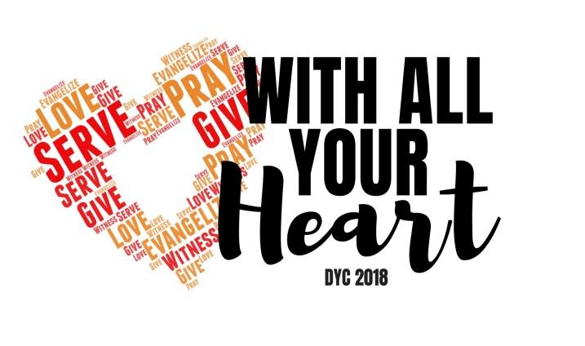
Baby diapers in various sizes
Baby wipes

These donations can be dropped off at stations
near registration in the morning.

Tentative Event Schedule: (Subject to change)
–Be sure to eat lunch before coming

12:30 p.m. – 12:55 p.m. Registration in the foyer near Main Doors/ Pre-session music
1:00 – 3:15 p.m. General Session #1 (Prayer, Keynote Speaker Jesse Manibusan,
ice-breakers, Eucharistic Adoration and Procession)
3:30 – 4:00 p.m. Breakout 1: Workshop with Jesse
or dinner (Confessions, displays) as assigned
4:00 – 4:05 p.m. Switch
4:05 – 4:35 p.m. Breakout 2: Workshop with Jesse
or dinner (Confessions, displays) as assigned
4:35 – 4:45 p.m. Break, move to Church
4:45 - 5:30 p.m. General Session 2 “A Conversation with the Bishop”/ Mass prep
5:30 – 6:45 p.m. Mass with Bishop George V. Murry, S.J.
6:45 – 6:55 p.m. Break, snack, some groups leave to travel home, others return to Church
7:00 – 8:30 p.m. Jesse Manibusan Concert (open to the public; reserved seats for DYCers)

You may notice that we will NOT have the large inter-active area this year with numerous tables of exhibits, hands-on activities and learning centers as we will try the Eucharistic Procession through the gym instead. However, a few select offices/organizations will have tables with during the supper break.

Dress for the Event:
For this DYC, we will spend a lot of our time in the main Church, and will also walk in a procession through part of the campus, so comfortable shoes would be helpful. A sweater or jacket may be helpful for those that chill easily. The dress for the event is fairly casual BUT respectful of being in a Church and participating in Mass with the bishop (so no inappropriate graphics or language on clothing, and much of the skin covered.)

Parish/school/youth ministry t-shirts are popular for this event, or asking everyone in your group to wear the same color (to help you try to identify them in the larger group as needed.) Jeans and kaiki’s are fine, and dressier outfits are welcomed for those that feel more comfortable.

Role of the Group Leader (Administrative):
- Read this packet thoroughly so that you are well prepared for your tasks. Hopefully, this does not seem overwhelming as it is intended to ‘map out the journey’ towards the DYC.
- Promote the Diocesan Youth Convention (DYC) utilizing all the means you have available – bulletins, newsletters, websites, social networking, announcements, and PERSONAL INVITATIONS!
- For school administrators, decide if you will organize a group from your school OR encourage the teens to connect with their parish. (Note: as not all teens are registered at a parish and not all parishes coordinate a group for DYC, you may do well to find one or two youth ministers who will welcome additional teens to their group so that your students have a place to go! This can easily be done by connecting with your Deanery Representative for parish ministry or contacting Cindee at OY&YAM).
- Print and copy all the necessary forms for the teens, parents and chaperones.
- Collect forms and monies from your group participants.
- Set your local deadline for October 5 or 10 (about a week before October 17th) so that you have time to have incomplete forms completed, make the copies, and type the information into the DYC Group Excel sheet.
- Double check all forms for completion BEFORE sending the originals to the diocesan office.
- Be sure to keep a copy of all the forms for your use during the event and to file until the youngest attendee turns 21 years of age.
- Type in the excel worksheet for your group and email it to ccase@youngstowndiocese.org, or burn it to a flash-drive and mail it with your forms and payment.
- Plan the transportation to/from St. Michael’s, provided by safe and reliable drivers over 21 years of age. As the group leader, you should have a copy of each driver’s license and insurance card. If a group is meeting at St. Michael’s, be sure that a clear meeting point is established and a chaperone is the first to arrive.
- Pray for the hearts of the teens to be touched by our Lord in a special way during the DYC experience!
- If you are unable to attend the DYC, you may designate an “Onsite Group Leader” who would then need to carry a copy of all release forms for your group. This person should be known to the chaperones and teen attendees.

Role of the Onsite Group Leader: (This may or may not be same person as above)
If the group leader on November 4th is also the one who completed all the administrative tasks, thank you for also taking this Sunday to be with the teens and chaperones.
IF THE ADMINISTRATIVE LEADER IS UNABLE to be at DYC, then please be sure that an Onsite Group Leader is identified and made aware of any special needs your group members may have, bring any outstanding monies or corrected forms, etc. for check-in onsite.

- Carry copies of the Youth and Adult forms for your group with you all day.
- Check-in all your group participants at the DYC Registration Table in the Church lobby. Submit any “Early Dismissal” forms you may have collected.
- Follow directions for donating the diapers and baby wipes.
- Encourage your chaperones to volunteer for one of the task areas, or to check the schedule if they volunteered on their registration form. (Note: the planning team is working to recruit several volunteers so we may not need as much help as in the past, but still best to be prepared! Thanks.)
- The day begins with music and mingling in the Church, followed by our first General Session. (Note: Breakfast/lunch is NOT included, so emphasize to your group members to eat prior to coming.)
- Assist, as necessary, with directing traffic as we move around to different locations at St. Michael’s, and check in at the General Sessions to make sure all your participants are with us.

Chaperones:
- Chaperones must be at least 21 years old and must be in full compliance with the Diocesan Child Protection Policy by September 30. (Do NOT wait until the last minute!) By submitting the adult forms for the chaperones, the Group Leader affirms that all adults are already in full compliance. All chaperone names WILL be double checked in the diocesan database and only permitted to attend if found to be in full compliance.
- Each group must provide adequate chaperones for their youth. The ratio of chaperones to youth must be at least 1 chaperone for every 6 youth (1:6). However, to keep in compliance with the Diocesan Child Protection Policy, each group should start with two chaperones – preferably of both genders if attendees are of both genders.

Number of Teens Attending: Minimum Number of Chaperones Required:
1 – 12 2
13 – 18 3
19 – 24 4
25 – 30 5
31 – 36 6
37 – 42 7
43 – 48 8
And so on. More adults are permitted so long as they pre-register, pay and are in full-compliance.

- Groups MAY combine with a neighboring parish to achieve these requirements, with all attendees made
well aware of this situation.
- Chaperones are asked to sign-up for volunteer duties for a brief time period at the convention: hall monitor, activity assistant or food distribution, as needed (See the adult registration form).
- Chaperones are responsible for helping the teens comply with the Code of Conduct, and thus should review the Code and use it as a guide for personal behavior as well.
- If you have a priest coming as one of your chaperones, he must remain all day. If a priest is only available for part of the day, please ask them to come as a guest (his registration is complementary and should be noted on your Group Summary Form.)

Registration Process:
- A Parish/School Group Registration Summary Form is provided. Each parish or school should register as one group (or a combined group with another parish). A YOUTH Registration/Medical Permission Form or an ADULT Registration/Medical Release Form must be completed for every participant and submitted with your group registration form. Information from these forms should be entered into the Group Excel Spreadsheet.
- Group leaders should send the original copy of the release to the Office of Youth and Young Adult Ministry (OY&YAM) and keep a second copy to carry during the day and to later keep on file. This is to ensure quick and easy access to necessary information in the event of a medical emergency. Do not forget to keep copies for your files.
- All participants are to pre-register. No Walk-Ins are permitted. Early registration is appreciated. Please make note of the deadline dates. No registrations will be accepted after October 24.
- Please keep a blank copy of the registration form in case of late or additional registrations or substitutions. You may also want to print out your Excel file with registration information.
- Teens over 18 coming as participants must still submit the YOUTH Registration Form. However, as with any youth program at the parish, they should read and sign off on the DCPP booklet just so they are aware that they are now legally an adult and need to be extra careful about their behavior with minors.
- Once your registration is received, you will receive an email confirmation from the OY&YAM. If you do not receive the confirmation within 10 days of sending in your registration, please call Cindee at (330) 744-8451 ext. 280 or email ccase@youngstowndiocese.org.

Cost and Deadlines:
- The Registration fees are the same for youth and for chaperones.
- The registration cost is only $30 per person by the October 17 deadline.
- If space permits, late registrations will be accepted until 3:00 p.m. on Wednesday, October 24. The late fee is $40 per person. No registrations will be accepted after October 24.
- Cancellations by October 17 will be refunded in full, although substitutions are strongly encouraged. After October 17, there will be no refunds. There will be no refunds for no-shows.
- The cost of the day covers all speakers, materials, and supper.
- Some parishes pay a portion of the registration fee. Consider having a fundraiser such as a car wash, leaf rake, pancake breakfast, spaghetti dinner, sale, etc., to help cover a portion of the registration fee for your participants. Knights of Columbus councils, Women’s Groups and other parish organizations may also be willing to help sponsor youth to participate.
- A limited amount of financial assistance is available. Please share the DYC scholarship form with a youth that may need financial assistance and encourage the youth to apply.

Publicity:
- A flyer and a customizable brochure have been provided for you to copy. Please utilize whatever will be most efficient for you to get the word out to your teens. A poster is available upon request, as are copies of color-printed fliers.
- Consider providing incentives to encourage participation, such as:
  - subsidizing the cost for youth involved in liturgical ministries;
  - granting “extra credit” for religion class;
  - make participation in the Diocesan Youth Convention a prerequisite for attending the 2019 National Catholic Youth Conference in Indianapolis, your summer mission trip, One Bread-One Cup at St. Meinrad, Franciscan University Summer Conference, ND Vision at Notre Dame, or other large youth ministry/campus ministry events.
- Invite high school teens from all four grade levels. Do not forget to reach out to the freshmen!
- Make sure this is on the parish/school calendar, and post reminders in the newsletter, weekly bulletins, etc. See announcement samples at:
https://youngstownoyyam.weebly.com/dyc18-group-leader-page.html
- Post pictures from previous youth conventions in the parish vestibule or hall. Be sure to include information for registering for the 2018 Youth Convention.
- If you use an online social networking site, and have permission, post pictures and comments for teens to see glimpses of the event. Feel free to adapt the Bulletin Announcements to post.
- You can also connect to the Facebook group DYC’18,
https://www.facebook.com/Youngstown-Diocesan-Youth-Convention-DYC-138163429550366/
and link to the OY&YAM resources on the diocesan webpage,
https://youngstownoyyam.weebly.com/dyc18.html
- Have youth who attended previous youth conventions make announcements inviting participation in the Diocesan Youth Convention.
- E-mail or text reminders to youth/parents of youth about the day and parish/school registration deadlines, as permitted. Share on your social media. Utilize the “Bulletin Announcements.”
- Post copies of the fliers or posters wherever you think teens and their parents may see them.
- Please keep in mind that the DYC is a biennial event, and so the youth of your parish or Catholic school only have one or two opportunities to participate in this experience as a Diocesan Church. Please consider making every effort to invite your youth.

Program Book Ads:
To help keep the cost of the DYC’18 registration down, we solicite program book ads from Catholic agencies, organizations, businesses, etc. We also encourage parish and school ads as we find that the teens like to see places they know and love in the program book. If you are able to assist the team in inviting potential ad-purchasers (or even anyone that would like to just make a donation of any size), it would be appreciated. And consider at least a one-line “shout out message” of support for your teens!

REMINDERS:
  - Be sure to double check all registration forms to make sure the information is complete.

  - Make sure the adults are in full compliance with the Diocesan Child Protection Policy, as they will NOT be allowed to participate if they are NOT verified by the diocesan database.

  - Be sure to contact Cindee at the OY&YAM if you have anyone with a special need that the Planning Team will need to address.

  - Make copies of all forms for your use at the DYC and parish files (hold until 2026).

  - Remind your group members to bring diapers or baby wipes to donate.

Paperwork Overview for Group Leader:

Use these checklists to assist in creating packets of information for your parish/school potential participants:

For teens and their parents:
- Pub 1: DYC Brochure (with your contact information and local price) or Pub 2: DYC Flier
- Form 6: Code of Conduct
- Form 5: Scholarship Request, if applicable
- Form 4: Youth Individual Registration Form
- Pub 3: Parent Information Sheet

For adult chaperones:
- Pub 1: DYC Brochure (customized) or Pub 2: DYC Flier
- Form 7: Chaperone Guidelines
- Form 3: Adult Individual Registration Form
- A copy of the Diocesan Child Protection Policy and “Treasured Gifts from God” In-service dates for any adult who is not yet in full compliance with the Diocesan Child Protection Policy (DCPP), but can be by September 30th.

What you need to submit to the OY&YAM:
- One copy of each registration form for each teen and adult attending (Forms 3 and 4)
- ONE CHECK covering the $30 registration costs for EACH participant, except priests,
payable to “The Diocese of Youngstown.” ($40 per person for late registration.)
- Form 1: The Group Registration Summary Sheet
- Form 2: Excel form with all registration information (via email to ccase@youngstowndiocese.org or on flash-drive mailed with the above items.)

Lastly, please remember that all of this paperwork and time will be worth it
when the teens increase their enthusiasm for the Lord by praying, playing, learning
and celebrating at the DYC’18!
THANKS for your work on making their participation possible!

2018 Diocesan Youth Convention Core Planning Team:
Cindee Case (OY&YAM)
Bob Barto (Holy Trinity, East Liverpool)
Maria Crookston (St. John School)
Marcy Fessler (St. Patrick, Youngstown)
Joseph Frangos (St. Paul, North Canton and Little Flower, Canton)
Jeff Fricker (St. Michael, Canton)
Cara Lipinski (St. Joseph, Massillon)
Rose Naegeli (St. Joseph, Canton)
Ashley Quinn (St. Michael, Canton)
Deacon Randy Smith (St. Joseph, Massillon and Vocations Office)

Please direct questions or concerns to: Office of Youth and Young Adult Ministry
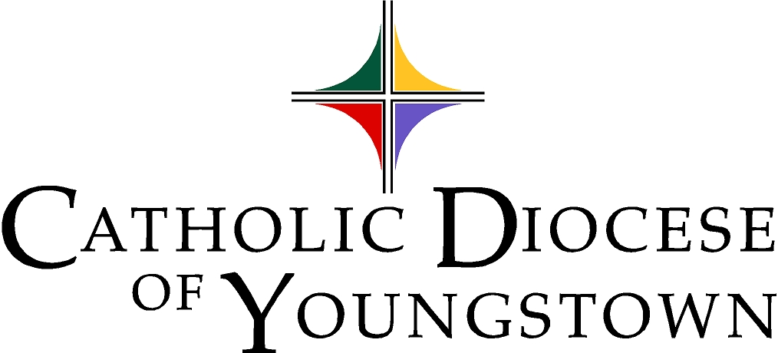
Cindee Case, Director
ccase@youngstowndiocese.org
144 West Wood Street, Youngstown, OH 44503

Phone: 330-744-8451 Fax: 330-744-5899

