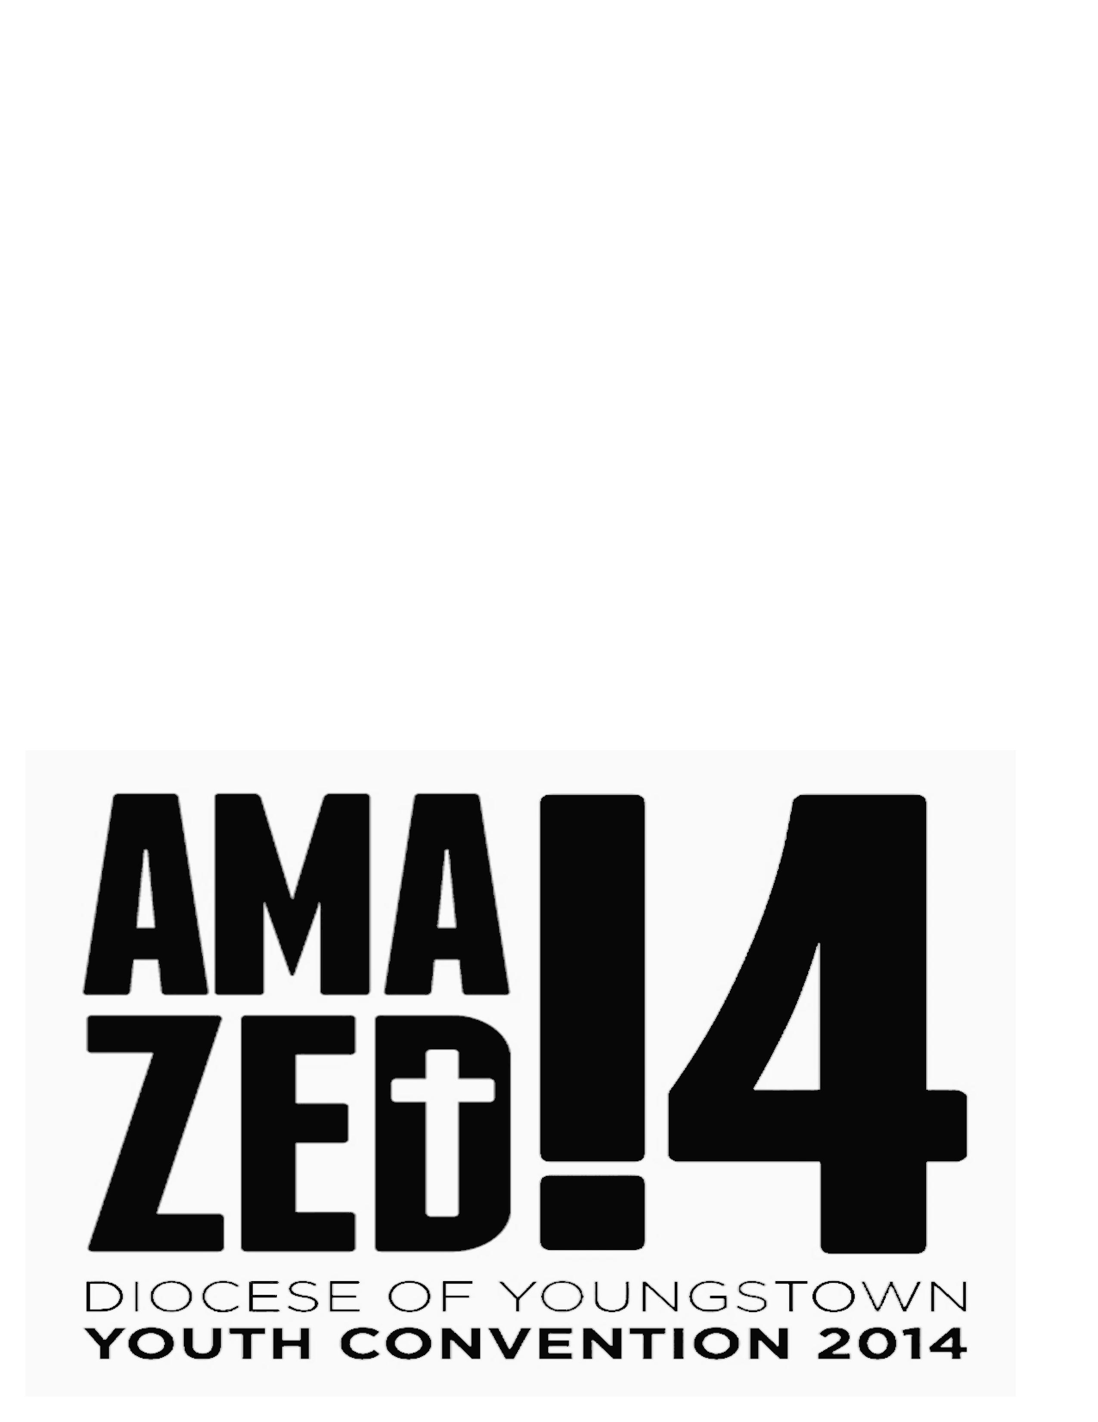

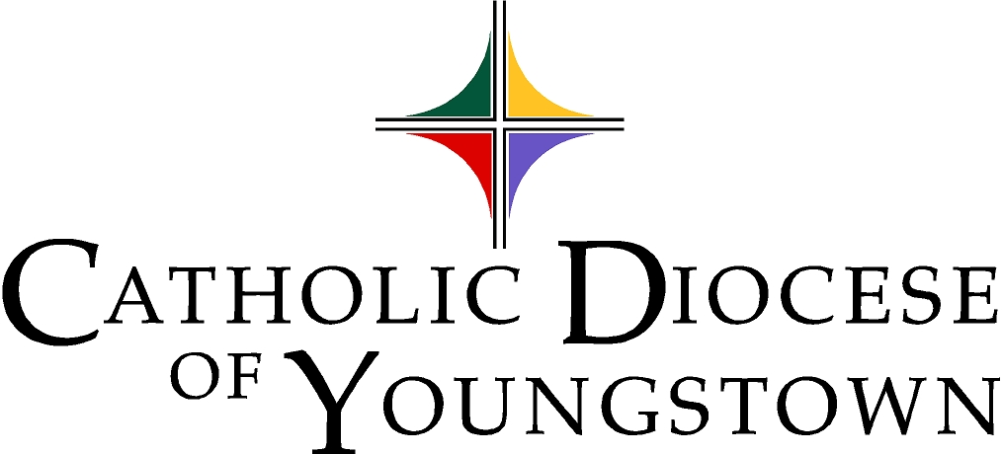

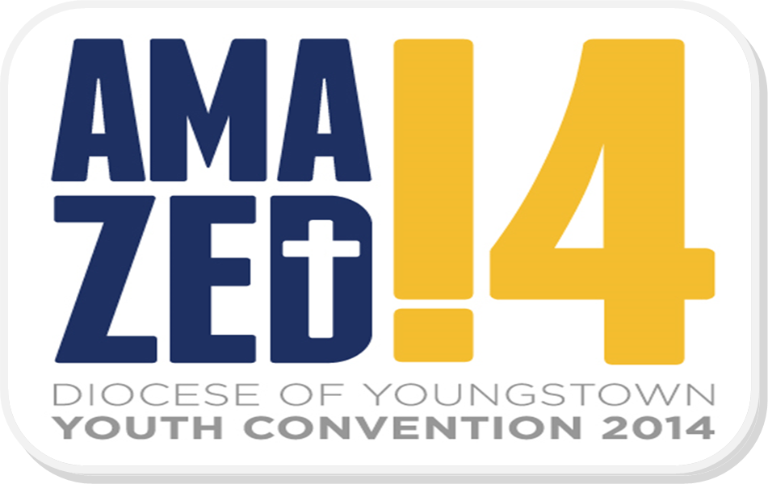

Administered by the Office of Youth and Young Adult Ministry

“Dear Young People, Do not be satisfied with a mediocre life,
Be amazed by what is true, beautiful, what is of God.”(Pope Francis)

DYC’14 For High School Teens

Sunday, November 2, 2014
12:30 p.m. – 7:30 p.m.
St. Michael the Archangel Parish, Canton, OH

Sponsored by the Diocesan Office of Youth & Young Adult Ministry

DYC’14 SCHEDULE:
Facilities map can be found on page 3

12:30 p.m. Registration, Music and Mingling (Gathering Space, Church)
+ Drop off donations for Joshua Casteel Catholic Worker House
+ Group Picture with DYC’14 banner
+ Jump into the music and ice-breakers

12:50 p.m. General Session #1 in the Church - Music, Prayer, Keynote address, see page 4

2:20 p.m. Move to workshop rooms – see pages 7 - 8

2:25 – 3:10 p.m. Workshops Round 1

3:10 p.m. Move to next workshop session

3:15 – 4:00 p.m. Workshops Round 2

4:00 p.m. GREEN NAME TAGS (Counties of Ashtabula, Columbiana, Mahoning and Trumbull)
Supper in School Cafeteria
Opportunity to celebrate the Sacrament of Reconciliation

BLUE NAME TAGS: (Counties of Portage and Stark)
Amazing Connections in the Gym, see pages 14, 15, 16

4:40 p.m. Switch

4:40 p.m. BLUE NAME TAGS: (Counties of Portage and Stark)
Supper in School Cafeteria
Opportunity to celebrate the Sacrament of Reconciliation

GREEN NAME TAGS: (Counties of Ashtabula, Columbiana, Mahoning and Trumbull)
Amazing Connections in the Gym, see pages 14, 15, 16

5:15 p.m. Restroom break & move to Church

5:30 p.m. Mass with Bishop Murry, S.J. in Church

6:30 p.m. General Session #2 in Church

7:15 p.m. Closing, Music & Sending Forth in Church

7:30 p.m. Event closes – Go in peace to continue to BE AMAZED in Christ!

1

My New DYC’14 Friends

(Challenge yourself: Try to meet at least ten new people, especially those from other counties of the diocese!)

Name Parish/City FB name/Instagram/Twitter Handle

1.

2.

3.

4.

5.

6.

7.

8.

9.

10.

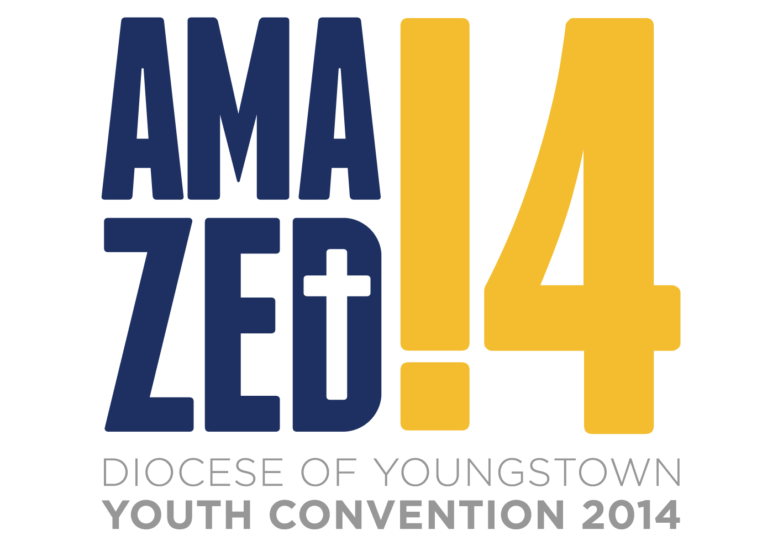

“Dear Young People, Do not be satisfied with a mediocre life, Be amazed by what is true,
beautiful, what is of God.” (Pope Francis)

30
Thank You!
Sincere appreciation goes to everyone who helped make this DYC’14 amazing, including:

St. Michael Parish, Fr. Donald King, Pastor
St. Michael’s Life Teen Youth Ministry, Knights of Columbus, and Meals Ministry
Keynote speaker Mary Lou Beers
Emcees Hannah Fricker and Kevin Ruppert
Our informative Workshop Speakers

All Priests and Religious in attendance

The amazing Adult Chaperones
The fabulous Activity Volunteers
All donors/program book advertisers
St Barbara Massillon Caring Stitchers for the Capes for Kids materials and preparations
Bob Barto and teens from Holy Trinity Parish
Stahlheber’s for printing bottles, bags and team shirts
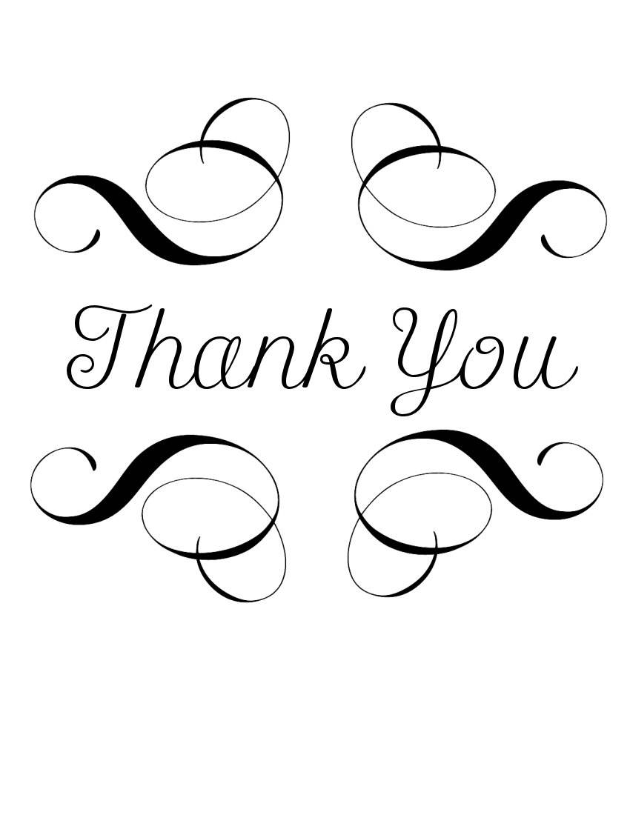
Elaine Donchess and Jenn Namsick for office help
TJ Lewis for designing our DYC’14 Logo
Mr. Mike’s Catering
Jeff Fricker for composing our DYC’14 Theme Song
Our Fantastic House Band from St. Michael’s Canton:
Joe Smithberger - bass and vocals
Kirk Lombardi - guitar
Bill Schweizer - guitar
Jeff Fricker - piano
Jim Krammes - drums
Mike Franzen – percussion
Bill Sparks – synthesizers
PJ Chavez – guitar and vocals
Life Teen Choir and DYC’14 teens in the Choir

And our Bishop of Youngstown: The Most Reverend George V. Murry, S.J.

A Special Note of Gratitude to the people who have been working on this event throughout the year - giving time, ideas, energy, and love…

The 2014 DYC Planning Team!
I give thanks to my God at every remembrance of you, praying always with joy in my every prayer for all of you, because of your partnership for the gospel from the first day until now. I am confident of this, that the one who began a good work in you will continue to complete it until the day of Christ Jesus.
(Philippians 1: 3 – 6)

Add your own notes of appreciate on Facebook, Twitter or Instagram with the hashtag: ‪#‎AmazedDYC2014‬

Thank you ~ Thank you ~ Thank you ~ Thank you ~ Thank you ~ Thank you ~ Thank you!

29
Teens, chaperones and volunteers –



to the 2014 Diocesan Youth Convention!

Today, the planning team and your caring chaperones are praying for you, that this day will help you grow in your faith through…
…listening to knowledgeable speakers,
…talking with your peers,
…interacting with caring people who offer their lives in service to others through various ministries, organizations and initiatives,
…praying in various formats throughout the day, and
…playing - fun is an important part of our faith – the need to balance our times of suffering, sacrifice and sorrow with our times of laughter and joy!

Try new things and meet new people today. If you come across an activity that is not to your liking, please hang in there and allow others to enjoy it, knowing there will be some other activity that will engage you. The planning team has worked hard to offer a great variety of options to help you take a few moments to reflect on our Amazing God!

Please keep this program book handy throughout the event as you will find key pieces of information about the General Sessions, workshop options, and interactive stations, plus you have space for note-taking.

Map of St. Michael’s page 3
General Session 1 page 4
General Session 2 page 9
Workshop Listing pages 7 - 8
Inter-actives Listing pages 14 – 16

If you have any questions, or need special assistance, please do not hesitate to ask one of the DYC’14 Planning Team Members wearing gold shirts today:

Cindee Case (OY&YAM) Jeff Fricker (St. Michael, Canton)
Cara Lipinski (St. Barbara) Roberta Muoio (St. Anthony/All Saints)
Rose Naegeli (St. Joseph, Canton) Terry Sibert (St. Joan of Arc, Canton)
Deacon Randy Smith (St. Joseph, Massillon) Maureen Wood (St. Peter)
2
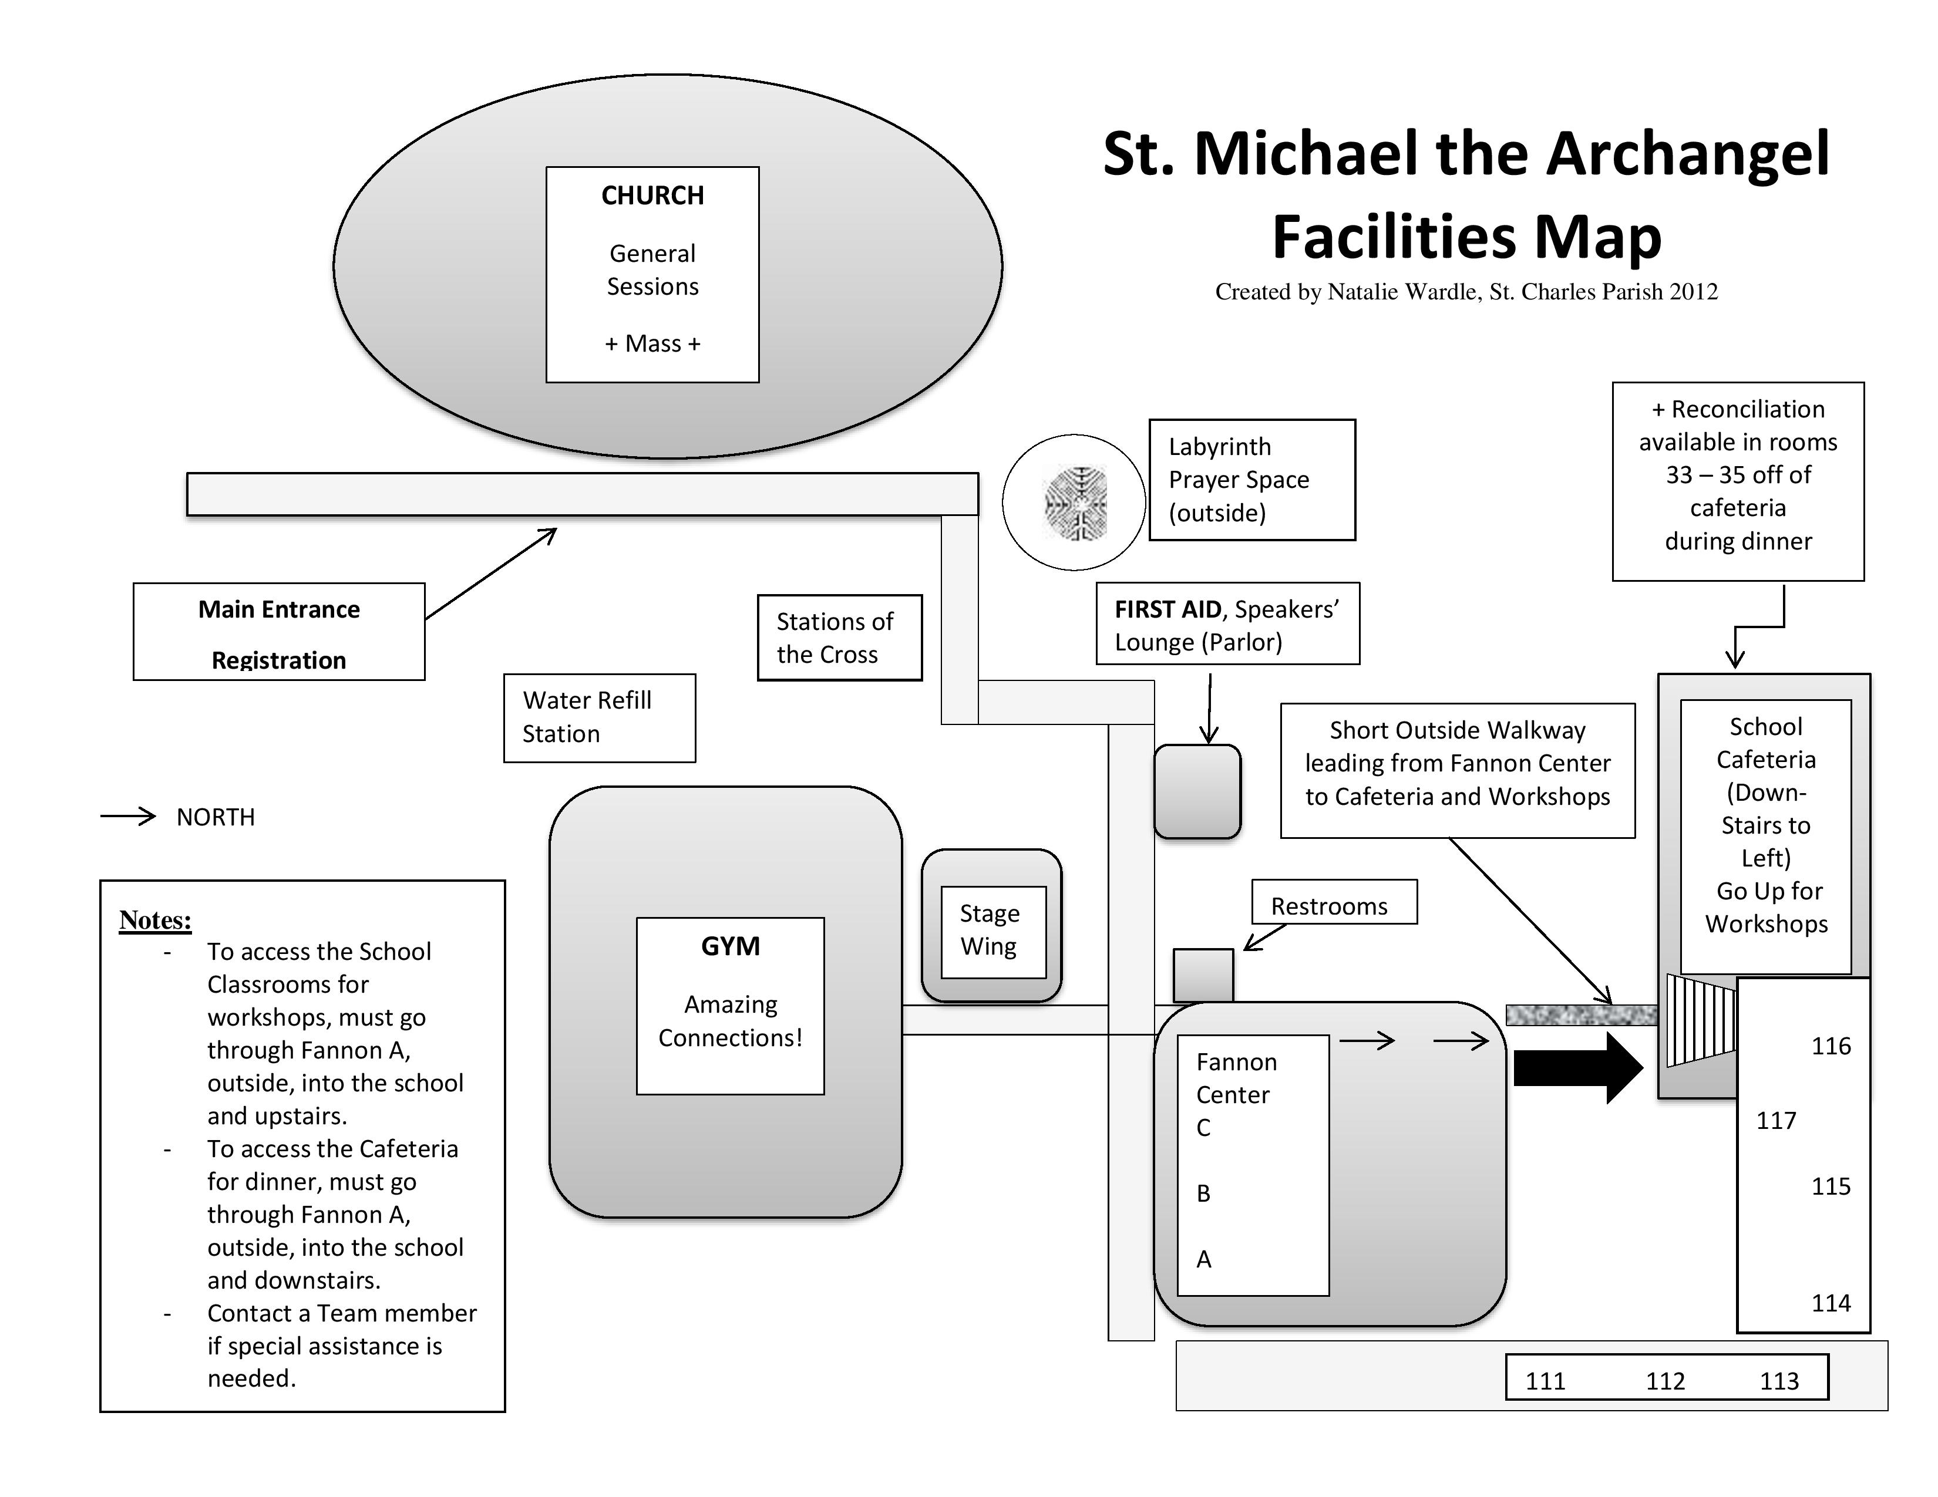

3

From the Diocesan Church to
THE NATIONAL CATHOLIC CHURCH


NCYC 2015:



“Here I am, Lord”

If you will still be a high school student next fall, plan to be a part of our
Diocesan Pilgrimage to the National Catholic Youth Conference (NCYC)
in Indianapolis, Indiana, November 19-22, 2015

Join 23,000 high school teens and adult leaders from around the USA for Exciting Speakers,
Prayer, Worship, Fun and a whole lot more!
See the NCYC Promo Videos at http://ncyc.nfcym.org/
Look for registration details through your parish next March.

Start saving & fundraising now. The trip will be approximately $575 per person - includes conference registration, motor coach transportation, hotel room (quad occupancy—4 people/2 beds), a diocesan shirt and trading items.

Class of 2015 – There is also a national conference for you!

NCCC: National Catholic Collegiate Conference
For ages 18 – 25 (whether in college or not)

Features some of the same excellent speakers as NCYC, and access to amazing exhibits, but geared to the young adult developing faith at a new level.
Look for information to be posted on Facebook in the DOY YAM group in June!

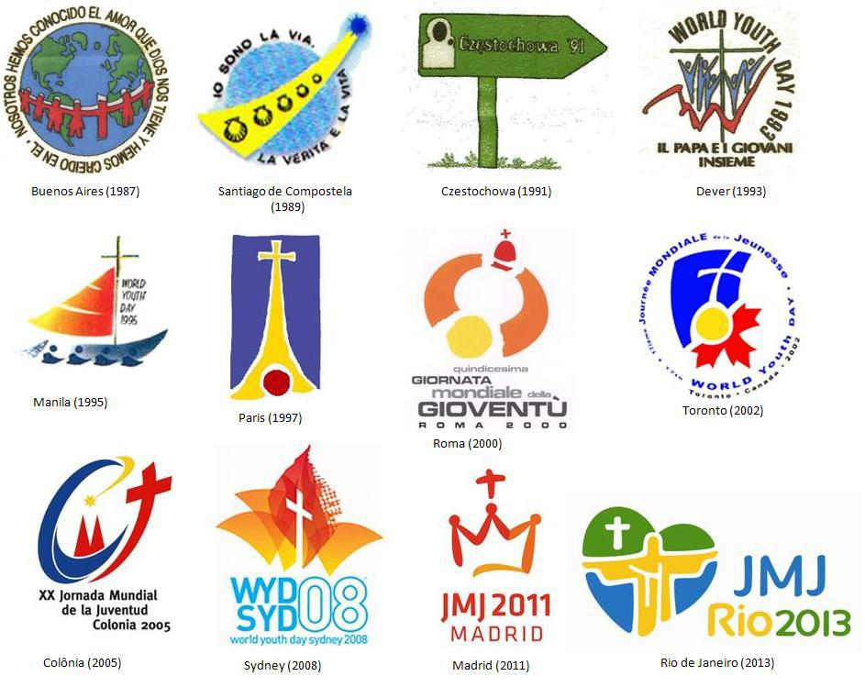

Young adults interested in a Pilgrimage to Krakow, Poland for the
World Youth Day International Gathering
July 2016
Should contact the OY&YAM in January 2015
To inquire about the package and make a deposit.

28
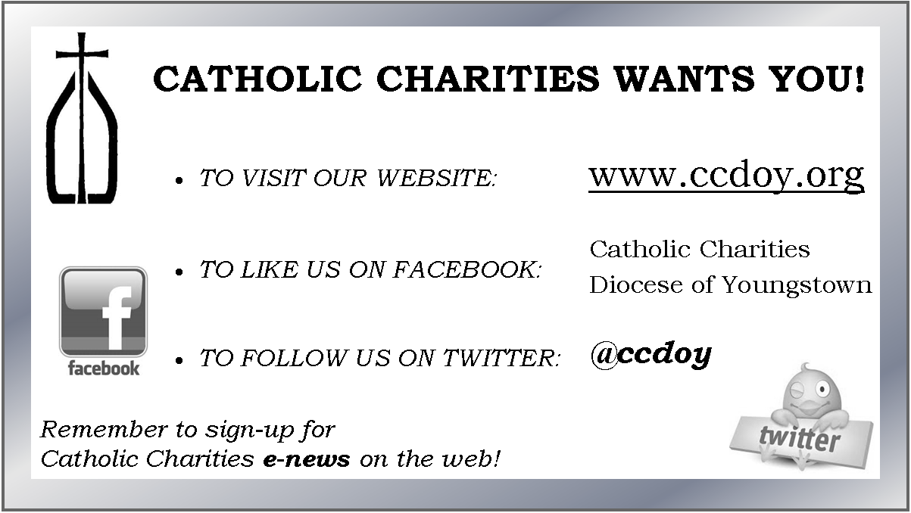

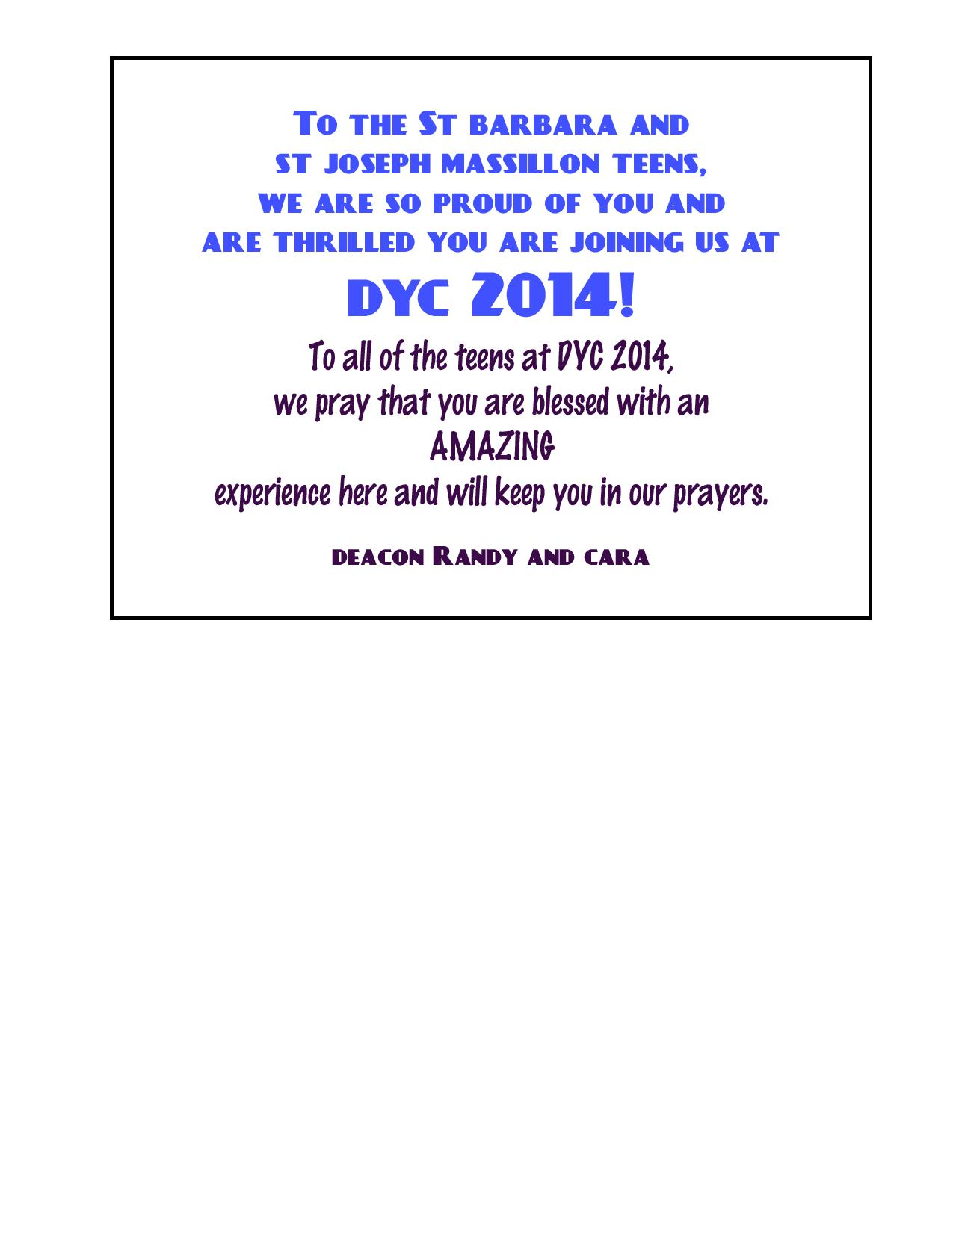
27

General Session #1

Pre-Session Music St. Michael Life Teen Praise and Worship Band

Welcoming

DYC’14 Emcees: Hannah Fricker and Kevin Ruppert
Jeff Fricker, Youth Minister and Music Minister, St. Michael Parish
Cindee Case, Director, Diocesan Office of Youth & Young Adult Ministry
Rev. Donald King, Pastor and Rev. Craig McHenry, Associate, St. Michael Parish

Opening Prayer

Opening song Our God is Here
# 305 in the Breaking Bread Hymnals
Greeting

Opening Prayer

Scripture Reading Mark 4:35-41

Reader: “The Gospel of the Lord.”
Response: Praise to you, Lord Jesus Christ.

Reflection on the Reading Fr. Don King
General Intercessions
Response: Lord, open our eyes to your amazing love
Sign of Peace

Closing Song

Our DYC’14 Theme Song: Amazed © 2014 Jeff Fricker

The journey of salvation, born anew in Christ. The joy that fills our hearts; show us the way.
The way to you Jesus our friendship with God. Our Savior and Redeemer, message of hope. R.

We are amazed, not ordinary, we celebrate in song!
Hands raised to heaven sing Alleluia!
We stand in awe of your glory, we are amazed by your love.
Sing praises to the Father and the Son!

The majesty of creation, all the power of our Lord. The fire deep within us; we stand in awe.
In awe of your glory, in awe of your love; this mystery and beauty joy from above. R.

4
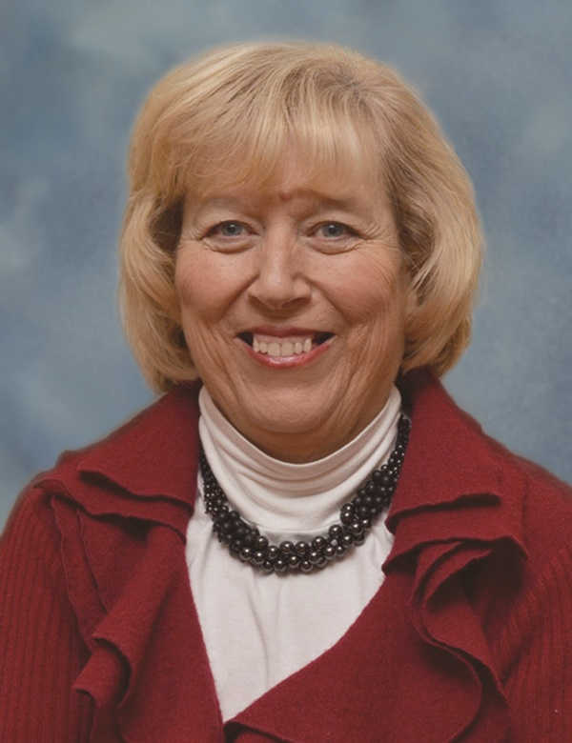
Our Keynote Speaker:
Mary Lou Beers

Mrs. Beers currently serves as the Pastoral Staff Coordinator for Sacraments and Bereavement at St. Mary Magdalene Parish in Willowick, Ohio (east of Cleveland), but you will be inspired by her personal story of faith as a wife, mother and care-giver.

Mrs. Beers was a workshop speaker at our DYC’12 and received such great reviews that we wanted more teens to hear her story of faith and perseverance. She has also presented at many parishes and at the Ohio Catholic Education Association (OCEA) Convention.

Our Emcees:
- Hannah B Fricker
Senior at GlenOak High School where she is actively involved in the Music and Theater departments. She has sung with their vocal jazz groups Notables and Drifters all four years at GlenOak. She is currently President of Chorale and a member of NHS. Hannah has had several lead female roles in high school plays. She currently participates as a cantor for the St. Michael Life Teen choir and participates as a choir member each Sunday night at the 5:30 mass. Hannah is hoping to attend Baldwin Wallace or another state school that offers Music Therapy as a major.
- Kevin Ruppert
Kevin is a member of St. Joseph Church in Massillon where he is an altar server, sings in the choir, helps with Faith Formation and participates in Youth Group. He is involved in theater and band at Jackson High School where he is a sophomore. Kevin is also a Life Scout in Troop 935 in Jackson Township.
- Cindee Case
Cindee is the Director of the Office of Youth and Young Adult Ministry for the Diocese of Youngstown. She is in her 13th year in this role after having served in the Archdiocese of Atlanta and the Dioceses of St. Augustine and Cleveland. She is the immediate past chair of the Board of Directors for the National Federation for Catholic Youth Ministry (NFCYM) and a charter member of the National Association of Catholic Youth Ministry Leaders (NACYML). Locally, she works with the Greater Ohio Area SuperKids Classic, the Ladies Ancient Order of Hibernians, and served on the Ursuline Center Board for 7 years.
- Jeff Fricker
Jeff is in his 12th year as the Youth Minister for St. Michael the Archangel parish in Canton, and the DYC’14 Musical Director who composed our theme song for the day. He also composed the parts of the Mass we will be singing, and produced, arranged and performed on the CD “The Gift” of liturgical music. Jeff was born and bred in Canton and has been active in music for decades. He and his wife Chris have 3 children.

5
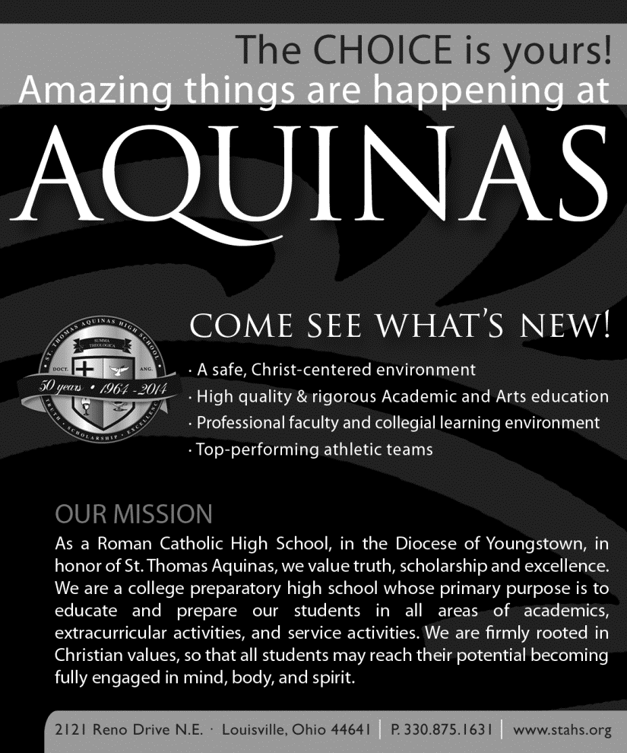
We are praying for the youth of our diocese—that you may be AMAZED by what is true, beautiful, and by what is of God!

Saint Peter and Christ the Servant Parish
Youth Ministry,
Canton, OH

Sacred Heart of Mary
& St. Louis
LIFE TEEN


When youth come together,
We are powerful.

Find us on Facebook
Sacred Heart of Mary and St. Louis Youth Ministry

For more information:
330-875-2827 or 330-875-1658

As you gather for the
2014 Diocesan Youth
Convention,
know that the
members of Men and Women
United for Life are
praying for you today!


For more information on
Men and Women United for Life,
Contact Judy Welsh
Judywelsh54@gmail.com
(330) 757-7552

26
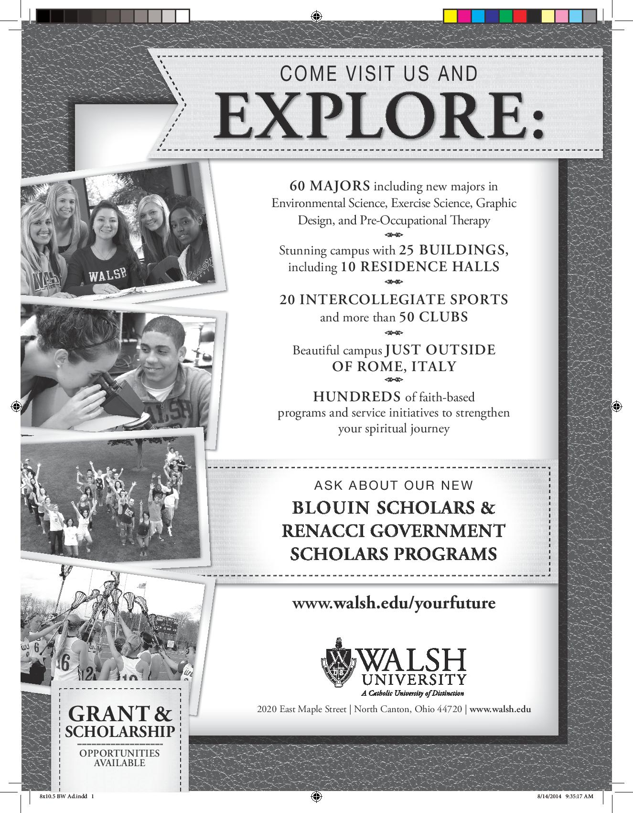

25

CODE OF CONDUCT

Please show your gratitude to St. Michael Parish for hosting our event by projecting an image of Christian consideration, sensitivity and respect to everyone and to the property around you. We are confident you will display the maturity, responsible leadership and character that have become the trademark qualities of Catholic youth. Thank you!

Respect each other.

- Safety First—please refrain from inappropriate physical contact or conduct: throwing objects, rough housing,
inappropriate language, or any other activity or behavior that may be harmful to yourself or others.

- If anyone becomes ill or injured, report it immediately to an adult chaperone so prompt treatment may be given.

- Turn off or silence your cell phone during the event so as to not interrupt anyone’s experience.

- Dress appropriately for the event – As we will be in a Catholic Church and celebrating Mass with our Bishop, please be sure to cover all undergarments and do not wear anything with offensive language or graphics.

Respect the property of St. Michael Parish.

- Please do not touch or play with audio-visual equipment or instruments.

- Be good stewards of the building equipment, furniture and environment.

- No alcohol, weapons or illegal drugs are permitted on the premises.

Respect the event.

- You are expected to participate in all events of the day. Please arrive promptly for all sessions.

- You may not leave the parish grounds at any time during the event unless you have submitted a signed
Early Dismissal slip to your parish or school leader.

- Nametags should be worn at all times to identify participants.

Respect the adult leaders.

- Please follow the instructions given to you by all adult chaperones, staff and emergency personnel.

- Kindly listen to speakers, prayer leaders and activity leaders.

Disruptive or uncooperative behavior or infractions of these guidelines may result in contacting your parents for immediate dismissal from this event.

Thank you for agreeing to all these points when you registered.
Adherence will help make for a safe and fun day!

6
WORKSHOPS

During your designated workshop times, you get to select TWO of the following options.
Please note that some rooms have very limited space, so when those seats/desks are filled, the door will be closed, indicating that you should choose another option.
Thank you for your cooperation should this issue arise.

1. Finding Faith in Movies Fannon A
Maria Dick, Religion Teacher, Central Catholic High School

Fact: Most of us love watching movies. What many might not realize is that this particular art form has tremendous capability to show us God in our world, God’s grace at work in our lives, the realities of good and evil and our Catholic belief that good can and will triumph in the end. The late Catholic Priest and Author Andrew Greeley often said that film has “sacramental potential” because of “its inherent power to affect the imagination.” This session will explore the capabilities that movies provide to enable our faith to grow and ultimately enable us to be closer to God and to each other.

2. Taize Prayer Meets Yoga: Incorporating Prayer into Our Lives Fannon B
Maureen Wood, Director of Religious Education, St. Peter Parish
Kristie Leahy, Registered Kripalu Yoga Teacher

Come experience a meditative Taize prayer session accompanied by yoga and scripture readings. Yoga is popular among teens and young adults, and we plan to show how this activity can be incorporate into one’s prayer life, even though it is not Catholic. Come learn that meditative prayers like Taize can be integrated into our everyday lives through creative movement.

3. Let’s Talk Trash . . . Then Eat It! Stage Wing
Wendy Bullock, Education Specialist Stark-Tuscarawas-Wayne Joint Solid Waste Management District

Discuss the influence of materialism on attitudes and behaviors of society like extravagance, a disposable society, money-driven goals, wastefulness, and more. Explain how to create a personal plan to practice environmental stewardship by Reducing, Reusing, and Recycling.
ALLERGY NOTE: PEANUTS are part of this presentation.

4. Amazed that I Matter: Living Faith, Sharing Faith, Making a Difference School Room 111
Justin Huyck, Pastoral Associate, Adult Faith Formation, St. Michael, Canton

Pope Francis has invited us to move to the joy of the Gospel, but what does this mean, and why do teens matter? Put simply, Pope Francis says that teens moving to the joy of the Gospel should “make a mess!” In this session, we will reflect on how faith can bring energy to our own life, and how Gospel joy can flow out of us to others. In fact, the pope reminds us that God has a plan for each and every one of us, and that each of us is called to make a difference in the Church and in the world – even if it means making a mess!

5. “Chosen” - An Honest and True story about Human Trafficking in the U.S. School Room 112
Brenda Antenucci, Director of Religious Education, Blessed Sacrament Parish
And members of the Collaborative Initiative to End Human Trafficking

Revealing the warning signs and sometimes fatal consequences of sex trafficking to equip teens to protect themselves and others from being trapped in the horrific and violent sex industry in the U.S.

7
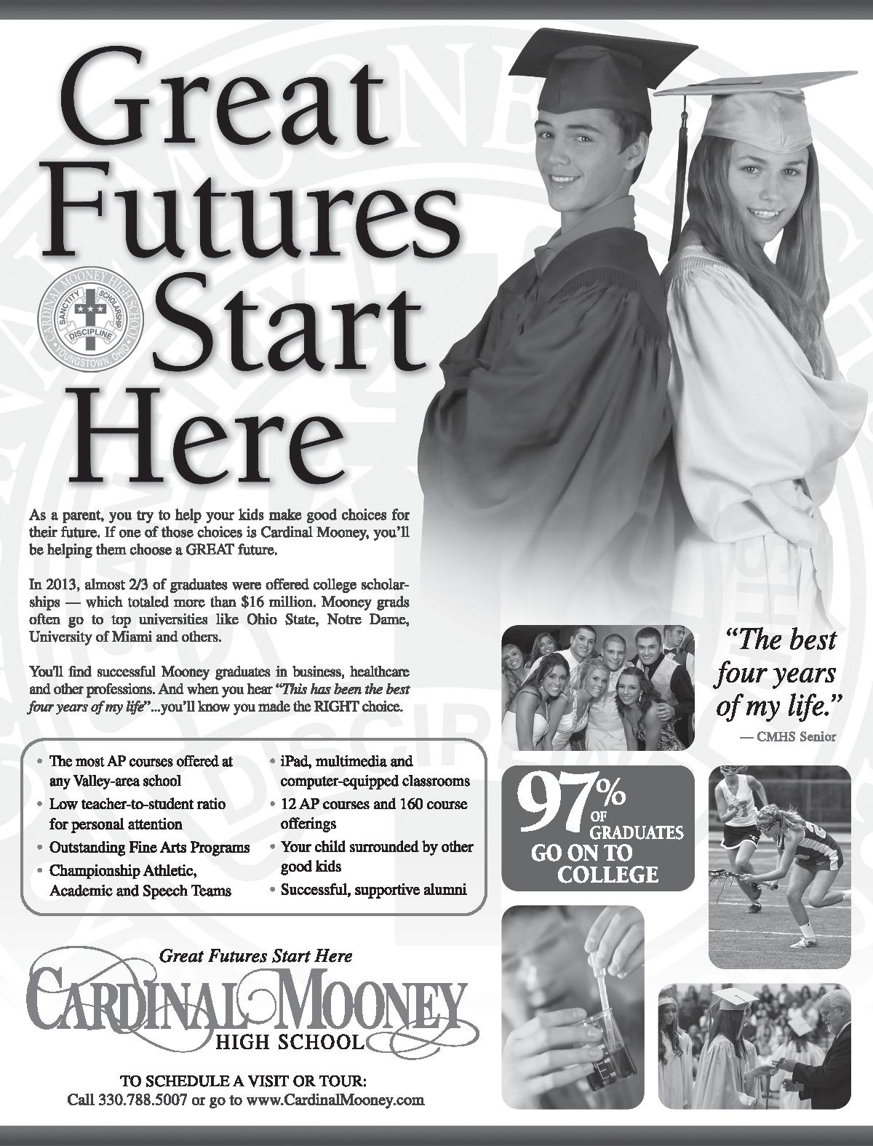

24

We are praying for you for an
Amazing Diocesan Youth Convention!
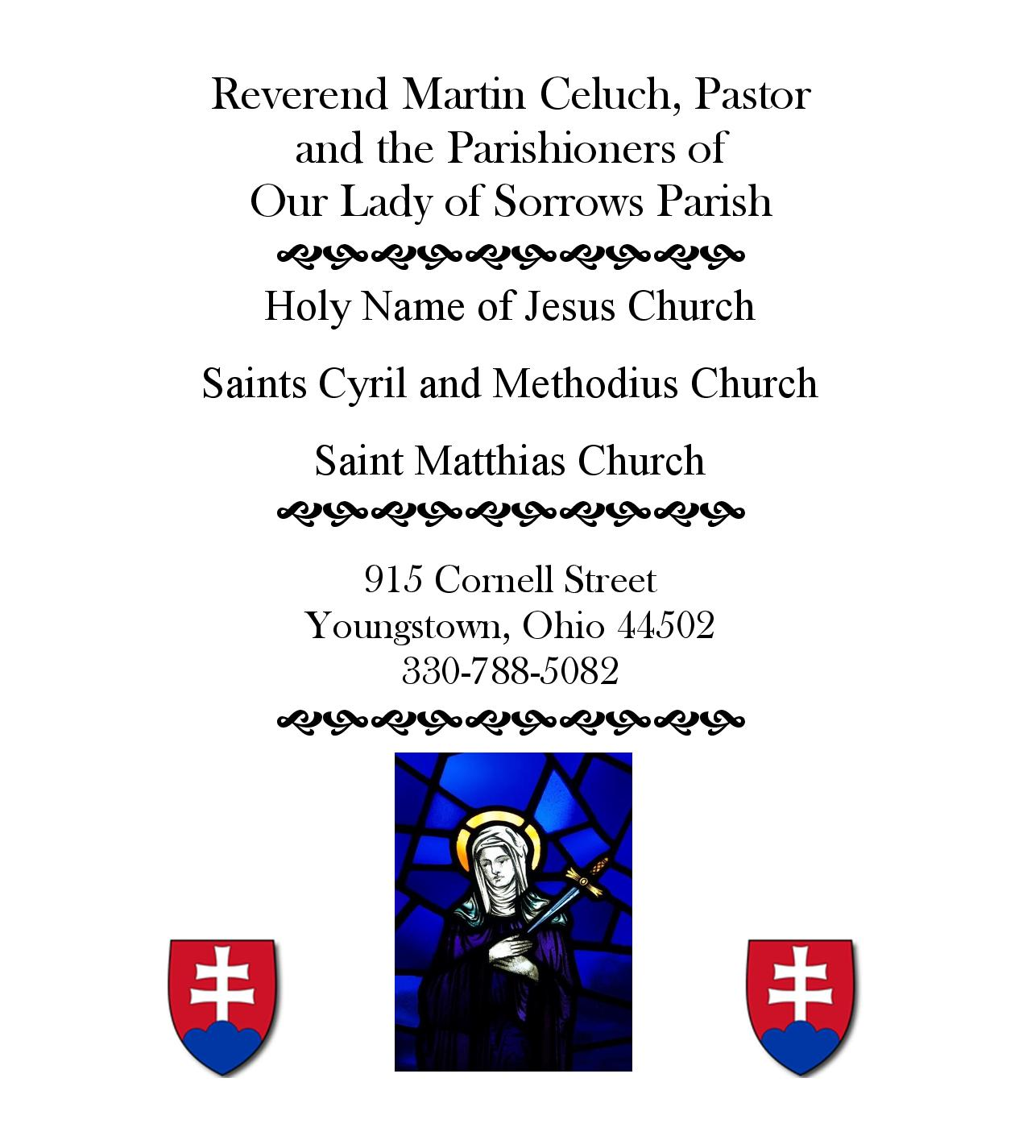

23
More Workshops:

6. Faith and Leadership in Sports School Room 113
Matt Creamer, Basketball Coach, Central Catholic High School

How can team sports and being a member of a team enhance your relationship with your peers as well as your community, school, family and help you to be more acceptant in your own faith? Being a member of a team or extracurricular activity teaches a selfless attitude and imposes qualities of serving others and making sacrifices upon yourself to make the whole better.

7. Love Worth Dying For School Room 114
Dominic Colucy, St. Peter Parish
Julianne Schrock, St. Peter Parish

In today’s culture, love is often portrayed as disposable, shallow, and self-fulfilling. We can be easily drawn to the love that we see in the media…a sort of “live in the moment” infatuation rather than a pure and sacrificial love that Jesus has shown. As Catholics, we must open our eyes and our hearts to the true love that God has given us: His; and realize that He wants our love just as we want to be loved by others. This workshop will focus on the difference between superficial and sacrificial love and what it has to do with dating in today’s world. We will discuss the value in understanding the sacred nature of love and sexuality as well as helpful advice for maintaining a healthy dating life.

8. Major in Faith School Room 115
Nicky Uerling, Campus Minister at Youngstown State University
and students from Kent State University Newman Center and Youngstown State CSA

With so many different things tugging at your attention, it can be hard to make faith a priority when you start college. Come hear students share how they fought to keep faith a priority while at college and how Campus Ministries can help.

9. Stressed Out? There’s an app for that! School Room 116
Michelle May, Campus Minister, St. Thomas Aquinas High School
Tim May, St. Paul Parish

STRESS = Family, friends, sports, job, school, and a culture filled with selfies, Snapchat, texting and who has the most likes on Instagram. How can I find peace and manage stress in my life without losing my identity as a Catholic Christian teenager?

10. Who Defines your Worth? Combating the World’s Lies School Room 117
Sadie Beadle, Stark County Pregnancy Support Center

We will be exploring the different lies we are told about where our self-esteem, self-image and self-worth are found. We will work through these different lies and replace them with the truths about how God created each of us unique and with a purpose. It is only through God that we can truly discover our TRUE worth.

Attention Chaperones: (2nd workshop session) Fannon C

One session especially for You! It will be offered during the second workshop time, approximately 3:15 p.m. to 4:00 p.m. Mary Lou Beers, our keynote speaker will stick around to talk with you about connecting stories from your own life experience to your faith as a means of evangelizing our teens.

8

Notes from Presentations:

Stark Catholic Youth Ministry
“Breakfast Club”

Serving Catholic Youth Ministry in Stark County

St. Joseph, Canton St. Louis, Louisville
St. Peter, Canton St. Barbara, Massillon
Christ the Servant St. Mary, Massillon
St. Anthony/All Saints St. Joan of Arc, Canton
St. John the Baptist Sacred Heart of Mary
St. Joseph, Massillon St. Paul, North Canton
St. Michael the Archangel Holy Spirit, Uniontown

9

What Amazing Call Does God Have for YOU?

After visiting the Inter-active stations related to vocations and family life,
be sure to check out the following website when you get home:
http://www.youngstownvocations.org/

Feel free to call (330) 744-8451 and ask for any of the individuals listed below,
or send an email, for more information regarding:

+ Priesthood Fr. Chris Luoni, cluoni@youngstowndiocese.org

+ Deacon Msgr. John Zuraw, jzuraw@youngstowndiocese.org

+ Marriage Mr. David Schmidt dschmidt@youngstowndiocese.org

+ Consecrated Life (sister, brother, nun), Sr. Joyce Candidi, sjcandidi@youngstowndiocese.org

+ Church Ministry as a Lay Person, Barbara Walko bwalko@youngstowndiocese.org
or Cindee Case ccase@youngstowndiocese.org

While the diocese does not currently have an official contact for the Single Life, you can contact Cindee Case regarding that vocation as well.
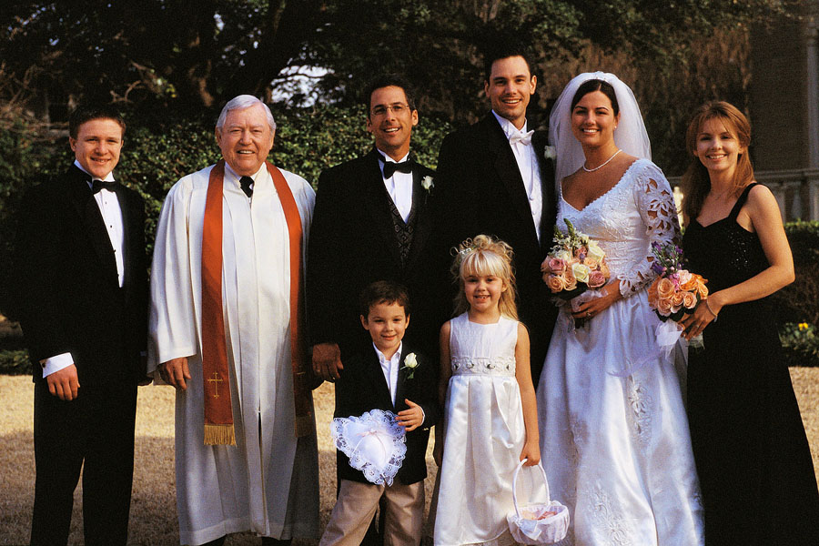
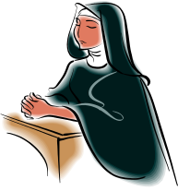



22

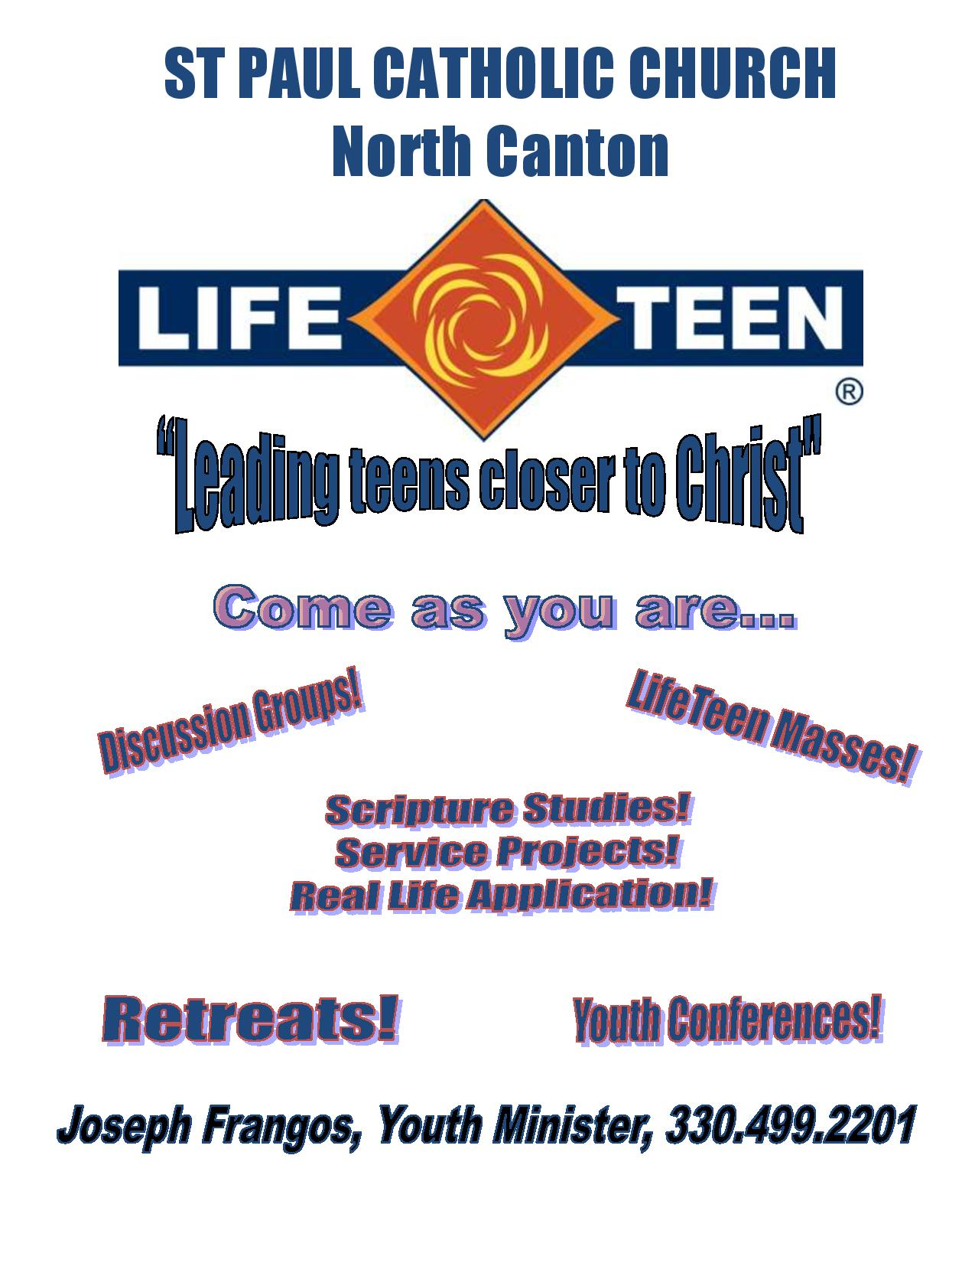

21

Liturgy: All Souls Day
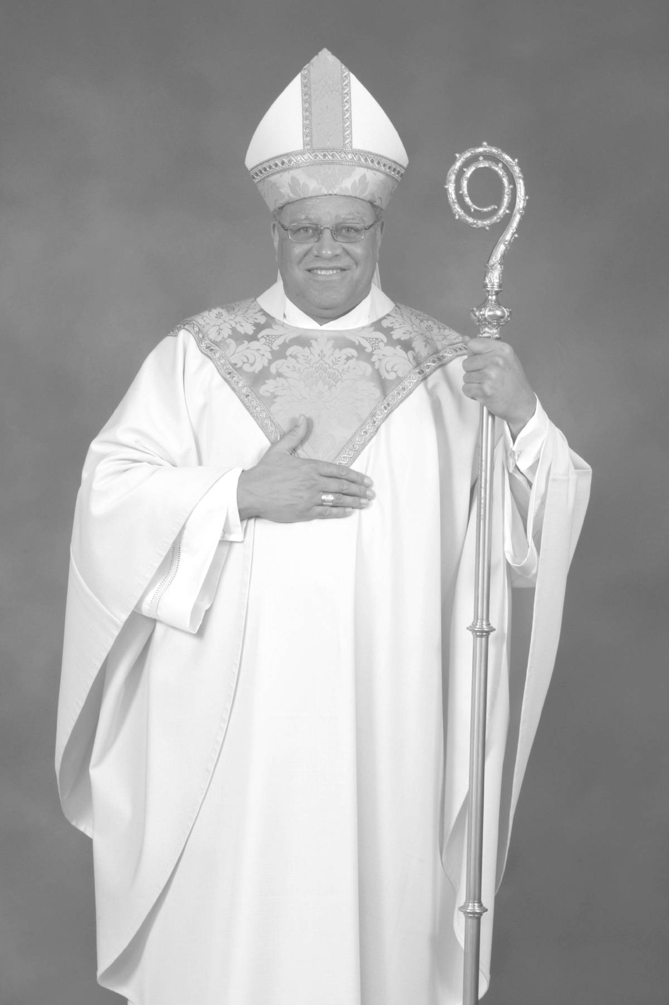
Our Mass will be celebrated with the
Most Reverend George V. Murry, S.J.
Bishop of Youngstown
And priests from around the diocese

Bishop Murry was born in Camden, New Jersey in 1948. He entered the Society of Jesus (the Jesuits) in 1972 and was ordained June 9, 1979. He earned a Masters of Divinity degree from the Jesuit School of Theology in Berkeley and a doctorate in American Cultural History from George Washington University in Washington, D.C. Bishop Murry served as Auxiliary Bishop of Chicago and Bishop of St. Thomas in the Virgin Islands. He was installed as the fifth Bishop of Youngstown on March 28, 2007.

Be sure to grab a song sheet on your way into Church!


Opening Song Come, Now is the Time to Worship

First Reading Wisdom 3:1 - 9

Responsorial Psalm The Lord is My Shepherd

Second Reading Romans 5: 5 - 11

Gospel John 6: 37 - 40

Homily The Most Reverend George V. Murry, S.J.

Institution of an Acolyte Mr. Dean Carson, Jr.

Seminarian Dean Carson, Jr. requested this this rite be celebrated with us today. Typically celebrated at the seminary, it is a special treat for us to be able to witness it and encourage him along in his preparations towards priesthood. He will address us briefly following Mass.

Presentation of the Gifts Amazed (DYC’14 Theme Song by Jeff Fricker, page 4 of this book)

Communion Walking in the Footsteps of Christ (DYC’12 Theme Song)

Meditation Song Open My Eyes Lord (with American Sign Language)

Closing Song That Where I Am There You May Also Be

Liturgical Ministers: DYC’14 Participants

Music by our House Band, St. Michael Life Teen Praise and Worship Band, Canton

Song sheets, Wine and Hosts for Mass provided by St. Michael Parish

Closing Session

- Witness to God’s Amazing Love

- Next steps

- Sending Forth

10
Continuing to be Amazed…

Following this DYC…..

This week, I will…

This month, I will…

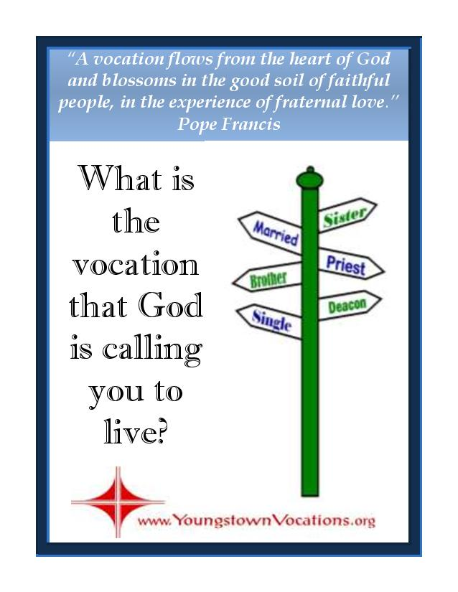
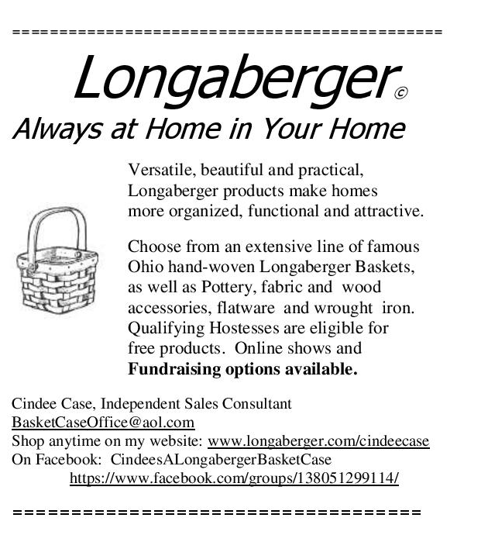
By the end of this year, I will…

Be sure to visit the website created just for you:

http://youngstownDYC.weebly.com

With more information the Amazing Connections organizations, our general sessions, and a place to share stories and pictures.
Also, please remember on Twitter, Facebook and Instagram to use the hashtag #‎AmazedDYC2014‬

11
Notes:

20

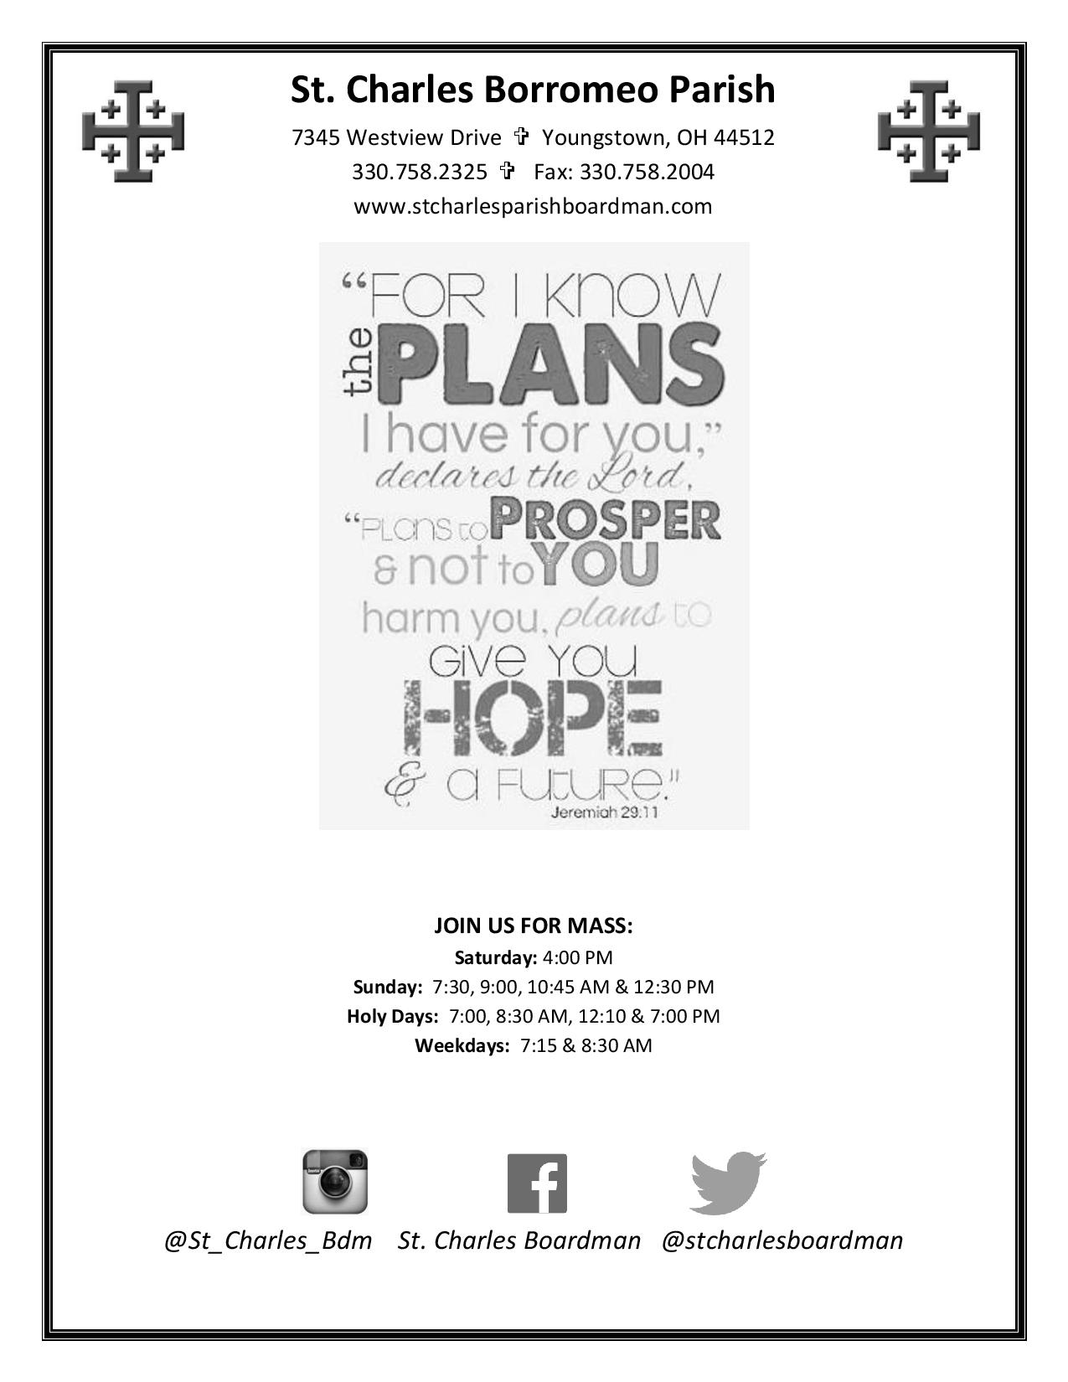
19
Office of Youth and Young Adult Ministry

Mission: Guided by the United States Bishop’s documents Renewing the Vision: A Framework for Catholic Youth Ministry (1997) and Sons and Daughters of the Light: A Pastoral Plan for Ministry with Young Adults (1997), The Office of Youth and Young Adult Ministry (OY&YAM) exists to serve as a resource for faith communities in the diocese in providing comprehensive outreach to high school teens as well as to young adults. The OY&YAM assists with including the ‘Church of Tomorrow’ into the ‘Church of Today.’

FOR TEENS: The OY&YAM sponsors periodic gathered events such as today’s Diocesan Youth Convention (DYC), diocesan excursion/pilgrimage to the National Catholic Youth Conference (NCYC), Eagle of the Cross annual awards Mass and Banquet, and other occasional one-day events. We also work with the adults in the parishes and Catholic schools to help evaluate, plan and improve youth ministry programming. Your ideas are welcomed!

FOR YOUNG ADULTS: The OY&YAM sponsors occasional programs like the YAMS (Young Adult Mass and Socials), periodic trainings, and administers the Facebook group “DOY-YAM” for those post-high school and in their twenties and thirties to network. So, don’t forget about us after you graduate!

FOR ADULTS: The OY&YAM supports those serving in ministries to, by, with, and for teens and young adults with trainings, consultations, and resources. Contact me for more information:


Cindee Case, Director
144 West Wood Street, Youngstown, OH 44503
Email – ccase@youngstowndiocese.org
Phone (330) 744-8451 ext. 280
Diocesan Website http://www.doy.org/
(click on Diocesan Offices and scroll to OY&YAM)
Office Website http://youngstownoyyam.weebly.com/
Like us on Facebook: Youth-and-Young-Adult-Ministry-Diocese-of-Youngstown
Follow us on Twitter “YoungInYtown”
And on Pinterest “http://www.pinterest.com/youngstownyouth/”

Amazed [uh-meyzd] adjective

- greatly surprised; astounded; suddenly filled with wonder

12
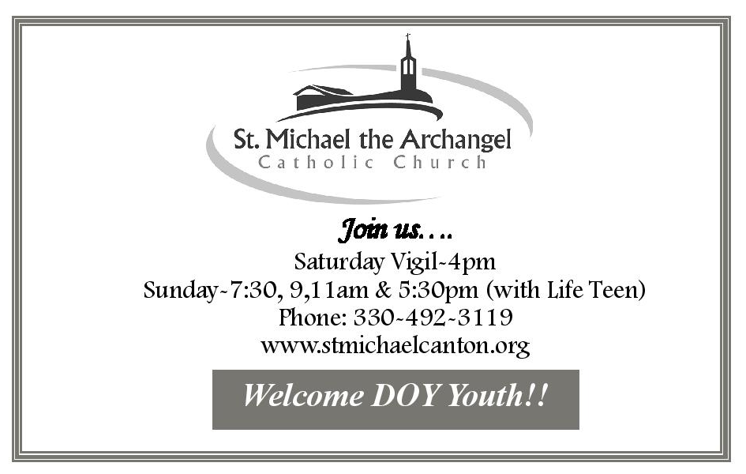

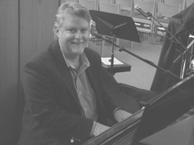
Our DYC Musical Director: Jeff Fricker
and the St. Michael's LifeTeen Band
Purchase a song or two by Jeff at
http://www.cdbaby.com/cd/jefffricker
Purchase the CD “The Gift”
(features last DYC theme song and some parts of the Mass we used at DYC'14)
http://www.jefffrickermusic.com/jfTheGift.html

Thank you to our PATRONS:

- St. Anthony/All Saints (Canton) Youth Ministry
- Bite Me Candies (Jenn Namsick), www.BiteMeCandies.com
- Greater Ohio Area SuperKids Classic, Inc., www.superkidsohio.org
- Rhoda Wise House and Grotto
- TJ Lewis, Novo Design, www.casadenovo.com

13

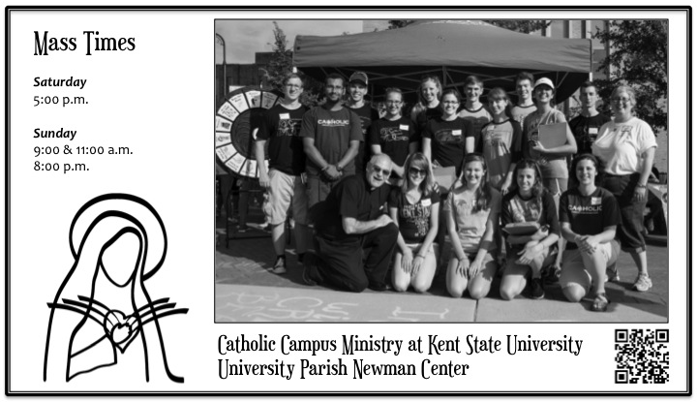
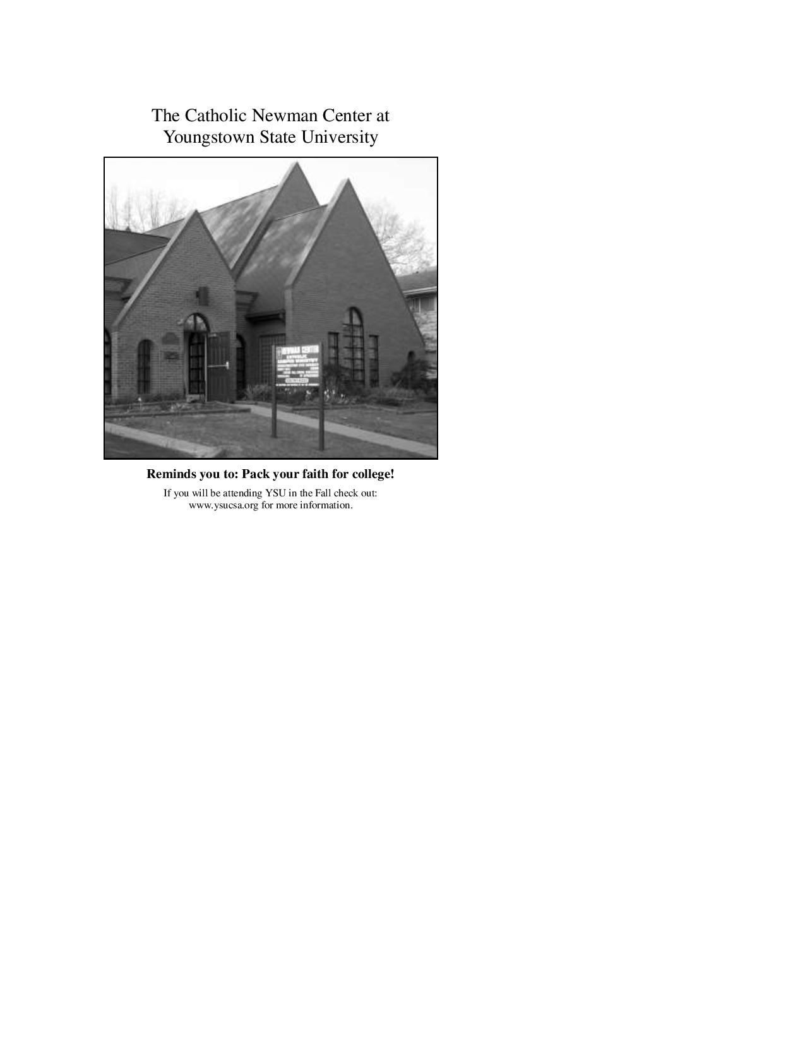
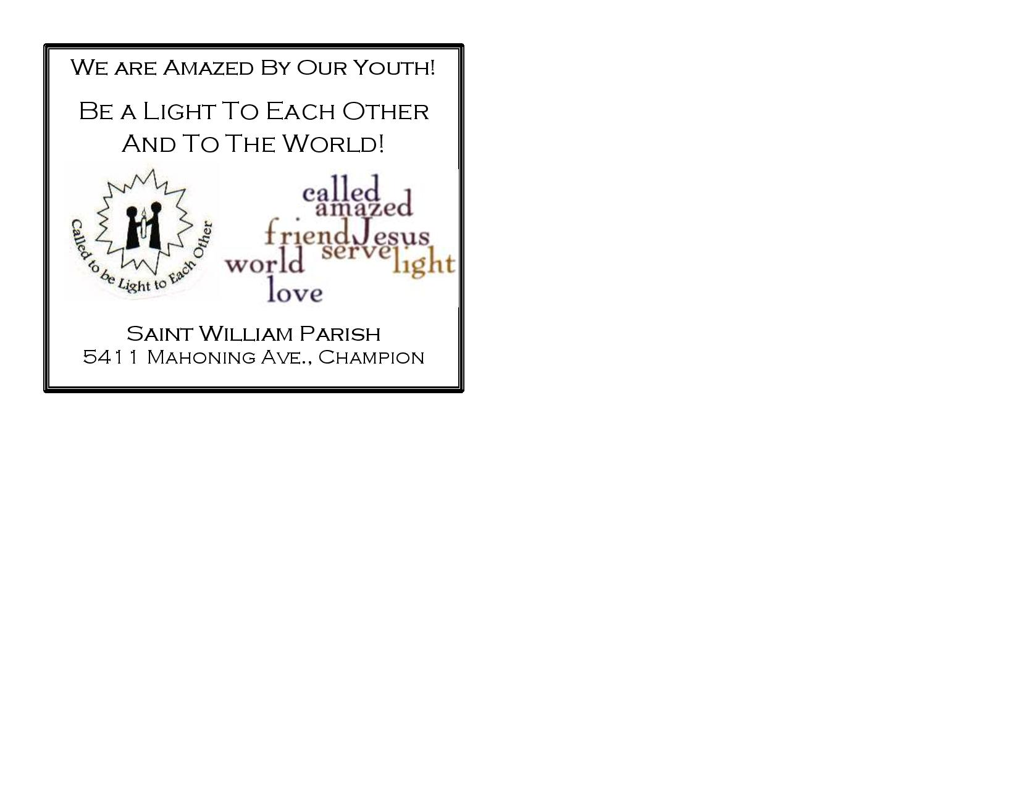
18
Lower Level Cafeteria Area

During Your Dinner Time…
Be Amazed – Be Forgiven!
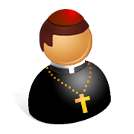
As you enjoy your dinner take some time to reach out to our visiting Priests. Fr. Dyer, Fr. Sheridan, Fr. Beneleit, Fr. McHenry and Fr. King will be available to celebrate the Sacrament of Reconciliation with you during this time if you so choose.
Just ask!
They would love to help you experience God’s amazing forgiveness!

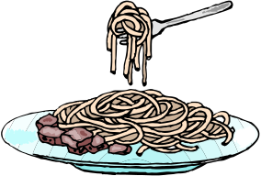

Speaking of dinner, if you requested a gluten-free meal,
please ask one of the kitchen volunteers, they will be
happy to pull the gluten-free pasta out for you!

What did you learn from the Amazing Connections Stations?

17
Amazing Connections
~ Prayer Spaces ~

Labyrinth – Grab your jacket, follow the signs and head outside for this reflective prayer style. It looks a bit like a maze, but your really just follow the path into and out of the center as you meditate. Resources are available to help you make the best use of this walking prayer.

Stations of the Cross – Along the hall between the gym and the Labyrinth are red signs with QR Codes that connect you with virtual Stations of the Cross, so grab a smart phone (or a friend with one) and pray along with Christ as you reflect upon his passion and amazing love for us!

~ Activities in the Gym ~
(Part 1 of 3, listed by approximate location in the gym, subject to change)
Ben Walther is a singer, songwriter, worship leader, husband, father and a national recording artist with OCP, and he is on our stage today. Enjoy his music as you wander through the stations.

Inspiration Board – What AMAZES or inspires you? Write about or draw your inspirations to our trifold board. We will display these inspirations during our Liturgy today.

Banner for Mass – Add you artistic touch to a banner we will use at mass to commemorate this special day. Jeff Fricker will also have his CD for sale at this station. Jeff has written our DYC theme song several times including this year’s song.

DYC Superhero Capes For Kids Project – Be sure to stop here to design and make capes with Caring Stitchers for the children at Akron Children’s Hospital! We will be creating capes of all colors and patterns and decorating them with fun shapes. These capes are sure to give a lil’ superhero at Akron Children’s the POWER to get well quickly and FLY home!

Living Bread Radio is here with a trivia challenge for you. Stop by to see what else they have to offer.

Walsh University – Popcorn and fun are waiting for you at the table showing off our only Catholic University in the Diocese of Youngstown.

Aultman Hospital – Come and hear some real nurses talk about healthy babies and all the care they need. Also, look out for Freddie the Frog!

Aultman Hospital – Wow Nurses- Being healthy is important to each of us. Stop by and check your Body Mass Index and get some tips on eating the best foods for you.

Stark County Waste Management is giving you the chance to try your skills at corn hole. See if you and the environment can both win!

St. Joseph Soup Kitchen serves many western Stark County residents each week. Help them out by adding a little joy to their meal by designing placemats for them to use during the holiday season.
14
Amazing Connections
~ Activities in the Gym ~
(Part 2 of 3)
Write a petition for our mass today with Bishop Murry. We will offer up all the petitions in the basket at our mass today at 5:30.

Ohio State Trooper Kaitlyn Griffith will help you understand how alcohol can influence your vision, and cause you to be an unsafe driver.

Hammer and Nails is an outreach ministry that assists disadvantaged homeowners in Stark County. Stop by to see how you can be a part of this endeavor.

Ursuline Sisters of Youngstown challenges you to complete the” Amazing Maze”. You may qualify for the chance to win a gift certificate and learn more about these dedicated Sisters.

Greater Ohio Area Super Kids Classic will give you a chance to race down a marble track or hot wheels track, and give you information about you can be involved in helping special needs kids race down the hill at Derby Downs in Akron.

Praying with Sign Language – Learn one of the songs we will be doing at our liturgy later today in American Sign Language (or sharpen your skills if you learned them at our Grotto event last September!) A great way to put some movement into your prayer while learning a little of a foreign language!

Brothers of Christian Instruction will help you discover how to get things done even with limited resources. This Religious Order at Walsh University is using more than hands and feet to pass on their message.

Campus Ministry from Kent State and Youngstown State University are here today with their prize wheel. Take a spin and see if you come away with an amazing prize.

Letters for Soldiers - We will forward them to active military personnel in hopes to brighten their day. Please let them know how thankful you are for their service to our country.

Sisters of Notre Dame can be found all around our Diocese in many different roles. Stop at their station and learn more about these very active sisters.

The Oblate Sisters of Sacred Heart of Jesus want you to realize how many good and wonderful things you do every day. Stop by and help them count up your good deeds.

Matthew 8:20 is an outreach ministry run by Little Flower Parish. Stop by this table to find out some of the struggles the homeless have, and how you could possibly help.

Brothers of the Province of the Immaculate Conception will try to show you how perseverance pays off with sweet rewards.

15
Amazing Connections
~ Activities in the Gym ~
(Part 3 of 3)

Vocations Office and seminarians for our Diocese - Stop by to chat with these dedicated young men and play some “Minute to Win It” games that may earn you a chance at winning a gift certificate.

Nursing Home Outreach –Make a card for a senior citizen in our community that is living in a nursing home. Your creative design could brighten their day. While your there don’t forget to sign our big Thank You cards for the Bishop and St. Michael’s Parish, our hosts today.

Boy Scouts and Girl Scouts – Stop by to find out what is new with scouting in our Diocese and look into Religious Emblems programs that might be of interest to you (some are open to all youth, not just scouts!)

The Council for Catholic Women is helping us with Project S.O.A.P. Help us as we try to clean up a little in the world- wide human trafficking problem. This is a great follow up for those who went to the Chosen workshop to DO something!

Missions Office of the Diocese of Youngstown – helping our communities through Project Grow. They are sponsors of the Kentucky Missions trip each summer. Stop by and see if Fr. Brienz can amaze you and help get you involved in these great outreach missions.

The Office of Pro-Life. Marriage & Family has facts on what life was like before you were born. Stop by and consider spiritually adopting an unborn child.

Joshua Casteel Catholic Worker House is alive and well in Alliance Ohio. Come see where all the generous donations you brought with you today will go.

Pregnancy Support Center offered the ‘Who Defines your Worth’ workshop earlier today. If you want to hear more about healthy relationships and how we should hold true to our values stop by and visit these ladies.

Sisters of the Congregation of the Divine Spirit from the House of Loretto want you to remember to pray each day. Stop by and they will show you how to make bracelet rosaries and you will have a prayer reminder and a souvenir for today.

Selfie or Instagram – Visit “Pope Francis” and feel free to use our collection of props to take selfies. Feel free to post them on Facebook, Instagram or wherever you want to let people know what an awesome time you are having!
Please remember to use the hashtag ‪#‎AmazedDYC2014‬ when posting on social media! Thanks!

And they were all amazed at the mighty power of God. (Luke 9:43)

16

