***10K/2 Mile Walk/Run***

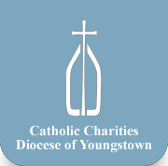 ***Sunday, AUGUST 24, 2014 starts @ 10:00am @ Covelli Center***

*Are you a serious Runner?*

*Enjoy a good walk?*

*Like Community Events?*

*Or just want to help fight Breast Cancer?*

***All are great reasons to get involved with Panerathon 2014!***

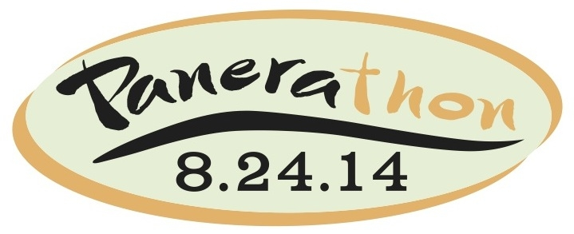229 Front Street, Youngstown OH 44503

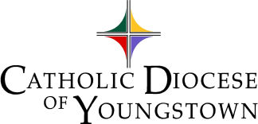

*If you love to run,*

*or just enjoy a nice walk…*

*If you like community events*

*or want to fight breast cancer*

Panerathon 2014 is for you!

**Teams**: Teams consist of 5 or more people at $20 per person to participate in either the 2 mile walk/run or the 10k. Each team is able to fundraise and compete against other fundraising teams participating to see who can raise the most money. Teams are a great way to get *youth organizations*, *young adults* and *families* involved in a fun and charitable event! By August 15, form your own team, or join ours…

**To join the “Diocese of Youngstown group” visit:** https://53599.thankyou4caring.org/sslpage.aspx?pid=379

(You will find the group name in the drop down box, then email [ccase@youngstowndiocese.org](mailto:ccase@youngstowndiocese.org) to receive team updates!)

**To make a donation, visit:** <http://www.active.com/donate/panerathon2014/cindeeDOY>

Support the Catholic Charities/Diocesan Team as we

take steps to fight breast cancer in our diocese!

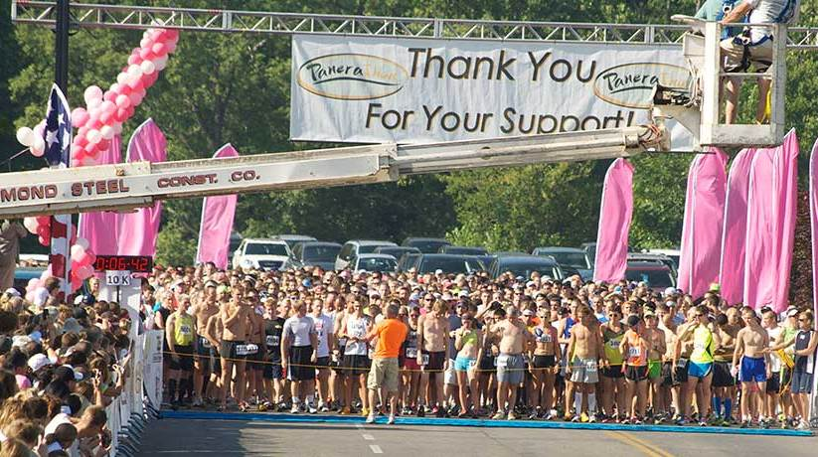

Please join us in this event by participating individually (information below), forming a team or joining the diocesan team (information to the right) to help support this area fight breast cancer. 100% of all proceeds stay local to support the Joanie Abdu Breast Care Center through grant program “Joanie’s Promise” Fund at the HMHP Foundation so more women can get breast care including screenings and services.

Individual Registration:

10k run: $30 pre-registration,

$35 race day (Timed for prizes/medals)

2 mile/ walk run: $25 pre-registration,

$30 race day

Kids Run (ages 10 and under): Free!

(Pre-Registration for individuals ends August 20, for teams by August 15)

Participant bags will include t-shirt.

**Read more at [www.panerathon.org](http://www.panerathon.org)**

Follow the hashtag -- #panerathon2014