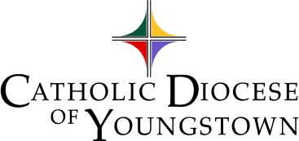

Administered by the
Office of Youth and Young Adult Ministry
Funded by the
Annual Bishop’s Appeal

Catholic Diocese of Youngstown

EAGLE of the CROSS

Awards

St. Columba Cathedral Altar
Chapel
Lector: Aja N. Shriver  Small pews | Aisle | Petitions: Aaron Ferguson
Blake Abbott |  | Reflection: Morgan Anderson
Megan Brockway |  | David J. DiSalvatore
Brooklyn Duguay |  | Lena Dunkerley
Victoria Flores |  | Nikolas Hackett
Emmanuel Heestand |  | Alannah Marie Hetzel
Stephen Hiner |  | Anna Hughes

Anthony Joseph Jones |  | Justin McLemore
Giovanni R. Mileto |  | Reagan Phillips
Barrett Christopher Scheatzle |  | Patrick Michael Wilson
Grace Witmer |  | Team
Cardinal Mooney |  | Central Catholic
Ursuline |  | St. John
Other guests |  | Other guests
Main Doors

Twenty-third Annual

EAGLE of the CROSS

Evening Prayer
and
Awards Presentation

Wednesday, April 14, 2021
Cathedral of St. Columba
Youngstown, Ohio
7:00 PM

Acknowledgements

Eagle of the Cross Judges

Lindsey Fuentes Maureen Hall
Cara Lipinski Dustine May
Tina McCue Julie Pertz
Cindee Case (Secretary)

Participating Clergy

Rev. Marian Babjak Rev. Michael Balash
Rev. Matthew Hummerickhouse
Rev. Scott Kopp Rev. David Misbrener
Rev. Richard Murphy Rev. Raymond Paul
Rev. Joseph Ruggieri Very Rev. Msgr. Robert Siffrin
Rev. Michael Swierz Very Rev. Raymond Thomas, V.F.
Rev. Stephen Zeigler Rev. Msgr. John Zuraw, J.C.L.

Special thanks to our Hosts for their generous hospitality

~~ St. Columba Cathedral ~~
Very Reverend Monsignor Peter Polando, J.C.L., Rector

Music printed under OneLicense.net no. A-702617: Psalm 62, text: Lectionary for Mass © 1969 ICEL and music: Robert J. Batastini © 1975; Psalm 67, text: Lectionary for Mass © 1969 ICEL and music: Marie Krener © 1975; Philippians Canticle, text: New American Bible © 1970 and music: Howard Hughes, S.M. © 1975; and My Soul Rejoices, Owen Alstott © 1984, 1991 OCP. GIA Publications. All rights reserved.

15

Acknowledgements

A sincere and heartfelt

Thank You

to all who helped in the preparation and celebration of this evening.

Most Reverend David J. Bonnar
Bishop of Youngstown

2021 Recipients who assisted with our evening

Dr. Daniel Laginya, Cathedral Music Director

Reverend Michael Balash, Director, Diocesan Office of Worship

Bob Zajack and Studio Six Photography

All the nominators who took the time to share stories with us
about these outstanding teens.

Families and mentors to the recipients who nurtured faith and
encouraged Christian Leadership.

14
Evening Prayer

Wednesday of the Second Week of Easter

WELCOME Cindee Case

INVITATORY
Presider: O God + come to my assistance
All: Lord, make haste to help me.
(Please bow) Glory to the Father and to the Son and
to the Holy Spirit, as it was in the beginning, is now and will
be forever. Amen. Alleluia.

HYMN All Creatures of Our God and King
3
PSALMODY

Psalm 62 Please be seated

Psalm Prayer Please stand

Psalm 67 Please be seated

PSALM PRAYER Please stand

4
WHAT IS THE EAGLE OF THE CROSS?

The Eagle of the Cross, created originally by the National
Federation for Catholic Youth Ministry (NFCYM), is the
highest recognition that our Diocese confers on a youth.
It is given to extraordinary teens who selflessly serve
their peers and parishes in unwavering commitment
and dedication as communicated by the nominating adult.

Since 1999, The Eagle of the Cross has been given annually in the Diocese of Youngstown to select high school juniors and seniors who show particular zeal in the improvement of their parish youth ministry program, high school ministry teams or other ministries within the Diocese. The nominees must be practicing Catholics who exemplify the qualities of moral integrity, prayer, good works and Christian leadership. Awardees can receive only once. You can find the names of previous recipients posted online at:

http://youngstownoyyam.weebly.com/eagle-of-cross-awards.html

Nominations for the Eagle of the Cross are to be completed by an adult (not the nominee), be it a parish staff member, high school personnel, parishioner, or friend. Each nominator must answer essay questions addressing the nominee’s participation in parish and high school youth ministry programs, providing examples of the qualities mentioned above. The award is not geared toward quantitative service hours but to the integrity of the individual and how well s/he is perceived by the nominator as an outstanding Catholic Christian.

13

Office of Youth and Young Adult Ministry

In addition to organizing this awards program on behalf of the diocese, the Office of Youth and Young Adult Ministry (OY&YAM) directs the biennial Diocesan Youth Convention (DYC) in even-numbered years and the diocesan delegation to the National Catholic Youth Conference (NCYC) in the odd years (November 18-21, 2021) in Indianapolis, Indiana, as well as other periodic programs. The OY&YAM provides resources to parishes and Catholic agencies within the diocese to assist with outreach to high school teens and those in their twenties and thirties.

After you graduate from high school, be sure to check out young adult ministry opportunities at your campus, post/station or parish, as well as those in our diocese!

Additional information about the programs and services of the OY&YAM are available on the diocesan website, http://doy.org/index.php/diocesan-offices/youth-a-young-adult-ministry and at http://youngstownoyyam.weebly.com.

OY&YAM also uses social media:

Facebook at “Youngstown-Youth Young-Adults”

Pinterest as “YoungstownYouth”

Twitter @YoungInYTown

12
CANTICLE Philippians 2: 6 - 11
5
SCRIPTURE READING Romans 12: 3 - 8
Read by Aja N. Shriver Please be seated

RESPONSORY

Presider: The Lord has risen from the tomb, alleluia, alleluia.
All: --The Lord has risen from the tomb, alleluia, alleluia.

Presider: He hung upon the cross for us,
All: -- alleluia, alleluia

Presider: Glory to the Father, and to the Son, and to the Holy Spirit.
All: --The Lord has risen from the tomb, alleluia, alleluia

6

Emmanuel Heestand St. Jude, Columbiana
Senior United Local High School

Alannah Marie Hetzel Christ Our Savior, Struthers
Senior Boardman High School

Steven Hiner Holy Family, Poland
Senior Cardinal Mooney High School

Anna Hughes Holy Family, Poland
Senior Cardinal Mooney High School

Anthony Joseph Jones St. Joseph, Massillon
Senior Perry High School

Justin David McLemore St. Paul the Apostle, New Middletown
Senior Springfield Local High School

Giovanni R. Mileto St. Patrick, Hubbard
Senior Hubbard High School

Reagan Phillips Little Flower, Middlebranch
Senior Hoover High School

Barrett Christopher Scheatzle St. Michael, Canton
Senior Canton Central Catholic High School

Aja N. Shriver Regina Coeli, Alliance
Senior St. Thomas Aquinas High School

Patrick Michael Joseph Wilson St. Stephen, Niles
Senior Ursuline High School

Grace Witmer St. Jude, Columbiana
Senior Columbiana High School

The 2021 EAGLE OF THE CROSS

AWARD RECIPIENTS

Blake Abbott St. Mary, Massillon
Senior Canton Central Catholic High School

Morgan Anderson Our Lady of Peace, Ashtabula
Senior St. John School

Megan Brockway Holy Family, Poland
Senior Ursuline High School

David J. DiSalvatore Our Lady of Peace, Ashtabula
Senior St. John School

Brooklyn Duguay Our Lady of Perpetual Help, Aurora
Senior Aurora High School

Lena Dunkerley St. Patrick, Hubbard
Senior Hubbard High School

Aaron Ferguson St. Michael, Canfield
Senior Canfield High School

Victoria Flores Holy Trinity, East Liverpool
Senior Columbiana High School

Nikolas Hackett St. Rose, Girard
Senior Ursuline High School

10
GOSPEL CANTICLE
Please stand and make the Sign of the Cross as you begin singing.

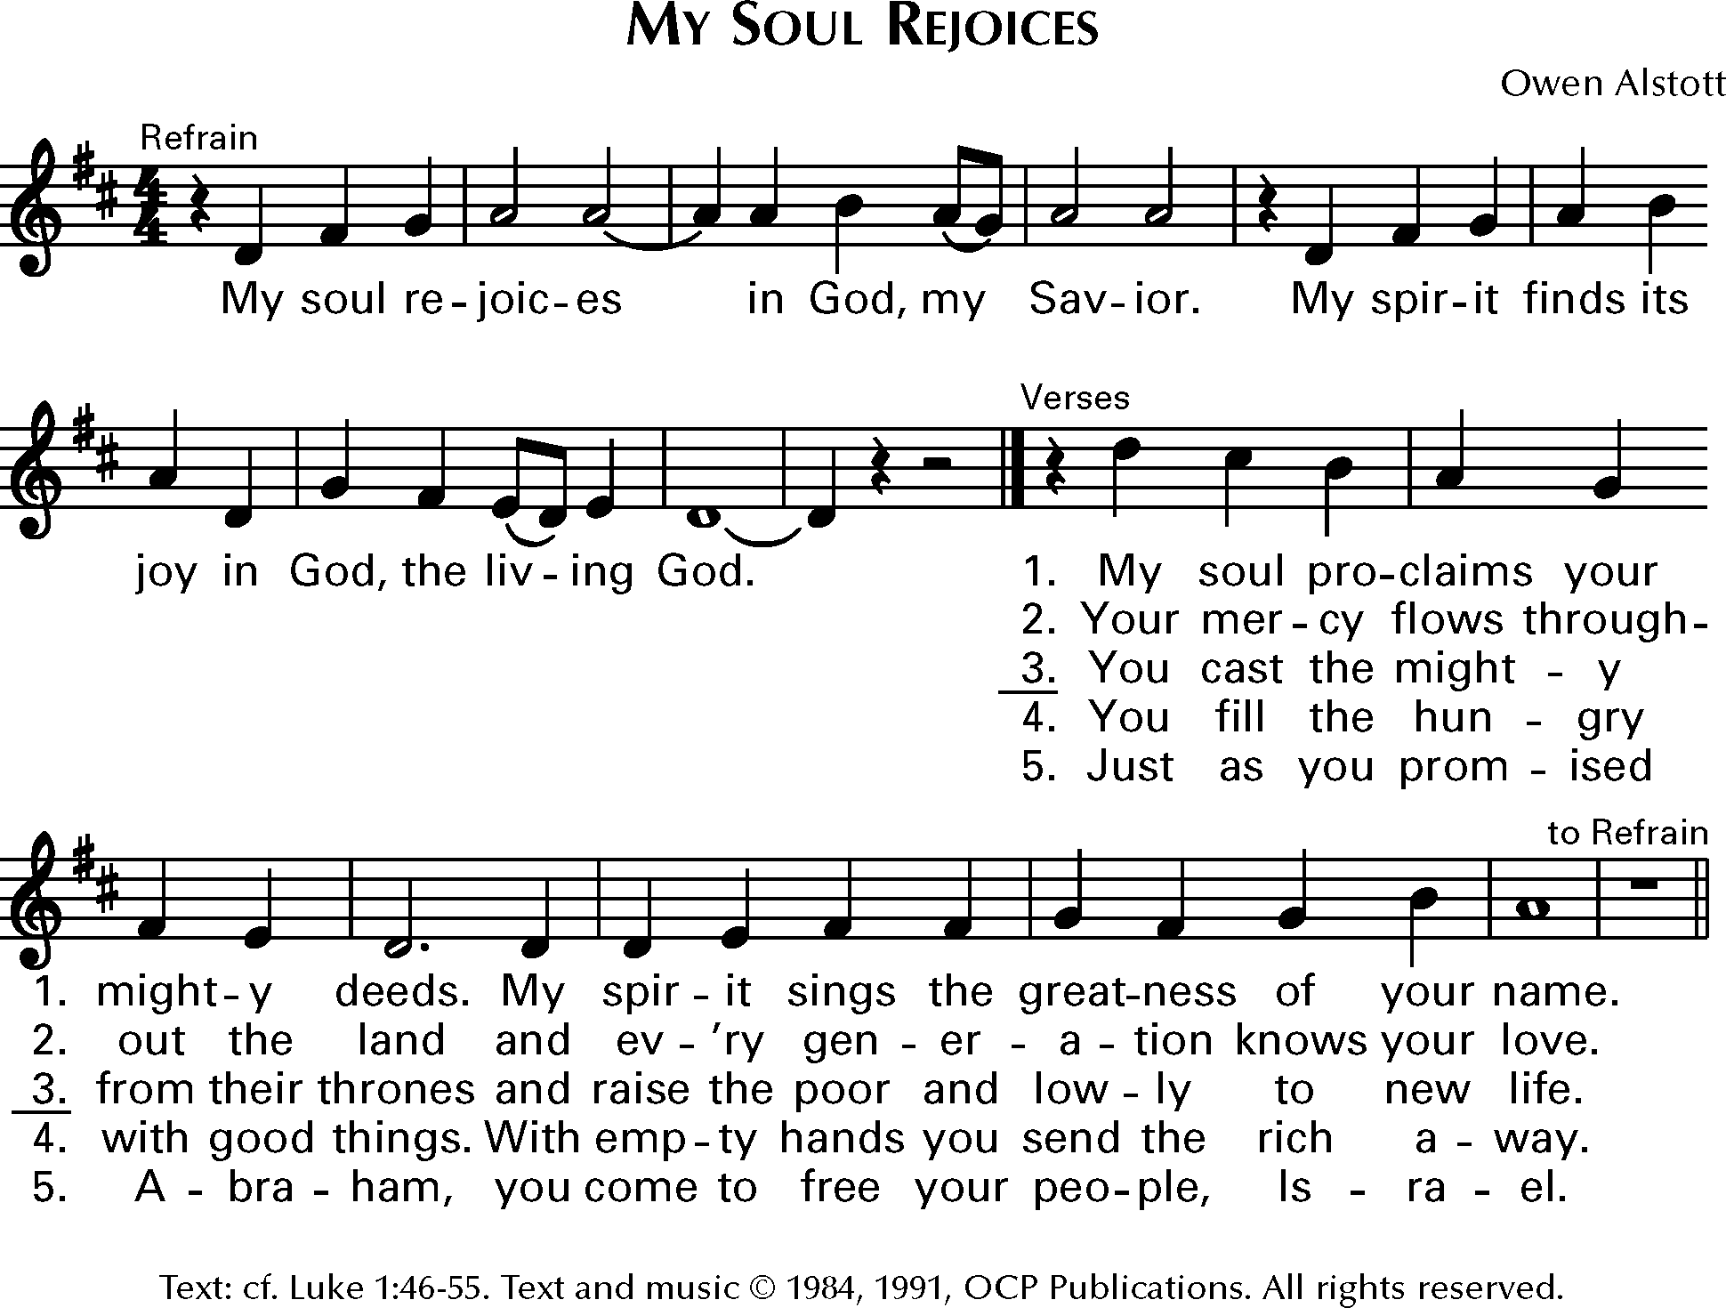

Universal Prayers
Response: Lord, hear our prayer.
Read by Aaron Ferguson

THE LORD’S PRAYER

CONCLUDING PRAYER

BLESSING

7

A Reflection on the “Eagle of the Cross” Award

Both the eagle and the cross are symbols deeply rooted in Scripture and Catholic tradition, and both speak to and about the young people being honored in this ceremony.

The cross…By the sign of the cross traced in Baptism, a person is marked forever as a follower of Jesus Christ. The cross is the trophy of victory of Jesus who overcame death and promises life forever. The cross is the unique sacrifice of Christ who calls his disciples to “Take up [their] cross and follow [him],” and who has left us “an example that [we] should follow in his steps.” (Catechism of the Catholic Church, #618)

The eagle…A symbol of integrity and faithfulness, individuality and majestic beauty. The eagle is a symbol of God’s faithful love and care. Unique among birds for its clarity of vision the eagle is the only bird that can look directly into the sun. The Book of Revelation speaks of four living creatures around the throne of God, symbolizing the writers of the four Gospels. The eagle in Christian tradition represents the Gospel of John which begins directly with the vision of God: “In the beginning was the Word, and the Word was with God, and the Word was God…” (John 1:1)

The eagle and the cross have a unique association in the person of John. As the youngest apostle, John was probably only a teenager and was the only apostle who stood near the cross of Jesus with Mary, his Mother. Just as he was one of the first disciples to be called by Jesus, John was the first person who ran to the tomb on Easter Morning; when he reached the tomb, the Scriptures record, “He saw and believed.” St. Paul wrote in his letter to Timothy, another young follower of Jesus, “Let no one disregard you because you are young, but be an example to all believers in the way you speak and behave, in your love, your faith and your purity. You have in you a spiritual gift…do not neglect it…”
(1 Timothy 4: 12, 14) © 1999, Sister Mary Brendon Zajac, SND

8
Awards Presentation

Opening Remarks Cindee Case
Director, Office of Youth and Young Adult Ministry

Reflection on the Eagle of the Cross Morgan Anderson

Presentation of Awards Most Reverend David J. Bonnar
Bishop of Youngstown

A picture will be taken of each recipient as s/he receives the award.
A copy of the picture will be mailed to each recipient in the
weeks following this ceremony.

Family and friends are permitted to take pictures but are asked to avoid interfering with our professional photographer, Mr. Robert Zajack.

Closing Prayer Most Reverend David J. Bonnar

Thank you for joining us.
Goodnight and safe travels!

9

