NEWS 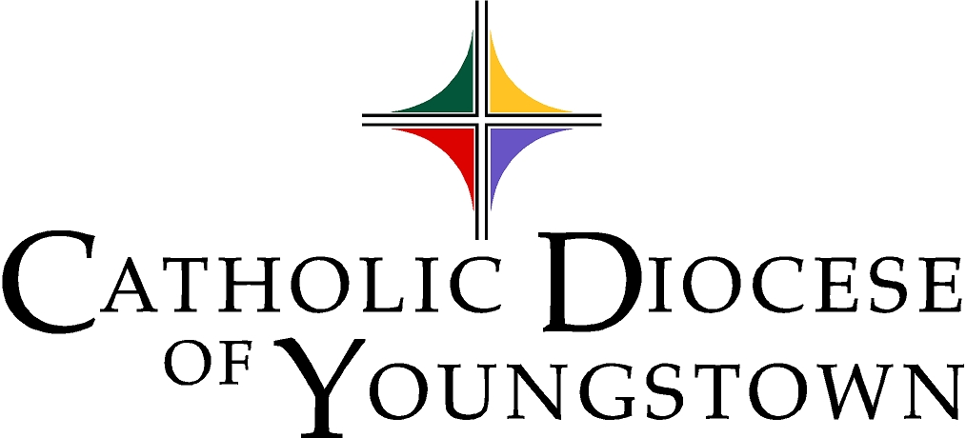
144 West Wood Street, Youngstown, OH 44503
Phone: 330-744-8451 Fax: 330-742-6448
Monsignor John A. Zuraw, Chancellor
FOR RELEASE: Immediate DATE SENT: March 29, 2021

SUBJECT: Twenty-One Teens to be Honored as Outstanding Christian Leaders at Twenty-third Annual Diocesan “Eagle of the Cross Award”

MORE INFO: Diocese of Youngstown Office of Youth and Young Adult Ministry, 330-744-8451

The Office of Youth and Young Adult Ministry of the Catholic Diocese of Youngstown is pleased to announce the recipients of the 2021 Eagle of the Cross Award. The Eagle of the Cross, created by the National Federation for Catholic Youth Ministry (NFCYM) and introduced to the diocese in 1999, is given each year to a group of extraordinary high school upperclassmen who model the dedication, integrity, values and promise for Church and society. The award is presented to teens in the six counties of the Diocese of Youngstown who model Christian discipleship and exemplify the qualities of moral integrity, prayer, good works and Christian leadership in their school and parish communities. While a limited number of recipients are chosen for the Eagle of the Cross Award, they represent many admirable young people around the diocese.

This year’s twenty-one recipients were chosen from 51 nominations that highlighted parish, school, and community youth involvement. A maximum of two Eagle of the Cross Awards are presented to students in each of the six diocesan Catholic high schools, and up to three involved in the parishes in each of the six counties of the diocese. The recipients of the 2021 Eagle of the Cross Award, as well as all of the nominees, are commended for their positive witness to their Catholic Christian faith and the value of youth involvement in parish, school and community, particularly in this past year during the pandemic.

Following Ohio Department of Health guidelines, an Evening Prayer and Awards Presentation will be held BY INVITATION ONLY on April 14. However, interested parties can watch the St. Columba Cathedral Live-streaming starting at 7:00 p.m. online at: https://doy.org/media/etclive-2/
(OVER)

EAGLE OF THE CROSS
PAGE 2

2021 Eagle of the Cross Award Recipients:
Name Grade High School Parish/City

Recipients demonstrating outstanding involvement in the parish and larger community:

Columbiana County:
Victoria Flores 12 Columbiana Holy Trinity
Emmanuel Heestand 12 United Local St. Jude
Grace Witmer 12 Columbiana St. Jude

Mahoning County:
Aaron Ferguson 12 Canfield St. Michael
Alannah Marie Hetzel 12 Boardman Christ Our Savior
Justin David McLemore 12 Springfield Local St. Paul the Apostle

Portage County:
Brooklyn Duguay 12 Aurora Our Lady of Perpetual Help

Stark County:
Anthony Joseph Jones 12 Perry St. Joseph, Massillon
Reagan Phillips 12 Hoover Little Flower
Aja N. Shriver 12 St. Thomas Aquinas Regina Coeli

Trumbull County:
Lena Dunkerley 12 Hubbard St. Patrick, Hubbard
Giovanni R. Mileto 12 Hubbard St. Patrick, Hubbard
Patrick Michael Joseph Wilson 12 Ursuline St. Stephen, Niles

Recipients demonstrating outstanding involvement in a diocesan Catholic school:
Name Grade Parish/City

Canton Central Catholic High School: (Stark County)
Blake Abbott 12 St. Mary, Massillon
Barrett Christopher Scheatzle 12 St. Michael the Archangel

Cardinal Mooney Catholic High School: (Mahoning County)
Steven Hiner 12 Holy Family
Anna Hughes 12 Holy Family
(OVER)

EAGLE OF THE CROSS
PAGE 3

Recipients demonstrating outstanding involvement in a diocesan Catholic school (continued):

Saint John Catholic High School: (Ashtabula County)
Morgan Anderson 12 Our Lady of Peace
David J. DiSalvatore 12 Our Lady of Peace

Ursuline Catholic High School: (Mahoning County)
Megan Brockway 12 Holy Family
Nikolas Hackett 12 St. Rose

The Diocese congratulates these teens on the outstanding Christiasn witness they have shared in our faith communities.

The parents, nominators, teachers, mentors, pastors and youth ministers of these youth are also congratulated for inspiring such outstanding teens.

For more information on the Eagle of the Cross Awards, or other programs of the Office of Youth and Young Adult Ministry, contact Cindee Case, Director, at 330-744-8451 or ccase@youngstowndiocese.org.

###

