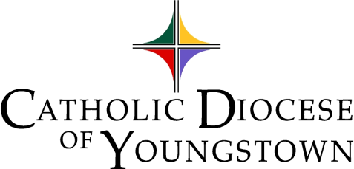

DYC’18 Bulletin Announcements

Pick your favorite, write your own, or use a combination over a couple of weekends to help promote the event in your parish. Do not limit yourself to the parish bulletin, but consider other official communication channels as well (i.e. parish newsletter, website, SNS page, approved text-messaging system, and so on.) Be sure to run these in September - before your registration deadline in October!

Diocesan Youth Convention 2018: Hundreds of high school teenagers will be gathering at St. Michael Parish in Canton on Sunday, November 4th for the 2018 Diocesan Youth Convention with Catholic composer, recording artist and storyteller Jesse Manibusan. Come be a part of it! Join young people from all over the Diocese for a day of music, food, prayer. Talk to _{insert your name and number here}___ by ______{your registration deadline} for more information and to register.

High School Students, do you want to meet new people and celebrate your faith? Teens from throughout the Diocese will gather on Sunday, November 4 at St. Michael Parish in Canton for the 2018 Diocesan Youth Convention. The day will include prayer, mixers, and faith-filled presentations by Catholic composer, recording artist and storyteller Jesse Manibusan as well as Mass celebrated by Bishop Murry following a conversation between he and the teens . For more information, contact _{insert your name and number here}___ by {date} !

TEENS: How much would you spend on a day out with your friends? How much did that last movie, along with snacks and dinner, cost? What about that concert ticket? How much did you spend on that new item of clothing? What did your last date cost you? Well, plan to make a date with God on Sunday, November 4^{h}. For only $__*__, you can spend the day singing, learning and celebrating with hundreds of high school teenagers at the Diocesan Youth Convention. Come to learn ways we can deepen our faith at St. Michael Parish in Canton. Call __{insert your name and number here}____ by {date} for more information and to register.

Diocesan Youth Convention
Sunday, November 4 2018
St. Michael Parish
Canton, Ohio
Cost: __*__
Come to the Diocesan Youth Convention (DYC) to help deepen your faith, celebrate Mass with our Bishop George V. Murry, S.J., explore our faith in sessions with Catholic composer, recording artist and storyteller Jesse Manibusan, all while meeting hundreds of teens from around the diocese.
Register with __{insert your name and number here}__—Today!

* The amount is left blank so you can decide the amount you will charge each participant.
{The registration fee is $30 until Wednesday, October 17, or late registration is $ 40 from October 17–24.
For example: determine whether the parish can subsidize a portion of the registration fees, and/or transportation costs, and list only the amount participants must contribute to the total registration cost. You may decide to meet for lunch prior to or dinner following the event and wish to factor that costs in as well. Your parish may need to charge $45 to cover costs, while another may charge only $15 due to fund-raising outcomes.}

